##### 

**ANUPRERONA**

**THE NEWSLETTER TO THE FRIENDS OF HSP**

**Issue 61 October, 2017 to March, 2018**

**EDITORIAL**

**Dear Friends, Partners and well wishers,**

**From this issue we are bringing out Anuprerona as a six monthly in-house Magazine. The reason being that within three months there is not much news to share about ourselves, our Homes, schools and Special programs. Besides, it also gives us time to evaluate each of our projects qualitatively. Henceforth, we will not only give the news but also share with you are views too. You can then guide us with your ideas, world-views and input to make Howrah South Point more relevant and helpful to the weaker sections of our society. As of today, we are deeply embedded to the vision, mission, objectives and praxis as enunciated in our Annual Reports.**

**With warm regards,**

Amulya Rajan Anthony Sah

**Hony. Secretary, HSP**

**To our Donors friends & well-wishers,**

**“LET NO WEAK MEMBERS OF HUMAN FAMILY BE IGNORED, NEGLECTED, NOR ATTENDED TO, NOR CARED FOR, NOR LOVED. OTHER WISE THE DIGNITY OF THE WHOLE FAMILY IS ADVERSELY AFFECTED.”**

With Love and regards,

Terence John

Hony. Secretary

***Mr. Terence John  
Secretary***

*Sincerely*

*Tapati Mukherjee*

HIGHLIGHTS

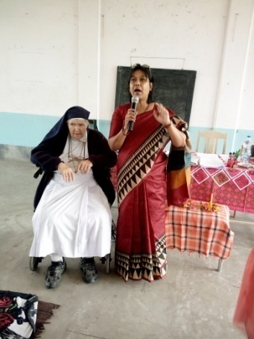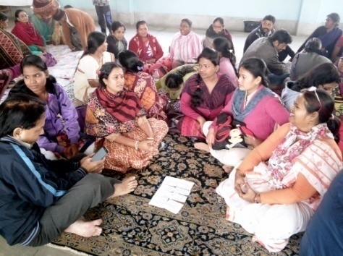

Spiritual Animation

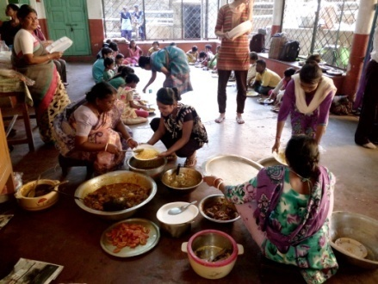

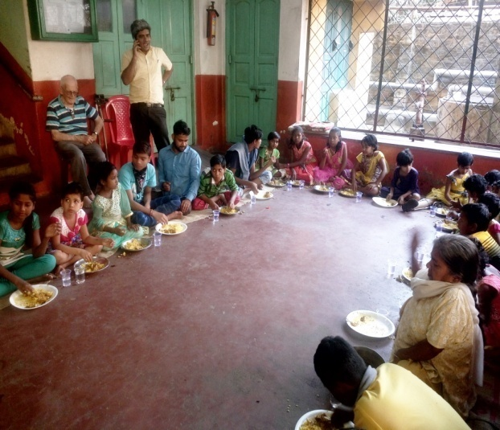

PICNIC (Botanical Garden)

**What is Howrah South Point ?**

**Howrah South Point is an Indian NGO working for the poorest of the poor, rendering services to poor handicap children and reaching to those, whom are in medical need but cannot afford, educating poor children formal and non-formal schools. That is giving education to those who cannot afford it nor are helped by the society.**

**This NGO was started in 1976 by Rev. Fr. Francis Laborde who was inspired to start this mission by two people, first, Blessed Fr. Antony Chevrier (1826-1879) a priest who lived at Lyons and consecrated his life to service of the poor, especially for the poor children in the beginning of Industrialization in Europe. Second, Cardinal L. T. Picachy, then the Archbishop of Kolkata. He summoned Fr. Laborde to start at Andul Road a home for poor handicapped children to which will be attached a dispensary for the poor of the locality. Since then till date poor and neglected of the society, irrespective of caste and religion have been the beneficiaries of this Organization.**

**Today HSP works in Providing services like, Rehabilitation of poor Handicapped children, Health Care, Education through Formal and informal schools. These services are provided through the Three Branches, Jalpaiguri, Howrah and Asansol.**

# Edited and Published by: Secretary H.S.P.

Email: [**hsouthpoint@gmail.com**](mailto:hsouthpoint@gmail.com)

# 

# For private circulation

**Website: www.howrahsouthpoint.org**

**ANUPRERONA**

**BAKSARA HOME**

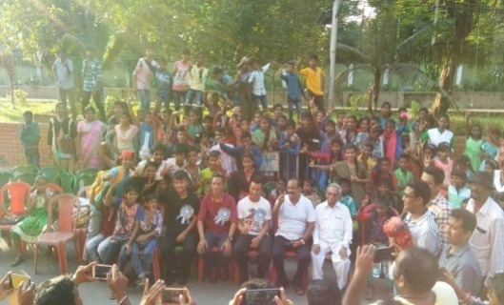**Received Blankets** - On 21st October 2017, Arabinda Guha, The Hon. Chairman of Howrah Municipal Corporation donated 100 Blankets to our children. He also provided a grand lunch. The children of Baksara, Lalkuthi and EPN were truly gratified.

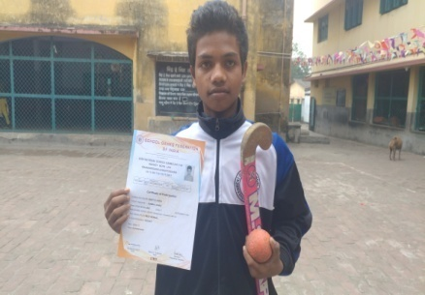

**Mantu Lohra -** One of our promising hockey player, Mantu Lohra got opportunity to participate in Under 14 Hockey (63rd National School Games 2017 - 2018) at Rajnandgaon, Chattisgarh. He was there for 5 days i.e. 10.11 17 to 14.11.17.

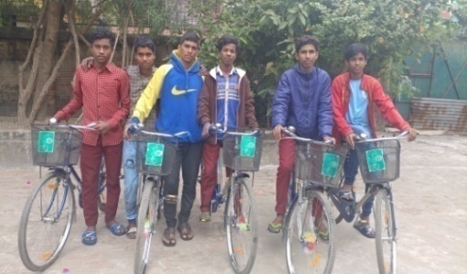**Donation Bicycles -** There are 11 children (X – 3, IX – 2 girls) (X – 5 Boys, IX – 1 Boy) in class IX & X. All have received bicycles from school under the scheme of Sabuj Sathi of West Bengal Govt.

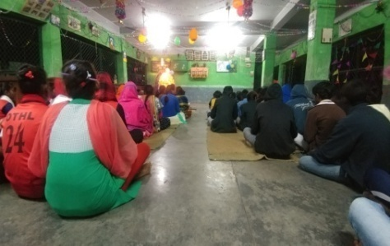

**Pre- Christmas Celebration -** On6th December 2017, Children of Baksara Home celebrated Christmas gathering. Christmas carols were sung by our children. Two folk dances were performed by the girls. At the end of the programme children received gifts.

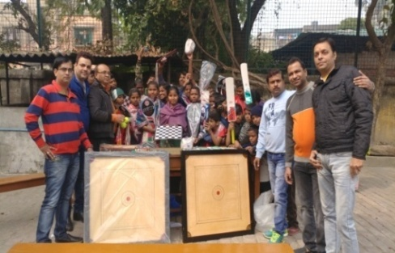**Visit of donors :**

1. Sushil Kumar Kedia & his group visited Baksara Home on 14th Jan 2018. They provided breakfast and lunch for the children. They also donated 100 pcs of woolen clothes, 4sets of ludo, 4 sets of chess game, 4 sets of badminton, 2 pcs of cricket ball and one bagaduli.
2. Mr. Sailendranath Pathak, a local well wisher organized breakfast and lunch for the children on his wife’s birthday on 18.02.2018. The children thanked Mrs. Pathak and wished her “Many Happy Returns of the Day”.

**New Admission 2018 –** Thirteen new children were admitted in Baksara home. Out of 13 there were 4 girls and 9 boys.

**Madhyamik Appeared –** In thisacademic year 3 girls and 5 boys appeared in the Madhyamik Examination.

**ANUPRERONA**

**Volunteer :**

1. 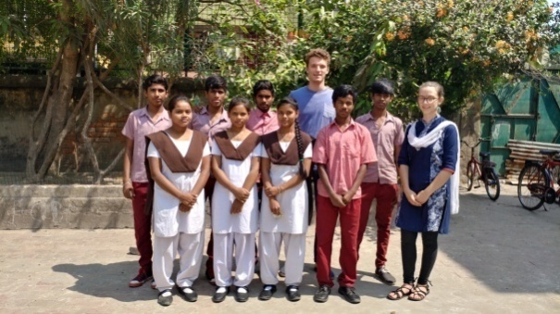HenryBeckenbauer, from Germany spent 3 weeks here in Baksara Home. While in Baksara he taught our children English and participated in games. His help was specially appreciated by class X boys.
2. Amodin, a french volunteer has joined just us after departure of Henry. We have a great expectation from her.

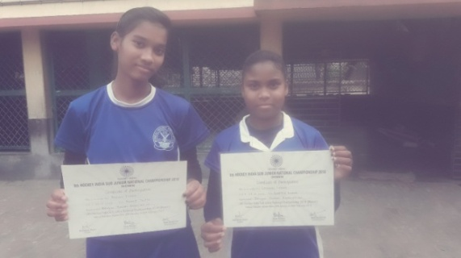

**Special mention** - We are proud to mention Anjali Toppo and Lakshmi Lohar. Both of them participated in Sub-Jr. Level womens Hockey at Kaliabor, Assam from 29th January 17 to 6th February 2018.

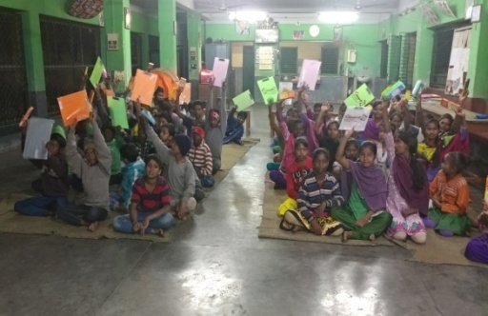**Annual Sports -** Anthony Mondal organized annual sports for the children of Baksara Home which was held on 4th Feb. 2018. Children participated and enjoyed every event. Come as you Like had full participation. **Mitan Soren - O**ne of our inmates, Mitan Soren Soren won 1st Prize in the event of 100 meters Race organized by Shibpur Police Station. **Sports Prize -** Most of our children won maximum number of prizes in the school sports Organized by Howrah South Point Vidyalaya, a Govt. School in Baksara.

**EPN HOME**

**Admission** –

* Strength of the home in previous year (2017) – 72 (47 Boys and 25 Girls)
* Children passed class IV successfully – 9 (6 boys and 3Girls)
* Total dropout children – 13 (1 girl and 12 boys)
* Transferred to another home – 5 (1 Ashaneer and 4 Baksara)
* New admission during this year 2018 – 13(10 boys and 3 girls)
* Strength of the home this year 2018 – 56 (31 boys and 25 girls)

**PICNIC** – Rotary Club of Calcutta arranged a picnic at NICO PARK on 26th November 2017. Children with teacher escort went with them by bus. They rode all the ‘riders’ and had great fun. The club also arranged lunch and Tiffin for the children. All children were given gifts of T shirts and badminton racket.

**HEALTH CHECKUP PROGRAMME** – A health checkup programme was held at EPN Home on 19th November 2017 (Sunday). An RMO from Pushpa Children Home came and checked all the children of this home.

**PICNIC** – On 24th February 2018 Uncle Juliyano arranged a picnic for all HSP children at Botanical Garden. Children played and had lunch. Thank you Uncle Juliyano.

**ANUPRERONA**

**DONATIONS** -

* Meena Kumari (Staff of St. Mary’s convent School) Provided lunch on 14th October 2017 and dinner on 19th October2017 for the children of this Home.
* Sister Santhana (St. Mary’s Convent School) donated lunch along with some gifts like – pencils, erasers, and pencil boxes for all the children on the occasion of her birth day. Even she provided snacks (72 pieces cake) for the children on 18th January 2018.
* Parimal Bhowmick (Guardian of Aridip Das) provided snacks for children on 6th January 2018 and 18th March 2018.
* Meena Kumari (Staff of St. Mary’s Convent School) gave dinner on 14th February 2018 and 8th March 2018 and lunch on 18th February 2018.

**EPN CRECHE –**

* Strength of crèche in previous year 2017 -19 (12 boys and 7 girls)
* Children sent for formal schooling during this year2018 - 11 children (6 boys and 5 girls)
* New admission during this year 2018 – 4 (2 boys and 2 girls)
* Strength of crèche during this year 2018 – 12 (8 boys and 4 girls)

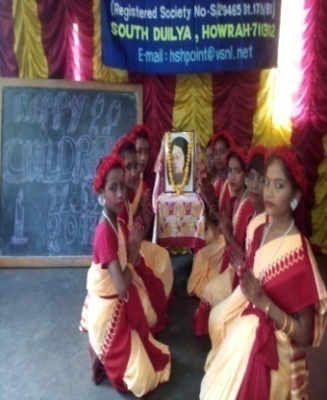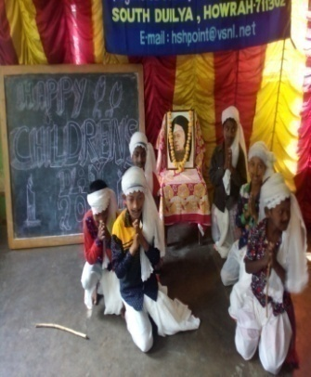**CHILDREN’S DAY CELEBRATION**“ On 14 September 2018. We were all children once. We all share the desire for the well-being of our children, which has always been and will continue to be the most universally cherished aspiration of humankind.”A day marking childhood. The day is also celebrated to pay tribute to the legendary freedom fighter Jawaharlal Nehru. The program started with a beautiful prayer. All the teachers welcomed the children by their melodious lyrics and garlanding the picture-frame of Jawaharlal Nehru. The memorable part of this year celebration was the function, performed by our little students. The best thing for the children was that they all came in colorful dresses and not in their school uniforms. The school play-ground was buzzing with excitement and joy of colorfully dressed children.

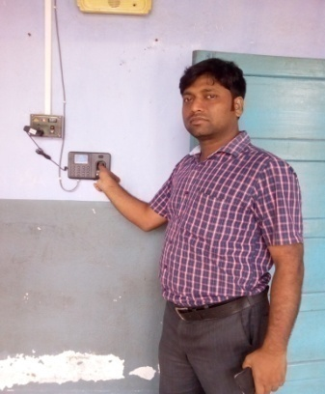

Bio-Metric Machine - A Biometric Machine has been fitted in our school to get the appropriate time of arrival and departure of our all staffs, including hostel and bridge-course school.

Guardian Meeting - Our school has organized a Guardian’s meeting on 27th November’2017 in the school premise. Our respected Secretary, Chief Co-Ordinator Officer and Public Relation Officer were present on that day. The main purpose of the meeting was to create a common platform, where teacher, parents and committee members come together to enrich the students’ educational experiences and discuss variety of issues, regarding all-round development of students.

**ANUPRERONA**

**Annual Examination** - The Annual Examination of our school started from 24th November’17 to 6th December’17. The announced result on 16th December’17 is as follow:

Result Out

|  |  |  |  |  |
| --- | --- | --- | --- | --- |
| BENGALI MEDIUM | |  | HINDI MEDIUM | |
| Students Appeared | 351 |  | Students Appeared | 267 |
| Passed | 351 |  | Passed | 260 |
| Failed | 00 |  | Failed | 7 |
| Percentage | 100 % |  | Percentage | 97 % |

We have to improve on our Hindi Medium section. Free coaching has to be given to weak students.

**Repairing**

The main gate of our school, some windows and some doors was been repaired in the month of December.

**New Admission & Re-Admission**

New-admission and re-admission was started from 4th January in our School by our teachers.

|  |  |  |
| --- | --- | --- |
|  | BENGALI MEDIUM | HINDI MEDIUM |
| New admission | 46 students | 43 students |
| Re-admission | 265 students | 195 students |
| Total | 311 students | 238 students |

**Republic Day’ 2018**

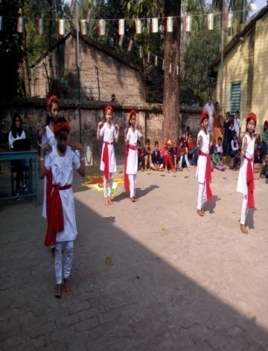

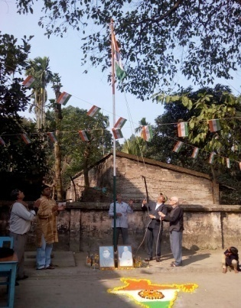Republic Day is celebrated every year on January 26 to honor the date, on which the constitution of India came into effect in 1950. Like every year, our school has organized a beautiful flag hoisting program with the help of our little children and our teachers. The program started with our National Anthem- Jana Gana Mana and then our guests Fr. Laborde and Chief Co-ordinator Officer hoisted the national flag. After that our respected teacher-in-charges gave a brief speech on the importance Republic Day. The program was finished with the beautiful performances of our children.

**ANUPRERONA**

**Annual Sports’ 2018**

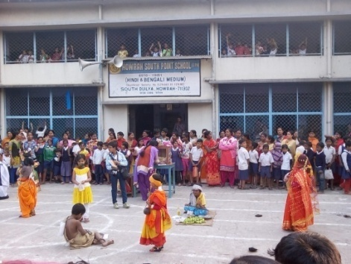“Talent wins games, but team-work and intelligence wins championships” Sports Day is a platform to showcase the talent and efforts put in by the little children to make it a successful event. Sports at Primary and Pre-Primary Level are not about competition. It is about having fun, being physically active and being inspired. So, we have organized the Annual Sports’2018 on 2nd February’2018. There was many exciting events, like-100meter race, spoon race, skip ping race, potato race and also the most interesting game, “Go As You Like” etc. The teachers also took part in it. After the final games, the young achievers were awarded by our guests.

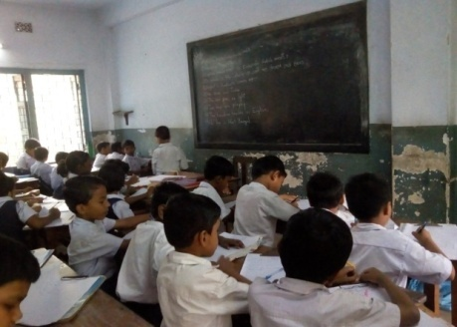**1st Unit Test -** 1st Unit Test was held on 15th, 16th & 17th March in our School.

**Electrical Repairing** - Electrical repairing was done on March’2018.

**Maintenance** - The main gate of our school, some windows and some doors are being repaired.

**CASE STUDY** - Manisha Sardar 1 month female baby D/O Ravi sardar, Mother – Mokhire sardar belong to Jamshedpur they work as brick field daily labourers for 6 month. They come in November and go back to their village in month of June. Parents bring the elder one to take care of toddler but we keep both giving them mid-day meals and teaching them as well.

**ASANSOL BRANCH**

* On 7th  October the children of the our Anand Bhawan Home returned back from their home after the DURGA PUJA vacation .They were once again back for their schedules and studies .They were very excited to return but some were disappointed as they were parting away from their parents.
* On the day of 18th October the children’s of our Anand Bhawan Home celebrated the festival of KALI PUJA &DIWALI along with the teachers by lighting phuljhari’s and firecrackers. They also distributed sweets and cakes. The children’s were very happy.
* 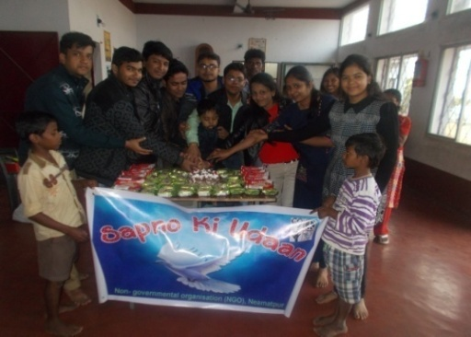On 4th November 2017, the group of ‘SAONO KI UDDAN’ came to our H.S.P. Ananad Bhawan home (ASANSOL BRANCH) and offered lunch to the children. They also spend their precious and memorable time with our children.
* On the same day the final examination of our kalipathar Hindi Primary School started. During this month the students and the teachers had a very hard time as they all were busy in their studies and examinations.

**ANUPRERONA**

* 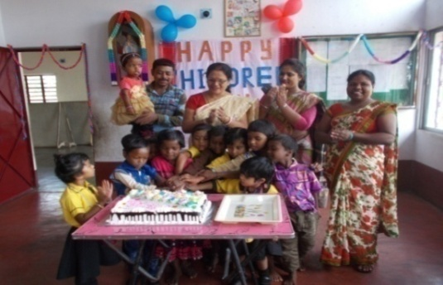On 14th November, the teachers and students of ‘LITTLE PALY SCHOOL’ visited our Anand Bhawan Home to celebrate the Children Day. They brought a cake which was and distributed. They also distributed chocolates and some game sets to our children home. The children‘s overjoyed and enjoyed it very much.
* 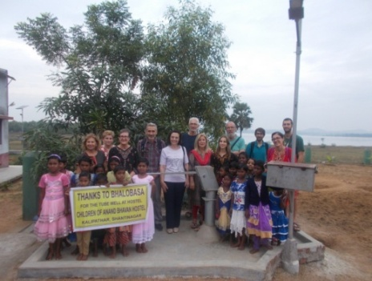On 15th of November, ‘THE BHALOBHASA GROUP ‘came to our home. They inaugurated the hand pump which was donated by them to our home and school. They were the guest of our parish priest Father RAHUL SEQUERA. They also distributed chocolates among all the childern’s of our home. We gave them our heartly thanks for providing us the hand pump with a welcome song and a dance programme performed by our childrens.
* 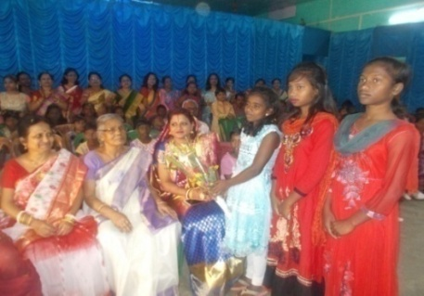On 6th December MR. SUBHASH PAL (OS) CLW invited our children of home and school at his son’s marriage Ceremony. We received a warm welcome and ate a grand lunch. Besides the children’s were given copies and pencils as a token of love. It can be said that the day was a feast day for the children.
* The 17th December REPORT CARD of our Kalipathar Hindi Primary School was distributed in presence of the guardians. The students who passed exams were promoted to higher classes. The students were very happy & excited to have done well in their exam. We *wish* them more success in future.
* 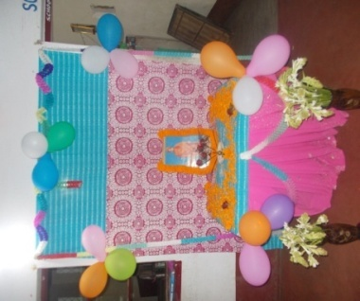On 23rd of December the girls of our Anand Bhawan home, received their report card. They all passed with good marks and have been promoted to higher classes. We wish them all success in life.
* On 12th January was an auspicious day celebrated as “SWAMI VIVEKA NANDA’S JAYANTI”. So, we started the day with his blessings by offering him our deepest gratitude through garlands, flowers and prayers.

**ANUPRERONA**

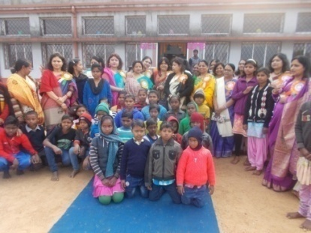

* On the same day ‘THE UDAY MAHILA MANDAL TEAM’ came to visit our Anand Bhavan Home from EASTERN COALFIELD LIMITED (ECL), Salanpur and each member of the team planted a fruit tree at our school campus. They planted nearly 15 fruit trees which consisted of Mango, Guava, Black berry, Kamranga, Lemon etc. They also distributed some blankets and copies to the children.
* 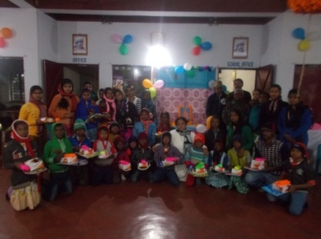As it was the day of ‘SWAMI VIVEKANANDA’S JAYANTI. The O. S. of CHITTARANJAN LOCOMOTIVE Mr. SUBASH PAL also and his family visited’ us in the evening. He spent time with our children and distributed copies, pencil boxes and Tiffin boxes to our children’s. MR. SUBASH PAL is indeed a charitable person frequently visiting. He brings happiness and gifts and lights up children’s face in his visits.

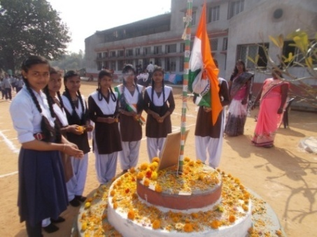

* On 26th of January we celebrated the ‘69th REPUBLIC DAY’ at our Kalipathar Hindi Primary School & Anand Bhavan Home. We invited our Parish Priest FR: RAHUL SEQUERA, as our Chief Guest, who hoisted the National Flag. This was his followed by good speech March-past by our children and National Anthem.

* 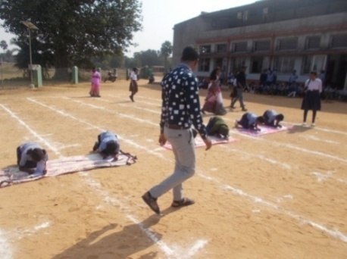On this same day ‘THE UNITY INDIA GROUP’ also came to our Anand Bhavan Home to celebrate the Republic Day with us through sports. They divided the children’s in groups and organized many events like 50m race, 100m race, sack race, spoon race, skipping race. The winners of these events were awarded prizes for 1st, 2nd and 3rd positions. The day was an eventful day for us as we all enjoyed a lot especially the children’s when they received prizes.
* 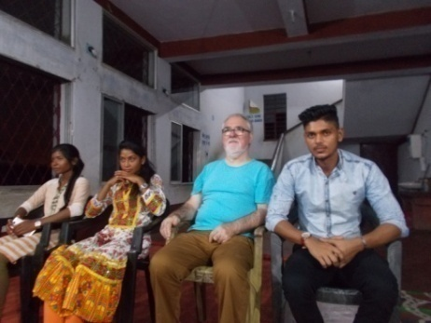On this day 03 (three) of our Guests- Mr. GUILIANO, Mr. BHIM and Miss. SUMITRA TIGGA came to visit us. The children’s gave them a warm welcome. They stayed at our Anand Bhavan home for nearly five days and were very happy to be here. Guiliano uncle offered some SWISS watches to the students of class X and also took them for a PICNIC. We are really grateful to him.

**ANUPRERONA**

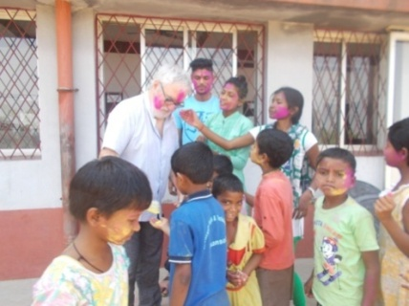

* This particular day on ‘HOLI’ festival day, the teachers and the children’s of our Anand Bhavan Home celebrated it whole heartedly by spraying colors and gulals on each other. The children’s were really happy and enjoyed this Holi Day.
* 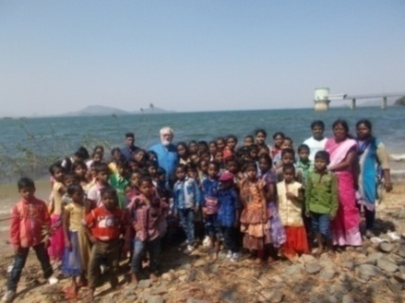On 03rd March children of Anand Bhavan enjoyed PICNIC at the ‘MAITHAN DAM’ along with our three guests. The children’s were very happy as they roamed and played at the dam side. The children also had ate grand sponsored by GUILIANO uncle.
* 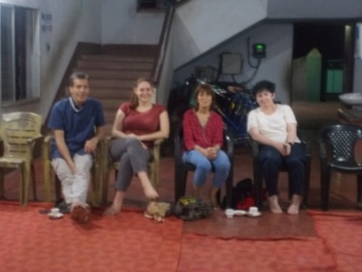On 14th March, 04 (four) guests from ‘NAMASKAR KOLKATTA : Miss. ROMENGAS MARIE, Mr. RUSE FRANCOISE, Mr. RUSE PASCAL & Mrs. BRAZALOTTO ISABELLE along with our President . FR: FRANCIS LABORDE came to visit our Anand Bhavan Home. The children greeted them by singing a welcome song. They also performed dances and staged a spit. The guests were very much impressed by the children’s and gave them Chocolates. They took photographs with all the children.

**Prognalaya Special School**

* **CHILDREN’S DAY -** Pandit Jawaharlal Nehru was born on 14th November 1889. It is celebrated on the 14th November in India as a tribute to Pandit Jawaharlal Nehru, known as Children’s Day on that day. We give our children two things: roots, like special school, and wings like celebration. Like preceding years, this year also we celebrated a small but colorful cultural awareness program and distributed some foods and sweets to all of our beautiful children.
* **WORLD DISABLED DAY** - 3rd December International day of persons with disabilities has been celebrated annually on 3rd December. It is known as “world disabled day” too. We celebrated this day with an entertainment program which included an inclusion massage. Like every year we arranged an awareness rally program. This year it has been Ashaneer complex, because some students were feeling bad in physically. So it was incomplete rally. But students were enjoying very much inside of the school building with some indoor game. After that we distributed fruits and sweets for all of our beautiful children.

**ANUPRERONA**

* 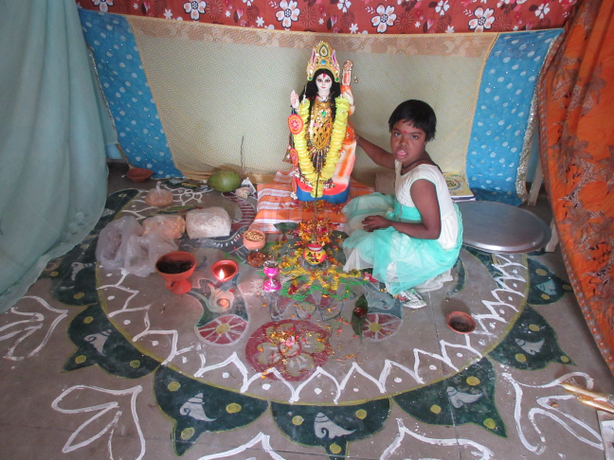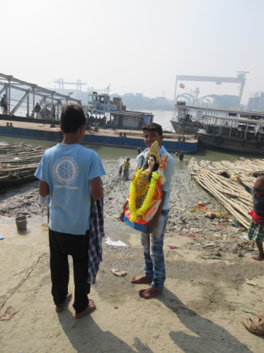 **CASE STUDY** - Manisha Das an 8 years old girl with Down syndrome from very low socio economic back ground was admitted to Prognalaya Special School. She was placed in care group. She was assessed under the functional assessment program. The child was assessed by observing the teacher. We have seen that she was a severe mentally challenged child, having very low attention span and sitting span. Sticky and monotones behavior also present in her character. And she was unable to follow instruction unnecessary crying, fearless and lethargic attitudes. Only saying some sound and meaningless word. The first challenge of the teacher was to increase her attention for require time and sustained. At present time through IEP (Individual education Program) the girl has shown considerable improvement. Now she is trying to understand and obey simple instructions. She can identified fruits, vegetables, animals, colors, etc. Manisha will improve more with time and proper guidance.

Manisha Das

* **SARASWATI PUJA -** 22nd January 2018 was Saraswati Puja. It is different kind of program which is jointly arranged by Ashaneer home and Prognalaya Special School. Every one enjoyed very much with colorful dresses. It was a meaningful occasion to discover about those who were not luckey, but whose smiles are a gift of God.
* **ANNUAL SPORTS -** On 9th February 2018 Prognalaya Special School hosted Annual sports meet. The day filled with fervor, excitement, amidst thrills and cheers. The Chief Guest for the day was chairman of Howrah Municipal honorable Mr. Arbind Guha. And HSP’s honorable father Laborde with others authorities were present as our special guest. The day started off with the lovely opening prayer. Honorable Chairman Mr. Guha thanked all the teachers and staff for their co operation and support and advised children to keep up their spirit.

Parents, staff and indoor children also participated on that day. At the end of the days, students departed with a clear smile on their face. It was a day filled with enthusiasm and memories to cherish.

**Psychotherapy Department**

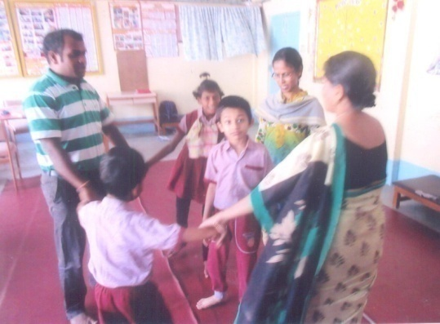The psychotherapy department is a special department in Ashaneer. This department is dedicated to 53 children who need different therapies due to their different psychological issues. These therapies are psychomotricity, story therapy, play therapy, pack therapy, bath therapy, clay therapy, music therapy and individual therapy. Our department is generally supported by French psychologists who came to this department in alternative years. Like the previous years two French psychologists have come to be with us guide us. They also advise specific needs of psychologically problematic children in a proper way. But French psychologist Elsa Leconte already has gone to Bakuabari centre (HSP) on 27th December 2017. But other French psychologist Diane Prodel is still with us.

**ANUPRERONA**

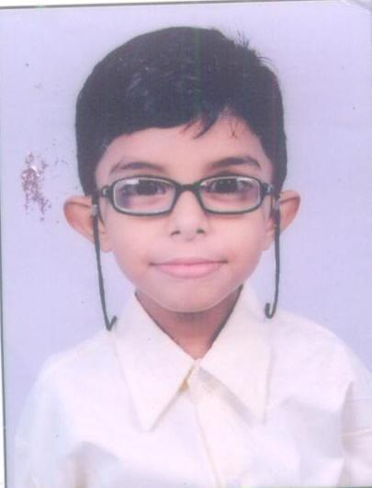**CASE STUDY -** Tridib Ghosh among these children Tridib has change a lot. He was admitted on 12th August 2015. Now he is 10 years old “cabuki syndrome” boy. In the beginning time he had relation problem. He always wanted fewer children and preferred less crowded place. He did not express any word and was not willing to play with us. He also felt afraid and had anxiety. Gradually by coming to psychomotricity he has learnt to socialize and is able to create relationship. He speaks meaningful words when therapists ask anything. He also remains quiet while he takes massage. Not only this he can follow therapeutic border and also accepts group activities. So parents and psychotherapy team is happy and satisfied.

The psychotherapy department really holds a special place in Ashaneer. Different categories of children come to this department who need different therapies. This department is always supported by French psychologists. Now one French psychologist Diane di is still with us. She trains us in both outdoor and indoor activities. She also advises specific needs therapy of psychologically problematic children in a proper way.

Statues of children of psychotherapy department

Indoor children - 16

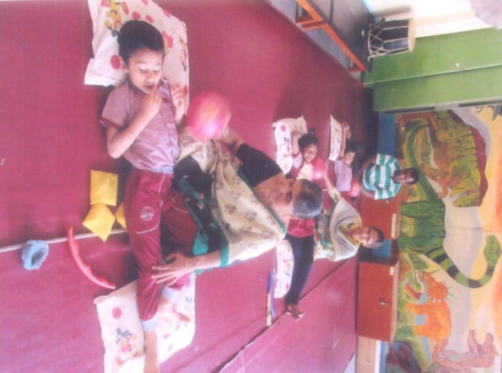Outdoor children - 35

New outdoor children - 01

Total number of children - 52

Total number of therapies of children

Psychomotricity - 40

Story therapy - 11

Play therapy - 30

Pack therapy - 06

Clay therapy - 08

Music therapy - 12

Bath therapy - 01

Individual therapy – 01

Eight types of therapies are given to the children by us.

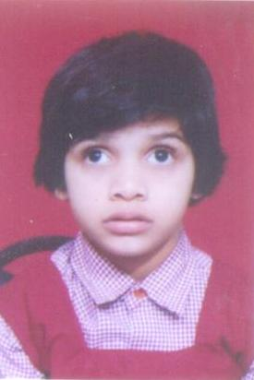**CASE STUDY -** Aditiya Kumari among these children Aditiya has change a little bit. She was admitted on 13th October 2012. She is now 6 years old autistic girl. In the beginning she had big relation problem. She could not follow the direction and roamed here and there. She always attacked as by biting during the therapy. Beside this, she attacked other children/Staff when she felt hungry and sick. She did not express any words. Sometimes she did toilet during the session and also laughed meaninglessly. Though pack therapy and Psychomotricity she has gradually learnt to accept the presence of others and is now able to create relationship with the staff. She remains quiet through the soft song during those therapies. Gradually she also can follow therapy border and tries to follow the direction. For this parents and psychotherapy department are happy and satisfied.

**ANUPRERONA**

**Ashaneer Physio Department**

Outdoor - 33 children

Indoor - 19

Pushpa Home and Children Ward - 10

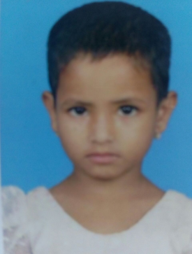Outdoor new admission - 12 children

**CASE STUDY -** Zarka Khatun, 6 years old girl, she had an old fracture on her left elbow when she came to our centre in February 2018. That times her elbow could not move and had swelling. She had difficulty in doing elbow flexion. Now she is able to do elbow flexion by herself.

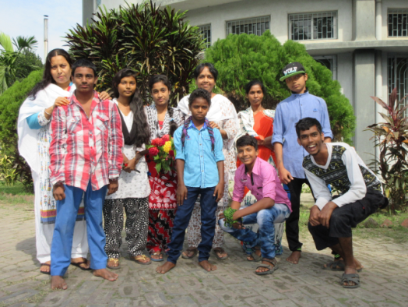**Ashaneer - St. Mary’s Home**

* We celebrated children day on 14th November 2017. Sister Santana Cyntliya from St. Mary’s convent school participated with her school children. They gave sweets and banana to all our children and staff. They gave lunch to our children. Our children enjoyed a program and they did a small program too.
* This animation was conducted by Sister Cyril, IBVM, who has consecrated her whole life in the field of education and has been presently asked by the government of west Bengal to work for the Ministry of Education. Spiritual Animation was held at Ashaneer on 20th and 21st of December 2017. All the Howrah, Asansol and Jalpaiguri staffs participated in this spiritual Animation. All staffs enjoyed and learn many things from this meeting. This animation gives us courage, inspiration, unity, love and peace. How we work with others? She teaches us though play, song, drawing and small play medium of group dynamics our improve ourselves in our future works.

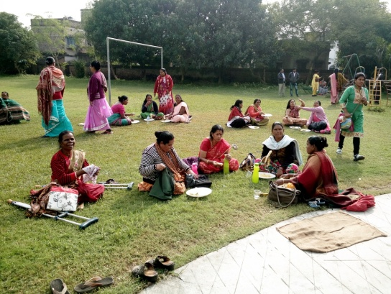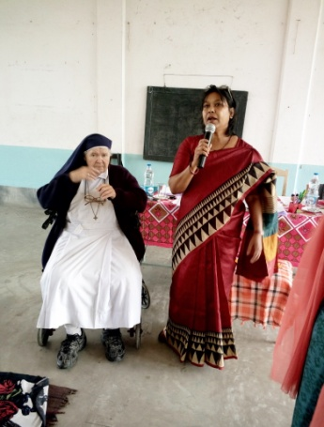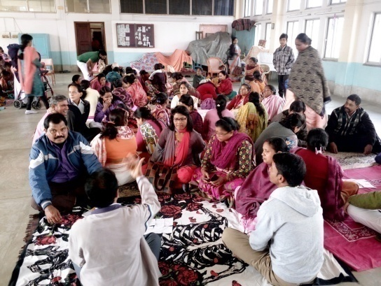

**ANUPRERONA**

* **New Admission**

In January 2018 three children are admitted in our Ashaneer home.

1) Ana Baidya (Hearing Impaired)

2) Augustin Roy (Normal)

3) Subhojit Hansdar (Normal)

* **Donation (8.02.2018)**

From Little Sisters Poor (Kolkata). They donated 148 pieces of orange and 16 pieces of watermelon to our children.

* Mrs. Manju Neegi from 83/2 Dakshin Baksara, near Lalkuthi home.

She gave 42 pieces cake, 42 packets biscuits, three dorjon bananas and 4 big sizes Maggie packet for our children.

* Our psychotherapist named Diane Prodel gave big mirror for Azima khatun. She is autistic and mental retarded, she is always eating her cloths and with this mirror she left her bad habits. Our psychotherapist suggested that if she can see herself in the mirror she will be able to feel more secure and since then she has habits to eat her clothes.
* Number of children of Ashaneer home
* Hearing Impaired - 7
* Mental Retardation - 7
* Cerebral Palsy - 11
* Orthopedic Handicapped - 4
* Autistic Feature and mental retardation - 2
* Mental retardation - 1
* Moderate - 2
* Down syndrome - 3
* Normal - 7

Total - 44 children

**ANUPRERONA**

**Lalkuthi Home**

* Our children of Lalkuthi took part in school programme. Peronica, Renu , Rinki, Puspita and Aparna were awarded 1st prize.
* Lalkuthi children were invited to take part in sport arranged by the Bahtri Sangha Club. Aparna, Rinki, Puspita, Jyostra and a little girl Lalita received 1st prize. They were very happy.
* Upoma, Anita, Bharoti, Soma and Juli had received cycle from their school. They wrote school final exams this in March 2018.
* Renu, Sheyati and Priti of Class IX had received cycle from their school.
* Mrs. Monalisa our song teacher is teaching Abriti song to our children; free of cost and also gives RS 500/ every month for the education of children. December 20-17, Monalisa had arranged a song competition in Dream Land School. Puspita, Aparna, Rinki, Anima, Mousumi, Jyostna, Santona and little Ishika had won the 1st prize among many other schools.
* Mr Ajay Gupta came on the occasion of Saraswati Puja with his students. They distributed exercises books, pen and pencil box, snacks, apples, oranges, bananas, biscuits, chips, fruiti, dolls, teddy bear and skipping rope to our children, they also gave Atta 10kg, rice 5kg, muri 2,5kg to our lalkuthi center. 45 blankets were given to our children.
* Parvindar, Sachin, Neha, Surati, Roshni, Mohit, Saharsh, Bajaj, Vivek, Sinjini, Hemlata and friends are our regular donors. Every months they gives 100 kg rice, 10kg Atta, 10kg Dal, 5kg Oil. Very often they also give cakes, biscuits, chanachur, and snacks. This year in March 2018 they gave Rs. 12000 to purchase education materials. They also gave copies, pen, and pencils to each girl.
* “Namaskar Kolkata” our sponsor donor Pascal, Francoise, Isabelle and Marie visited their sponsored children at Lalkuthi, Baksara and EPN School. They gave many gifts to all the children. Our Lalkuthi children were very happy to get beautiful gifts by the lotary made by them. They also gave chocolate, fruits, salad to our children and staffs. All of us were very happy to meet them at Lalkuthi. We are very grateful to our donors.

**Picnic in Botanical Garden**

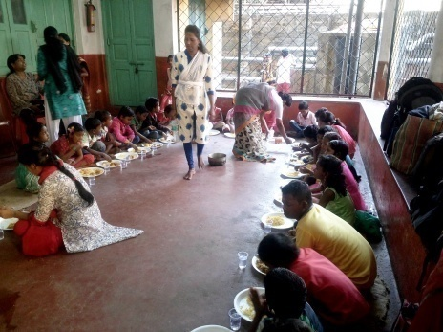 Juliano Uncle had invited all children and staffs of 4 centers at Howrah. Food was cooked at Lalkuthi. Fried rice, chicken, apple, orange were served to everyone. All children were very happy to meet Didis, dadas and children of other centers. They enjoyed different trees and flowers. Their happiness had no words to express. All expenses of Picnic was beared by Juliano uncle.

**ANUPRERONA**

**JALPAIGURI**

**Renovation:**

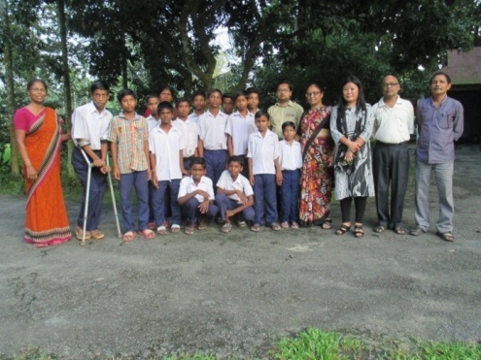

**Shikarpur School**: The roof of the Shikarpur School was bamboo thatch with plastic sheet. So very often it was affected by storm and heavy rain and it was difficult to continue the classes. We applied to Block Development Office at Rajganj and Rajganj Panchayet Samity renovated the roof with corrugated tin sheets. On 4th Nov 17 the school was inaugurated by the Block Development Officer, Rajganj, MLA of Rajganj, Sabhapati & Panchayet Pradhan. The children are happy for the new development of their school.

**Mogradangi Home Solar PV:**

3 KWp Solar Photo Voltic Panels were installed in Jan 2015; purpose was to save the electricity bills connecting to the power grid. But for the Grid connection needed more 2 KWp. After long wait to complete the project work, in Oct 17 more 3KWp panels installation & Grid Connection has been done. Now daily average 15-20 KV. Produced is linked with GPS system. Thanks to Stephanie Perregaux of Indian Project, Switzerland for their guidance & financial support.

**Jordighi Home:**

The entrance road of Jordighi home was broken badly. It has been repaired by the help of road contractor Mr. Jayanta Ghosh.

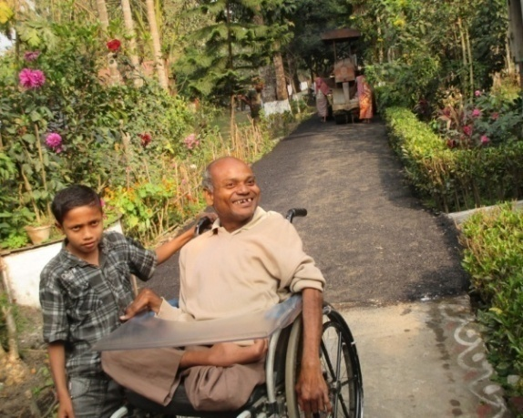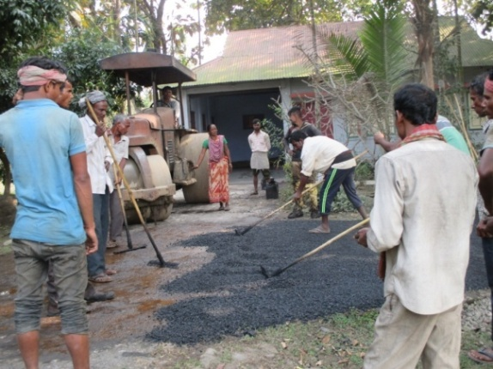

**Re-organisation at Jalpaiguri**:-

On 22nd Dec 2017 big changes have been made for Bakuabari and Mogradangi Home. To run a home it is compulsory to get registration under Juvenile Justice Act 2015 (JJ Act). According to JJ Act boys and girls could not reside in the same compound using one common entrance. So now Bakuabari home is only for the Girls and Mogradangi for the boys and capacity of both the homes are 50 for the children with special needs. So the Jeevan Path Community is for male Adult orphans and severely mentally & physically challenged are sent to Day Centre, the vocational training centre at Bakuabari Dosh Bigha.

**ANUPRERONA**

**Annual Sports**:

on 17th Dec 2017 Boys and Girls (10+10) from Jordighi, Mogradangi and Bakuabari home participated in “MUSKAN “the Annual Sports meet for the disabled organized by NBCD, Siliguri and most of them won the prizes . Besides, the girls group bagged the runners’ trophy.

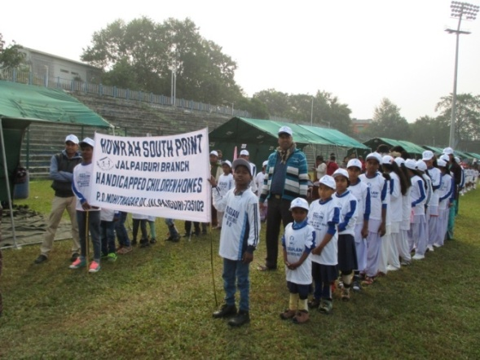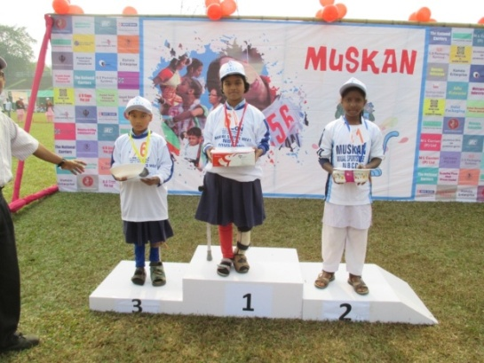

**Manus Domini Special School**, Bakuabari organized its Annual Sports on 15th Dec 17. All the school children along with the children from Outdoor Post physio center also participated. The Sabhapati of Rajganj Panchayet Samity attended the sports and distributed the prizes to the winner.

The annual sports was held for **Shikarpur School** on 26th January.

**Educational**:

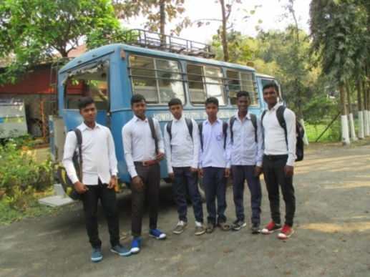All the boys and girls attending formal schools passed their yearend annual exams and were readmitted to the next higher class.

Mr. J. L. Lakhotia, a well-wisher of Howrah South Point offered new books for the girls of Big Girls, Bakuabari.

7 boys from Jordighi home and 7 girls from Bakuabari Big-Girls appeared in Madhyamik exams (school final) which was held in March 18.

**Surgery Camp:**

The 18th cleft lip & palate surgery camp was organized from 5th Nov. to 23rd Nov. 2017. Total 39 children were treated with the support of Pro-Interplast by Garman Doctors, Germany at Goodricke group hospital, Chalsa.

The children with Congenital Tibial Equino Verus (CTEV) foot deformity have been corrected by Serial Plaster cast. This winter we have completed 17 children serial plaster and provided boots and bar. 9 children are under this management.

Pro-interplast, Germany supported us by meeting the cost of materials.

**ANUPRERONA**

**Celebration**:

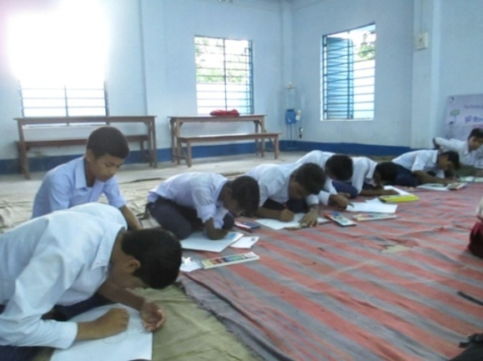All the four homes of Jalpaiguri celebrated 23rd January and the 26th January by March Past, Flag Hoisting and singing patriotic songs. On the Re-public day 26th January the respected Additional District Magistrate, Jalpaiguri paid his valuable visit to our Jordighi Home and offered sweets packets to all the children.

On 13th Nov 2017 a **Drawing Competition** was held at Jordighi home among the Jordighi home children on the occasion of childrens’ day. 6 boys bagged the prizes in two categories.

Also 10 boys participated in Rangoli competition in which they pained the road near Teesta Garden, Jalpaiguri with oil painting.

All the boys attended the cultural programme at town club hall, Jalpaiguri on 14th Nov.2017. All these were organised by the District Administration-District Child Protection Unit (DCPU), Jalpaiguri on the occasion of Children day.

**World Disabled Day**:

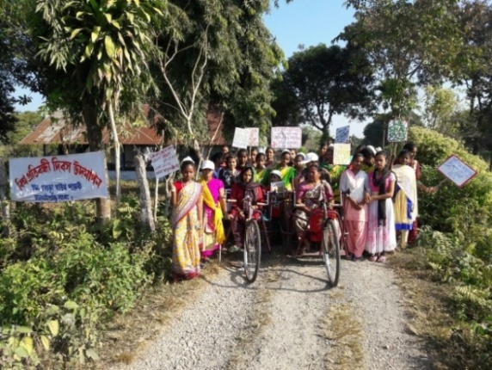This year we celebrated the day in a different way. All the children, didis and dadas from Bakuabari and Mogradangi home gathered at a open place near to Bakuabari home besides national highway & *Bandhunagar* bus stop. The children from our outdoor physio centre also joined with their parents. There we organized a small cultural programme where the children sang and danced. Then the children took out a procession with poster and banner though the village to our Bakuabari Home. On our way of walking we met many villagers who were interested to know our purpose. The children who cannot walk and cannot move by wheel chair went out by our jeep following the procession. Coming back at Bakuabari we had a big picnic all together.

**Picnic & Outing**:

Jeevan path members went out to Bengal Safari near Siliguri. They enjoyed the animals and also had good food!

The Women Community Of **Mariabasti home** also went to Bengal Safari.

Mrs. Malavika Byanwala ,Siliguri sponsored the trip, food etc. for them. They have enjoyed a lot.

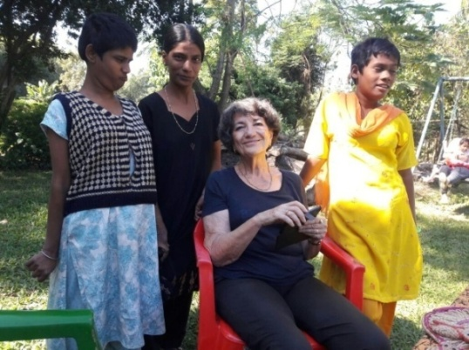**Volunteers & Friends:-**

Maryse Favre came to visit along with her grand daughter Miss Elice Favre to Jalpaiguri.

A French Psychologist, **Elsa** came for 6 months at Bakuabari Manus Domini Special School. She has shared her knowledge about psychotherapy with our team at Bakuabari. Besides she visited our other three Homes at Jalpaiguri. She made group counseling with teen age children at Jordighi and Bakuabari.

**ANUPRERONA**

Once again, we welcomed our dear friend **Pascale Cochet** from France for one month. During her stay she stayed at Bakuabari and shared her experience, knowledge, ideas with the physiotherapy team. She checked the children with physical needs & gave training accordingly. We are thankful for helping us with her presence and experience.

**Alibaba** from Switzerland and friend of Giuliano Uncle paid his visit at Jalpaiguri Centre. He is travelled by his car from Switzerland! Jordighi boys were very much interested and excited to share his experience.

Like the previous years **Giuliano Minisini**, from Switzerland came to Jalpaiguri. During his stay he has visited all our centers and organized Picnics.

**Co-operation of Govt:**

Manus Domini Special School received grants for Festival Garments, Shoes and Bags from Mass Education Department West Bengal.

Block Administration of Rajganj started Pond digging Work at Bakuabari under MGRES.

**Local Assistance:**

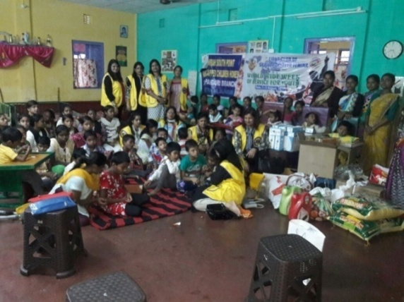Puja garments distributed to the Children of Bakuabari Home by Akhil Bhartiya Mahila Mandali Siliguri and for Mogradangi Home children by Mrs. Kiron Periwal and her family members, relatives etc.

School Uniform for 45 Girls and boys were distributed by the women group of Kiron devi, Madhu, Sarita, Abha,Shakuntala and their friends from Siliguri.

Siliguri Textiles Welfare Association provided Rice and Grocery Items.

We are very much thankful to Mrs. Kiran Devi Periwal, Siliguri, who introduced her friends for Howrah South Point and extended their generous help.

.

* 





 !

" #$





%&'$

 #$%





( )'*)

+) ,' %





'!--$  

#$%

.



'/)0)$1 ") 

#$2%





' !

#3"  #$2%





'(4'526 #$)

6)%

.



'(!  #$

+)%

7



'(8) %

9 :,)'"'$'#8

 #$8%%#$* 

%

;



<(* #$+)%

7



<'(%!'!--*





<'( !#$+)%





<'(%/!'2'* 

!-=#'%

* 

/+

<'(%#$34 ! !

#$2

7



<'(4' !29

 #)$)

**BOOK POST**

## HOWRAH SOUTH POINT

P-249, Andul Road, Podrah, Halderpara, Howrah-711109

Telephone: 6292120324 / 25

E-mail – [hsouthpoint@gmail.com](mailto:hsouthpoint@gmail.com)

Website – www.howrahsouthpoint.org.in