##### 

**ANUPRERONA**

**THE NEWSLETTER TO THE FRIENDS OF HSP**

**Issue 60 October,2017**

**EDITORIAL**

**Dear Friends, Partners and well wishers,**

**At the outset, my apologies for the delay in bringing out this News Letter. However, I take this opportunity in wishing all our benefactors in all fields A very Joyful Merry Christmas. We request you to allow the Infinite in you (finite entity) to grow so that you are showered with His all around bliss, peace and prosperity this season and in the years to come. Dear friends, please do continue to support us with your physical, mental, financial and prayerful activities so that the marginalized, poor and needy denizens of our hospitals, dispensaries, homes and schools can proudly be a global citizen. Wishing you all a HAPPY NEW YEAR – God Bless.**

**With warm regards,**

Amulya Rajan Anthony Sah

**Hony.Secretary, HSP**

**To our Donors friends & well-wishers,**

**“LET NO WEAK MEMBERS OF HUMAN FAMILY BE IGNORED, NEGLECTED, NOR ATTENDED TO, NOR CARED FOR, NOR LOVED OTHER WISE THE DIGNITY OF THE WHOLE FAMILY IS ADVERSELY AFFECTED.”**

With Love and regards,

Terence John

Hony. Secretary

***Mr. Terence John  
Secretary***

*Sincerely*

*Tapati Mukherjee*

HIGHLIGHTS

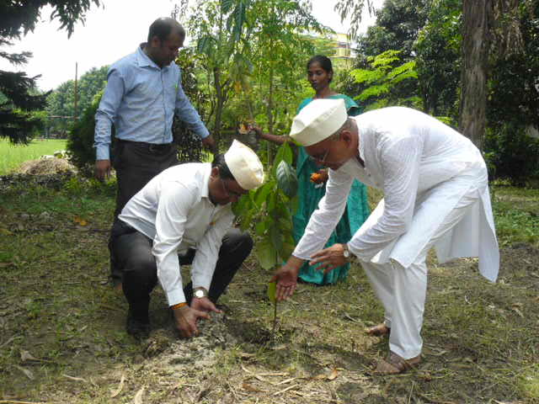

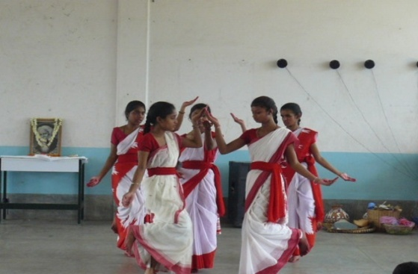

**What is Howrah South Point ?**

**Howrah South Point is an Indian NGO working for the poorest of the poor, rendering services to poor handicap children and reaching to those, whom are in medical need but cannot afford, educating poor children formal and non-formal schools. That is giving education to those who cannot afford it nor are helped by the society.**

**This NGO was started in 1976 by Rev. Fr. Francis Laborde who was inspired to start this mission by two people, first, Blessed Fr. Antony Chevrier (1826-1879) a priest who lived at Lyons and consecrated his life to service of the poor, especially for the poor children in the beginning of Industrialization in Europe. Second, Cardinal L. T. Picachy, then the Archbishop of Kolkata. He summoned Fr. Laborde to start at Andul Road a home for poor handicapped children to which will be attached a dispensary for the poor of the locality. Since then till date poor and neglected of the society, irrespective of caste and religion have been the beneficiaries of this Organization.**

**Today HSP works in Providing services like, Rehabilitation of poor Handicapped children, Health Care, Education through Formal and informal schools. These services are provided through the Three Branches, Jalpaiguri, Howrah and Asansol.**

# Published by: Secretary H.S.P.

Email: [**hsouthpoint@gmail.com**](mailto:hsouthpoint@gmail.com)

# 

# For private circulation

Website: www.howrahsouthpoint.org

**ANUPRERONA**

# 

# C:\Users\HSP\Desktop\New folder (12)\DSCN2580.JPGKALIPATHER ANAND BHAWAN HOME ASANSOL

It was the day of 22nd 0f July when MR. ANIRUDH GHOSH, MR. MAYANK GHOSH and MR. MICHAEL GOMES came to our KALIPATHER ANANAD BHAWAN HOME. They are the auditor’s and accountant of our Howrah South Point. They came for the verification and also audited our accounts. They also spend their valuable times with the children.

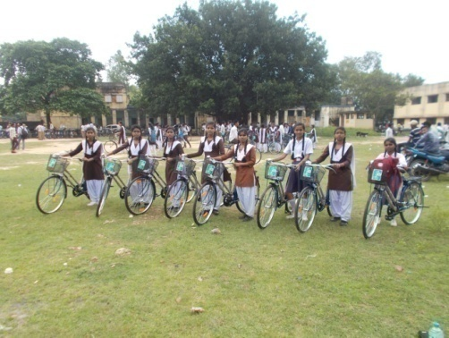

On 2nd of August 8 girls of our Kalipathar home who go to Chittaranjan Kasturba Gandhi Vidyalaya (H.S) received bicycle from the West Bengal Government. The girls were very excited after receiving the cycles.

Seventh of August was a graceful day for our children as they were very excited on this day. The “UNITY INDIA GROUP” came to our Kalipathar home to celebrate the “RAKSHA BANDHAN” festival. All the girls of our home tied Rakhi’s to all the members of the Unity India Group. The girls also tied Rakhi’s to the boys of our home .The Unity India Group gave cosmetic gifts to the girls as a token of love to their little sisters and also distributed sweets among all the children.

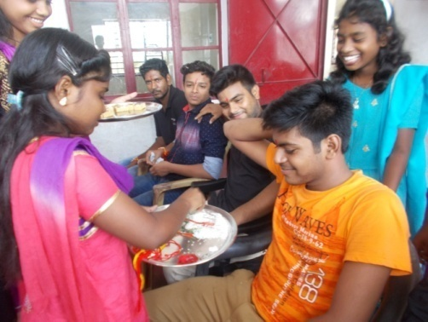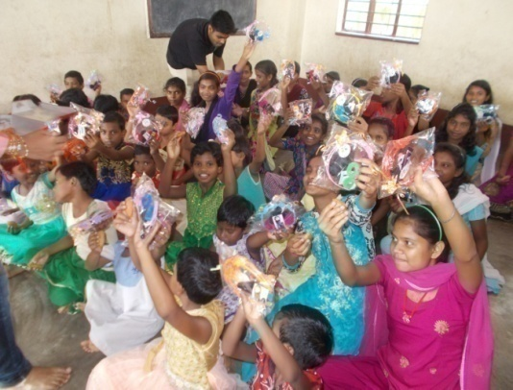

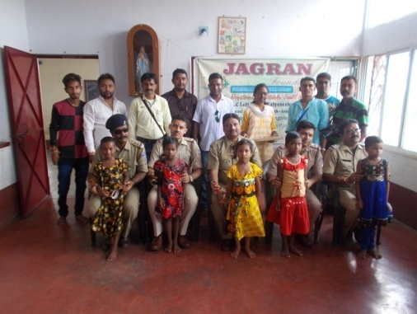

On the same day “THE JAGRAN FOUNDATION” also came to celebrate the ‘RAKHSA BHANDHAN’. The D.I.G (police) and the Senior Inspector of Salanpur police station were also present on this auspicious day .They distributed Rakhi’s to the girls of our Kalipathar home. They also distributed pens, sweets, biscuits, chocolates, and cakes to all the children.

Senior Inspector of Salanpur

Police station with children

**ANUPRERONA**

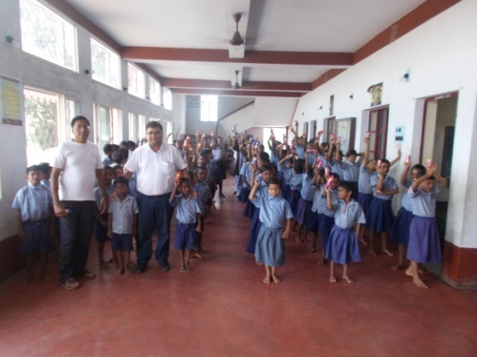

On of 8th August MR.PAWAN BURNWAL & MR. PIYUSH AGARWAL donated an “AQUAFINA” to our Anand Bhawan Home. They met the children and distributed sweets and fruits to the children.

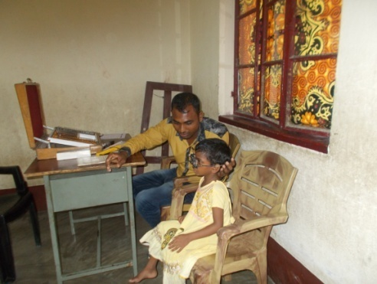

On 13th of August our Parish Priest FR. RAHUL SIQUERA organized a free Eye check up camp for Anand Bhawan Home. DR.BHUDEV MAHATO and his four assistant from ‘NAYAN EYE HOSPITAL’ did the Eye checkup. Some nearby villagers also came for their Eye checkup in our campus.

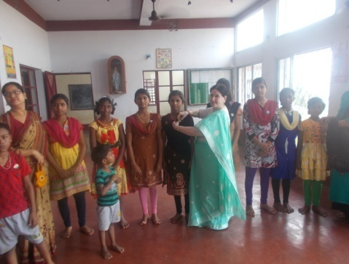

On 14th August “KULTI FOUNDATION” came to our Kalipathar home. They met the children and blessed them for their bright future and also offered badges of Independence Day to all the children.

As we all know that 15th of August is our “NATIONAL INDEPENDANCE DAY” It was a very joyful day. for our Kalipathar Anand Bhawan home (Asansol). We decorated the whole campus with the National Flag After the grand March Past performed by our children the national flag was hoisted by our chief guest MR. MAYANK AGARWAL. He also distributed chocolates and biscuits to all the children.

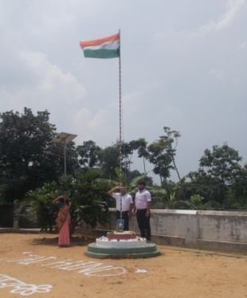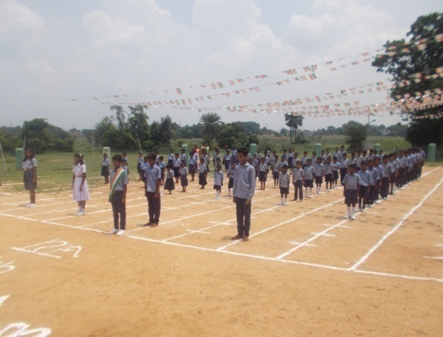

INDEPENDANCE DAY CELEBRATION AT KALIPATHAR HOME

**ANUPRERONA**

On 5th September we celebrated “TEACHERS’ DAY” with great pomp and joy. We also offered prayer to our beloved MOTHER TERESA on her death Anniversary. The children organized a program for all the teachers of our school. They sang song performed, dance, recited poems, and staged dramas this memorable Teachers Day left a great impression on every teacher of our school.

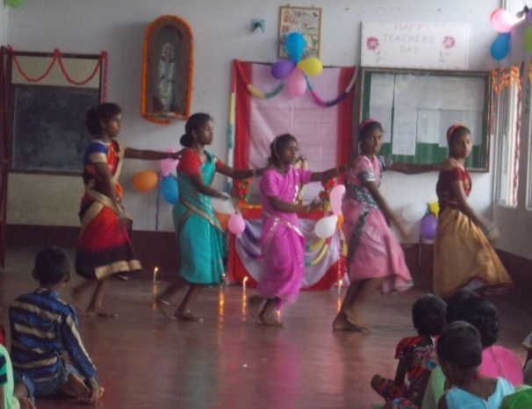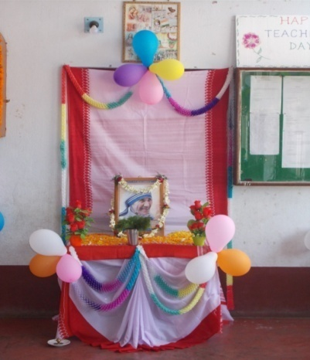

TEACHERS’ DAY CELEBATION AT KALIPATHAR HOME

**CASE HISTORY (BAKSARA HOME)**

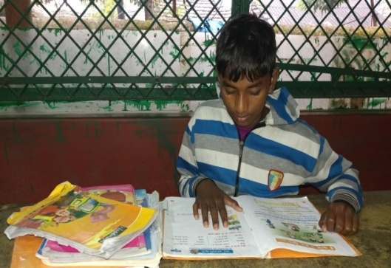

**SAMAYRAM HANSDA** - 12 years old Samayram Hansda is from Dumka in Jharkhand. His father Ravan Hansda is a daily labourer and his mother Surjamuni is a house wife. Ravan is an illiterate person but he had a dream to educate his children. Ravan learnt about Howrah South Point and along with Samayram appealed to the official of Howrah South Point. Santhali speaking Samayram is a happy resident of Baksara Home now where he receives food, shelter, education, medical attention and recreation. Samayram is in bridge course where he started to learn Hindi language instead of Santhali and within this short period he improved a lot.

SAMAYRAM HANSDA

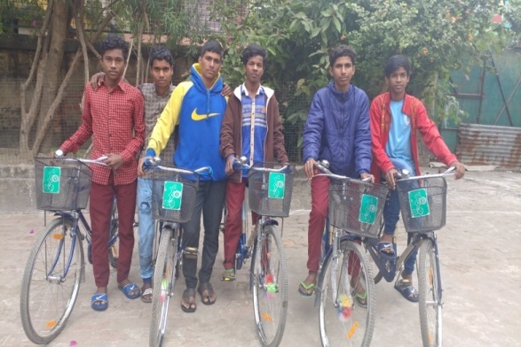

**CYCLE -** There are 11 young children in classes IX and X who received cycle from school under the scheme of **SABUJ SATHI** of West Bengal Govt.

Young children class IX and X of Baksara Home

**ANUPRERONA**

**BAKSARA VIDYALAYA**

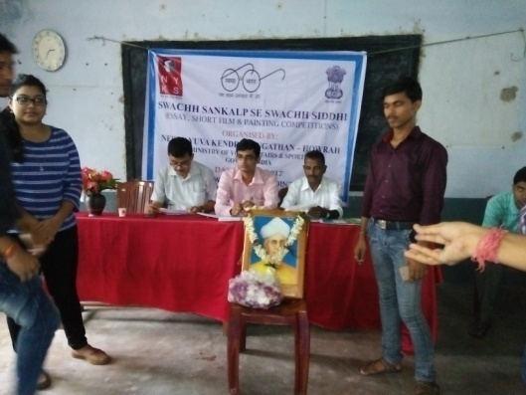**Ministry of youth affairs and sports programme - Nehru Youth Kendra** Sangathan of Howrah (Ministry of Youth Affairs and Sports, Govt. of India) had organized Essay, Short film and Painting competition in our school at Howrah South Point Vidyalaya Baksara. For these competitions candidates from all over Howrah district came to participate and this competition was based on ‘Swachh Bharat’. Many successful students won the prizes. Some of our school students also had taken part. Two of our students from class three and four won the second and third prizes in painting. Their names are Sunny Shaw and MD. Sahid. Congratulations to them, keep up the spirit! It was a proud moment for us that our school was selected for this purpose and Mr. S. Savarimuthu Satyraj the Headmaster of Baksara School was one of the judge for these competitions. The organizer distributed refreshment to all the candidates which was cherished by all.

Team of Nehru Youth Kendra, Howrah

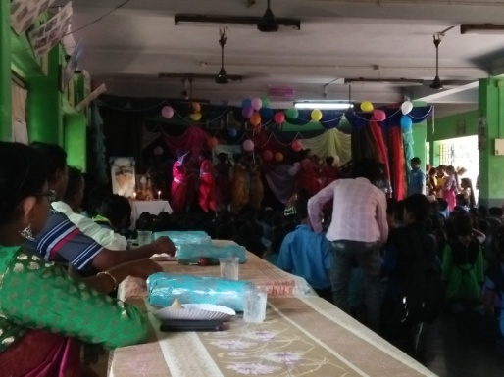**Teachers’ Day Celebrations -** Class VIII students of our Baksara Vidyalaya celebrated the Birthday of our former President Sarvapally Radha Krishnan who was also a teacher. On 5th September in honour of teachers, as Teachers’ Day. Colourful cultural programmes of Dance and Drama, which mesmerized one and all were organised. This programme began with a prayer and welcome dance, As the teachers and staff entered the Hall everyone was given warm welcome with flowers and then all the teachers witnessed the events and the entertainments. All the children participated enthusiastically in all the items and entertained all of us. As always this programme keeps up ‘Guru and Sishya’ healthy relationship and the children showed their love and affection and gratitude through this programme to all the teachers. The children served the teachers with refreshments during the programme and thereafter there was a special delicious meal for all the children, staff and teachers.

Teachers’ Day Celebration

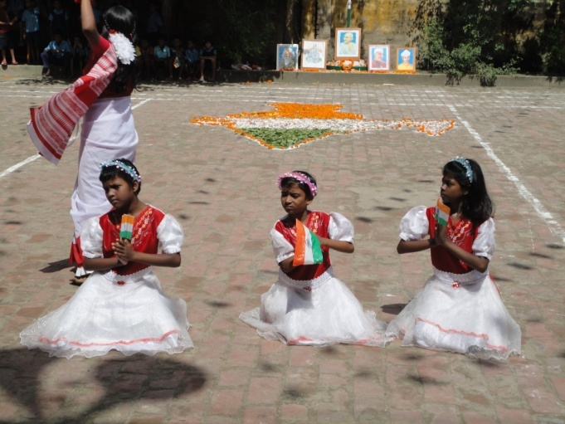 **Independence Day -** The 70th Independence day was celebrated on 15th August with Flag hoisting, March past, parade and cultural progammes at Baksara Vidyalaya. All the staff and students were very highly spirited to celebrate it. As the day arrived everyone was in patriotic mood. All of them enthusiastically participated in all the events. There was a beautiful Dance programme on patriotic songs. Our beloved and Rev, Fr. Labord and our chief co-ordinator Mr. A. S. Nigam Sir were guests for this programme. Fr. F. Laborde unfurled the National flag and our C.C.O gave a small speech on this occasion. He emphasized on education and unity of one and all. All the students should work hard and serve India as they are being served by HSP. The celebration closed with Tea and sweet, Bapuji Cake.

**ANUPRERONA**

**EPN HOME**

NEW ADMISSION IN EPN CRECHE – There were 14 children in EPN Creche. On September 4th a new girl named Himanushu Sharma has been admitted. So now there are 15 children in the creche.

**Local Donation**

* On July 15th, 20kg of small fishes were dropped into the pond of EPN Home by the fishery dept. After growth they will be eaten by children at a late date.
* Duilya Panchayat Pradhan agreed to help cleaning the home. Already they are providing 5 kg bleaching Powder per month.
* Teacher of St. Mary’s convent school offerred lunch (rice, dal, chiken and sweets) to the children of EPN Home for four days (dated : 13.08.17, 16.09.17, 14.10.17 and 18.11.17) and dinner ( rice, dal, chicken) on October 19th.
* On september 20th Mr. P. Agarwal provided rice 10 kg, flour 10kg, sugar 5kg, soyabin oil 2 ltr. And 50 pkt. Cream biscuits for children.

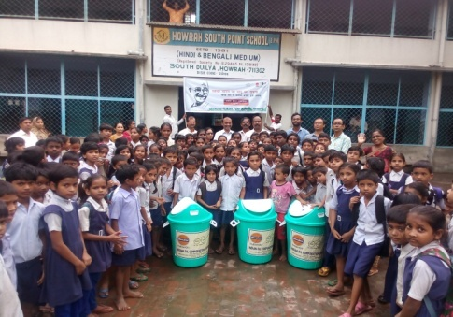**EPN SCHOOL**

**LOCAL VISITORS:**

Indian Oil Corporation - In the month of July the team of Indian Oil Corporation visited our school. They said they will come again. They donated three big dustbins for school.

Team of Indian Oil Corporation

with children

**Independence Day Celebration** - It was a red letter day in the history of India, when the country got freedom on 15th August’ 1947. It took hundreds of years to us to break shackles of slavery. We celebrate this festival every year with great pomp. In the morning we decorate the flag-hosting area with flowers and colors. Our chief Guest our Major A.R.A.SHA (Retd.) respected secretary hoisted the national flag sharp at 8 AM. All the students and teachers saluted the flag and sang the national anthem secretary speech. Then these followed the cultural programs. Patriotic poems and songs were recited / sung both by the teachers and the students and also dance-programs were staged. Our hostel-students presented two beautiful group dances. At the end of the program, our secretary distributed some cakes to the students. The celebration ended with the beautiful smiles on our children’s faces.

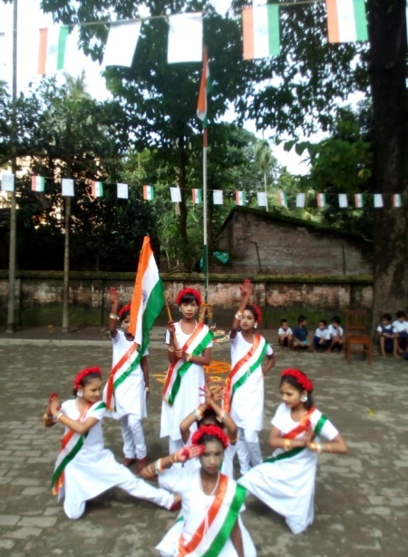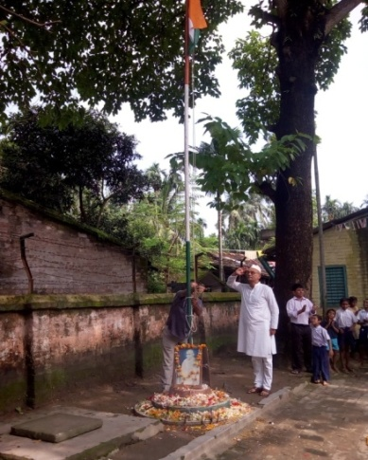

Children (Girl)

Performing a National dance

Hony. Secy. A.R.A.SAH

Saluting the National Flag

**ANUPRERONA**

ASHANEER HOME

RAKHI PURNIMA - We celebrated Rakhi Purnima with Imon Cultural and Social Welfare Society in Ashaneer 06.08.2017. They participate with our children and every children put rakhi on that day. They gave gifts and sweets to our children. They have done fruitful work for us. Children enjoyed a lot that day. They have planted same fruits plant at Ashaneer. That day our Rev. Fr. F. Laborde was present with us. He also helps us to plant the fruit tree. We enjoyed with children very much.

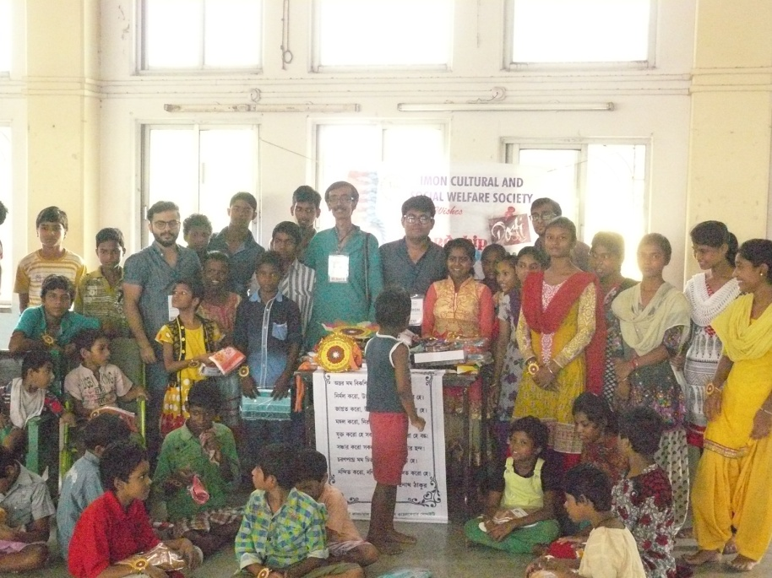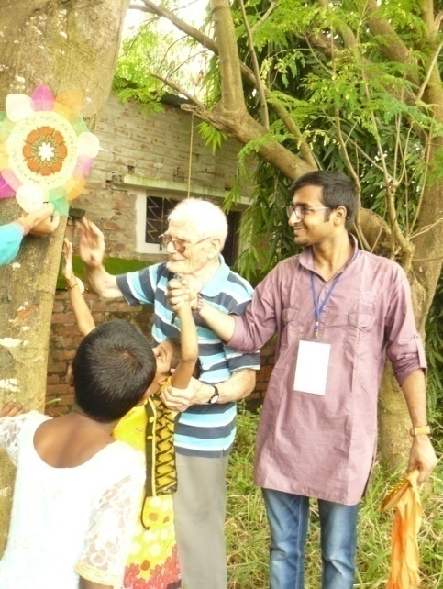

Rev. Fr. Laborde with I.C.S.W.S.

Children with I.C.S.W.S.

INDEPENDENCE DAY - Like every year on 15th August we celebrated Independence Day this year in Ashaneer Home. Our chief guest Rev. Fr. F. Laborde hoisted the National Flag at Ashaneer. Our Secretary Mr. A.R.A. Sah gave the speech on that day. We planted the trees that day the celebration ended with distribution of sweets to all children and staffs.

INDIAN OIL CORPORATION LIMITED - On 20th September 2017 from Indian Oil Corporation Limited Eastern Region Pipe Line Executive Director Mr. S.K. Satija and their staff came to Ashaneer. Sports were held with Disabled child that day. All our children are participated in games and enjoyed it a lot. They gave first, second and third prizes to our children. All participants got consolation Prize. They distributed gifts to our children like school bags, bed sheets, Buckets, bath Tubs, First Aid Boxes, Notebooks, and pencil etc.

**PROGNALAYA SPECIAL SCHOOL**

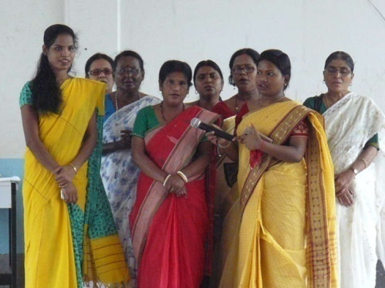In India Teachers’ Day is celebrated every year on 5th of September to pay honour to our selfless teachers this day is also the birth anniversary of our earlier president Dr. Sarvapali Radha Krishnan’ who had requested to celebrate his birth day as the teachers day to pay respect to teachers all over India.

Parents of children of this special school participated fun activities for teachers which made them of feel good. It was wonderful celebration and ended with sweets and beautiful gifts for all the teachers.

Teachers’ Day

**ANUPRERONA**

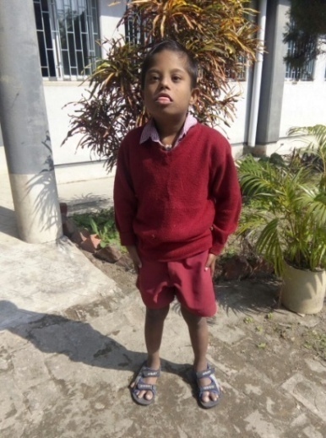**CASE STUDY - Soif Ali Khan** was born on 15th October 2006. He came with all his developmental delayed milestones. He is different and unlike others. He only started walking at the age of three. Soon after a year or so, he was laughed at which made him cry at regular school. Gradually his energy was channelized in the right direction. He can now follow simple communication. Our effort is to provide him behavior modification, speech developmental skill training etc. He has learnt localized right communication skills and some other activities. Now he is happy with the school and gets bored on holidays. It is here that he stays involved, does some work at school and spends time with his friends. He likes being busy all the time and hates sitting idle. He always shows a keen interest in music. Now he can communicates distinctly with gestures and one can easily follow what he tries to say. We wish him good luck.

Soif Ali Khan

**PSYCHOTHERAPY**

Psychotherapy is a special course at Prognalaya special school in Ashaneer. There are 53 children (indoor – 15 and outdoor – 38) who need 8 different types of therapies due to their Artistic, MR, CP, Microcephaly, Hydrocephaly, ASDH, Down-syndrome, Multiple disability etc.

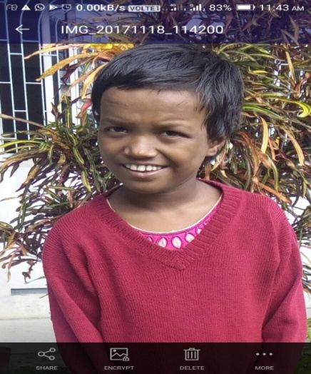**CASE STUDY -** Among these children Susmita Bose has shown remarkable improvement. She is 10 years old, mentally retarded girl and she was admitted on 7th July 2016. In the starting time, it was difficult for her to express herself with words. She made a peculiar sound and laughed too much. She found difficulty in group activity programme. Now she has changed and communicates with others because of psychomotorcity, play and music therapy. She has learnt to socialize. Gradually she is able to follow instructions. She tries to make herself understood through peculiar sound and laughs whenever we ask her name which shows that she has understood the question. She now remains quite while taking massage. She tries to do all activities with a smile on her face. Now she speaks few words. She shows namaskar and speaks Ta Ta, she also has good relationship with of her. Though she has changed a lot expect more improvement as time goes by.

Susmita Bose

PHYSIOTHERAPY

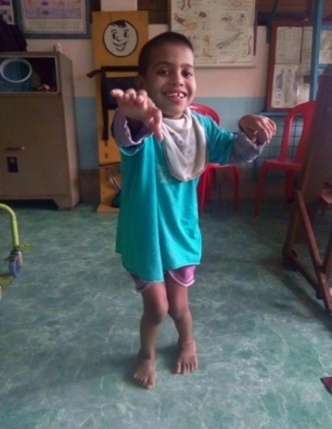

**Case Study**

**Ashaneer** - One Cerebral Palsy boy Sk. Minaj Ali is 7 years old. He is admitted in Ashaneer Home in March 2017. When he came to our centre that time he cannot be able to stand alone. We have done seven months physio for him. Now he can able to stand for few seconds and can able to walk one or two steps.

Sk. Minaj Ali

**ANUPRERONA**

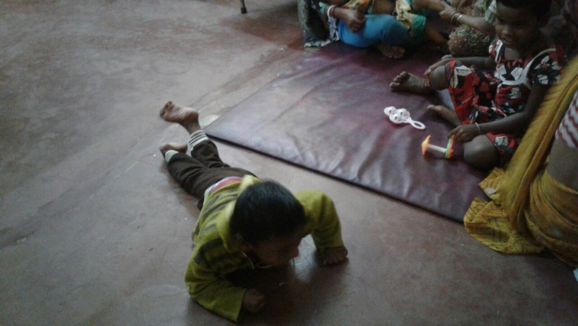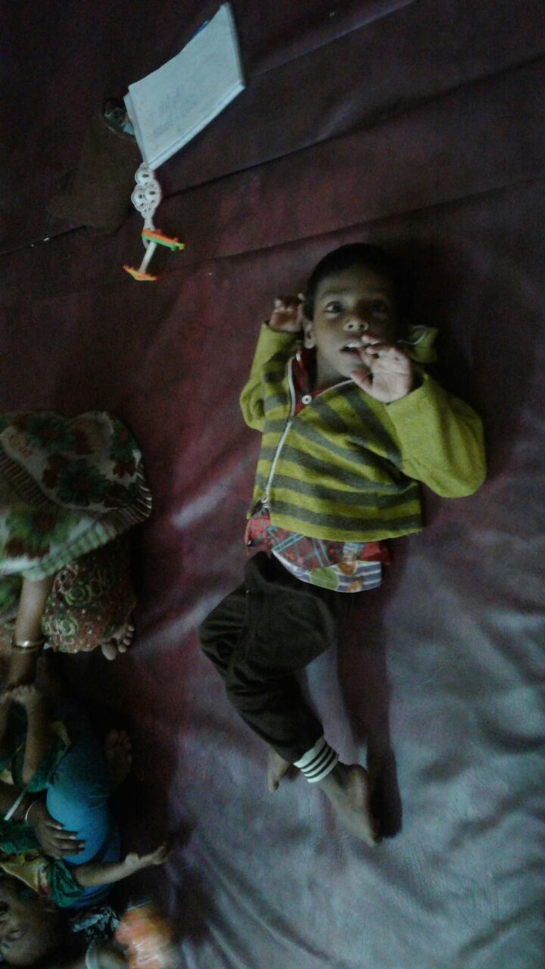 **Lalkuthi** – Sk. Sarfaraj is a 5 years old boy, who is a Cerebral Palsy sever stiff child. He belongs to very poor family; they are four members of his family. His father name is Sk. Sabiruddin who is a factory worker and his mother name is Sabina Begum who is house wife. He has a elder sister who is student of class II. When he was came to physio dept. only 8 months baby and was completely lying position. He was unable to sit, stand creeping, rolling and always crying. He had no hand function and eye co-odination so poor. Now Sk. Sarfarj can sit stand by standing board. He can rolling and move one place to another place and creeping take and eat by himself. Now he regularly comes to physio and enjoys physio therapy and smile and everybody.

Sk. Sarfaraj - After

Sk. Sarfaraj -Before



* 





 !

" #$





%&'$

 #$%





( )'*)

+) ,' %





'!--$  

#$%

.



'/)0)$1 ") 

#$2%





' !

#3"  #$2%





'(4'526 #$)

6)%

.



'(!  #$

+)%

7



'(8) %

9 :,)'"'$'#8

 #$8%%#$* 

%

;



<(* #$+)%

7



<'(%!'!--*





<'( !#$+)%





<'(%/!'2'* 

!-=#'%

* 

/+

<'(%#$34 ! !

#$2

7



<'(4' !29

 #)$)

**BOOK POST**

## HOWRAH SOUTH POINT

P-249 Andul Road, Podrah, Halderpara, Howrah-711109

Telephone: 7604061660/7604061680

E-mail – [hsouthpoint@gmail.com](mailto:hsouthpoint@gmail.com)

Website – www.howrahsouthpoint.org