##### 

**ANUPRERONA**

**THE NEWSLETTER TO THE FRIENDS OF HSP**

**Issue 59 July,2017**

**EDITORIAL**

Dear Friends, Partners and well wishers,

Greetings from the extended family of Howrah South Point. It gives me once again great pleasure in extending my heartfelt thanks to all of you who have been supporting the mission of Howrah South Point. Anupreona will take you to a journey in Howrah South Point through its activities that you have been supporting. I take this opportunity to make a fond appeal to you all, our Dear friends, to continue extending your helping hand to us so that we will continue to reach out to the poor and needy who look upon us with great hope for help. I would like to thank the team that takes so much effort to bring out this ‘Anuperona’ which means inspiration.

With warm regards

Amulya Rajan Anthony Sah  
 Hony.Secretary, HSP

**To our Donors friends & well-wishers**

**The mission of HSP can be summed up in few words “If we are believers, we believe that we receive from God the mission to honour our brothers\sisters\ which are His weakest\poorest; the mission to make our talents at their service, to help them to develop their own talents; LET NO WEAK MEMBERS OF HUMAN FAMILY BE IGNORED,NEGLECTED,NOT, ATTENDED,NOT CARED OF WITH LOVE,IT IS THE DIGNITY OF THE WHOLE FAMILY THAT IS JEORPARDIZE IF THESE ARE IGNORED.”**

With Love and regards,

Terence John

Hony. Secretary

***Mr. Terence John  
Secretary***

*Sincerely*

*Tapati Mukherjee*

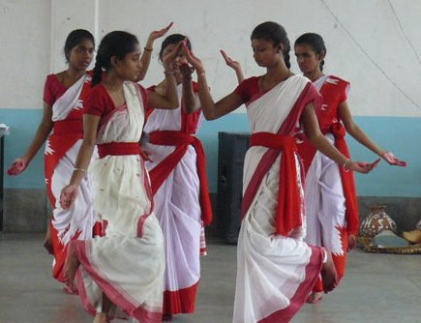

HIGHLIGHTS

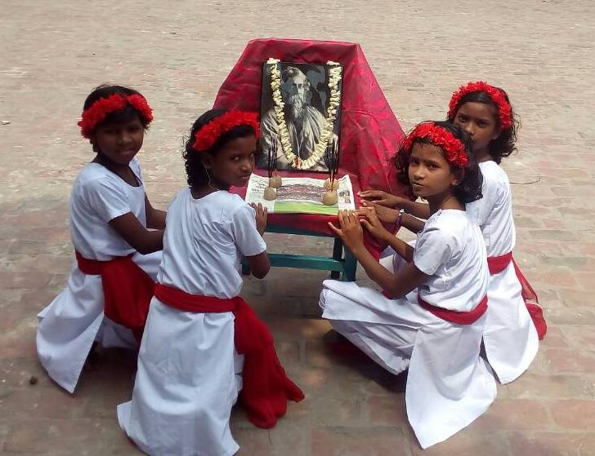

**What is Howrah South Point ?**

**Howrah South Point is an Indian NGO working for the poorest of the poor, rendering services to poor handicap children and reaching to those, whom are in medical need but cannot afford, educating poor children formal and non-formal schools. That is giving education to those who cannot afford it nor are helped by the society.**

**This NGO was started in 1976 by Rev. Fr. Francis Laborde who was inspired to start this mission by two people, first, (blessed) Fr. Antony Chevrier (1826-1879) a priest who lived at Lyons and consecrated his life to service of the poor, especially for the poor children in the beginning of Industrialization in Europe. Second, Cardinal L. T. Picachy, then the Archbishop of Kolkata. He summoned Fr. Laborde to start at Andul Road a home for poor handicapped children to which will be attached a dispensary for the poor of the locality. Since then till date poor and neglected of the society, irrespective of caste and religion have been the beneficiaries of this Organization.**

**Today HSP works in Providing services like, Rehabilitation of poor Handicapped children, Health Care, Education through Formal and informal schools. These services are provided through the Three Branches, Jalpaiguri, Howrah and Asansol.**

# Published by: Secretary H.S.P.

Email: [**hsouthpoint@gmail.com**](mailto:hsouthpoint@gmail.com)

# 

# For private circulation

Website: www.howrahsouthpoint.org

**ANUPRERONA**

# 

**ACHIEVEMENT**

* This year 5 students of Lalkuthi Home appeared for school final exams in Chittaranjan school – Piya Halder, Binita Soren, Lucy Das, Mamoni Mirdha, Sampa Mahato.There were no failiures. Sampa Mahato (Cerebral Pulsy) who moves on wheel chair. We were a bit worried for her but she also passed.

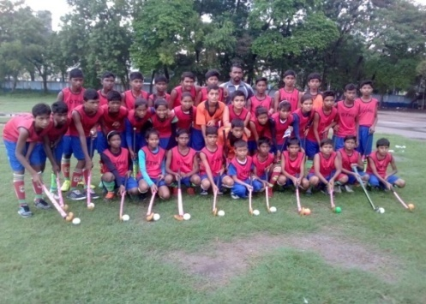

* **HOCKEY, JERSY ETC:** Howrah District Hockey Association have given 20 Hockey, 20 Jersey, 20 stockings and 20 balls to our boys and girls of Baksara Home in Howrah. Who are regularly practicing hockey.

Baksara Home in Howrah

* **Half yearly Examination:** Half Yearly Examination was held from 8 May 2017 to 19th may 2017 by teachers. After students left the classes the teachers evaluated the answer. From Bengali Medium 349 students appeared in examination of which 82% passed. Few students who are weak in studies are working hard. In Hindi Medium 266 students appeared and 77% passed. Weak students are working hard to pass the examination.
* 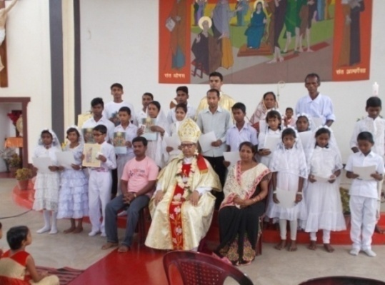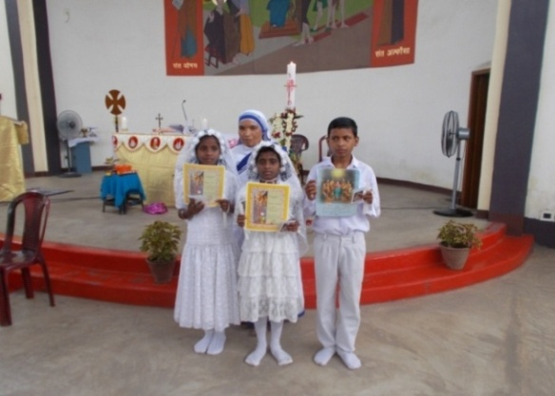23rd of APRIL was a holy day for some of our ANAND BHAVAN HOME children at Kalipathar Home Asansol. AREBICA DAS and BERONICA DAS received their first “HOLY COMMUNION” to become one and with Jesus. ASHISH MISHRA was “CONFIRMED’’ and received the blessing of the Holy Spirit. On this special day Bishop: CYPRIAN MONIS, Bishop of Asansol and Rev Father RAHUL SEQUIERA also blessed the children.

Anand Bhavan Home Asansol

* The month of MAY was really a bit tough for our children as in this month they had their FIRST TERM EXAMINATION from 02.06.17.to 11.05.17.But the news of SUMMER VACATION on 22.05.17gave them a slight relief from their regular routines .We could experience their internal happiness for vacation.

**ANUPRERONA**

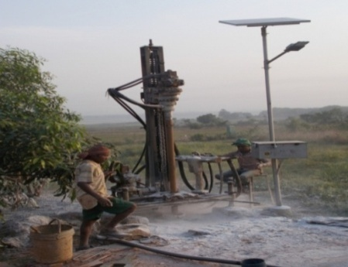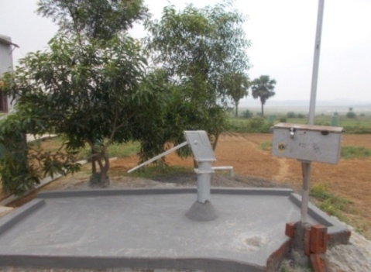

* **WATER HAND PUMP** - Apart from this on 31st MAY a water hand pump was drilled in our home for the Children. This was donated by the “BHALOBASA” organization. The function was presided by our Parish Rev FR. RAHUL SEQUIERA.

Anand Bhavan Home Asansol

* 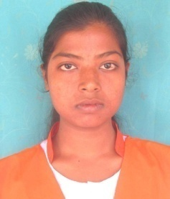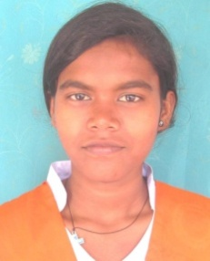Puja Tudu and Puja Marandi both are destitutes of Bakuabari Big Girls Home JPG. They are from tribal family. They passed Madhyamik Exam (school Final) 2017 successfully. Puja Tudu was placed in 1st first division and Puja Marandi was got 2nd division.
* 10 boys appeared in Madhyamik Exams and all have passed successfully in Jordighi JPG.

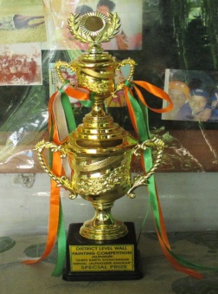

* Three Jordighi boys-Bholanath Marandi, Bekrant Oraon & Manab Roy participated in District Level wall painting competition at Jalpaiguri town. They were selected by Jalpaiguri Zilla Parishad to Paint Wall for –Toilet in each House- ‘Swachha Bharat’ Campaign and they won the Special prize.
* Jeevan Path JPG residents entitled Bay **Leave plantation project** under ***Mahatma Ganghi*** ***National Rural Employment Guarantee Scheme*** *in June17. They have prepared the land and planted the seedlings.*

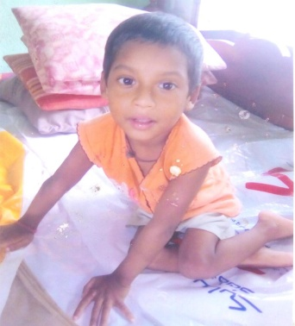**CASE STUDY**

* Sonu Samanto age 5 is a cerebral palsy child. When he was admitted to Lalkuthi lying, he was alone in the family. His father is a cycle mechanic. He had no head control and was unable to sit, stand, creep, roll, as he had no movement of body. Now, he has good head control and he can sit alone without support and he can slowly do all four positions. He smiles and responds to whoever calls his name as he can now sit, stand and creep.

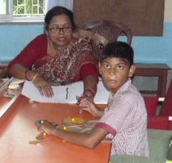

* Rajen kumar Shaw, D.O.B 06.06.05. He was admitted on 19 .01. 2015 at Ashaneer Home, Howrah. He suffers from mental retardation. When he came to Ashaneer Home he was very very restless and he could not wash, bathe or dress properly. He was also reticent. Now a lot of changes have come in his movement. He always tries to communicate with others and he is able to dress brush and bathe on his own. Now everyday he goes to Special School. He enjoys psychotherapy and everything. His father is now very happy.

**ANUPRERONA**

* 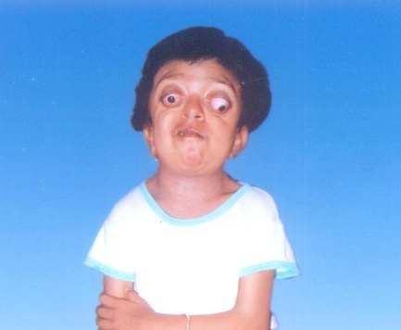Name - Konkona Das, Disability – Hypothyroidism multiple disorder, Date of birth – 01.07.2009. Konkona Das was born with multiple congenital defects. At the age of 5, she was admitted at Prognalaya Special School Ashaneer in Howrah. She is suffering from Pfeiffer syndrome – It is a very rare genetic disorder characterized by the premature fusion on certain bones of the skull which affects the shape of the head and face. This early fusion presents the skull from growing normally and affects the shape of the head and face. Big round eyes, eyes balls don’t move abnormal body shape, low height and feather weight. Her oral speech was restricted. Mother sickness was present in her behavior. Her early days were spent crying. Different teaching therapies were done: I.Q – Language communication, occupational therapy and fine motor and gross motor skill developmental training. Gradually she settled down as her energy was channelized in the right direction. She became so interested that she did not even like to go to her home. She also improves academically. We noticed in her a lot of improvement. At present she pursues normal Special School curriculum. A lot of successes are waiting for her.

**NEW ADMISSIONS AT NIRMALA NIVAS JPG**

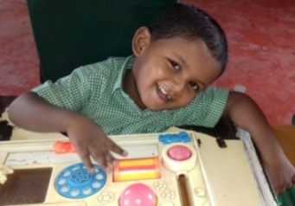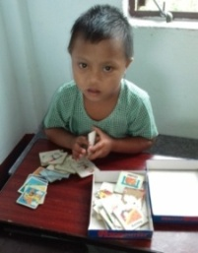Harshit Barla from Aibheel Tea Garden, Chalsa he is five years old boy suffering from Cerebral Palsy with difficulties in sitting, head & trunk control and speech problem.

Manabi Roy is a six year old girl suffering from Mentally challenged (chromosomal abnormality as Down’s syndrome) from Ambari Falakata Jalpaiguri. Her mother is partially visual impaired.

**Harshit Barla**

Manabi Roy

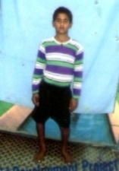AT JORDIGHI JPG

Rakesh Malakar, cerebral palsy boy from Rajganj, Jalpaiguri was admitted at Jordighi centre Jalpaiguri on May 17

**AT MOGRADANGI JPG**

Parul Ray with CTEV (Left Leg) from Maldah admitted in Mogradangi Jalpaiguri on 19th june17.

Rakesh Malakar

**ANUPRERONA**

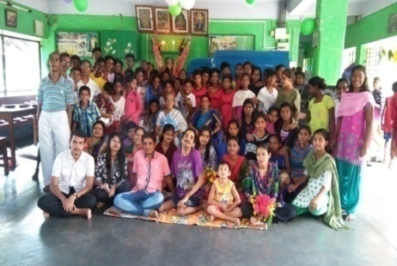**CELEBRATIONS**

**GRAND FEAST** : On 22nd April 2017, Mr. Prem Rathi from Howrah arranged a grand feast for the Children of Baksara Home Howrah. Children enjoyed fried Puri, alu dom, rice, mixed veg, salad, raita and sweets. It was Mr. Rathi’s birthday. On 2nd July 2017, Mr. Pathak, a local well-wisher of Baksara Home, gave breakfast and lunch for Children. They were very happy to eat. Mr. Pathak celebrated the birth day of his twins at Baksara Home.

Baksara Home Howrah

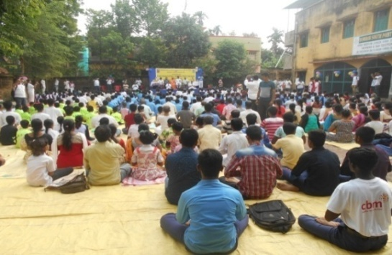

**WORLD YOGA DAY:** World Yoga Day was celebrated on 21.06.17 at Baksara Home. It was organized by Kanak Kanan Football Coaching Centre, Baksara. Due to heavy rain the venue shifted to our campus. There were more than 400 participants including our Children. The ADM of Howrah was the chief guest who gave special thanks to Howrah South Point, Baksara. It was followed by a hearty lunch.

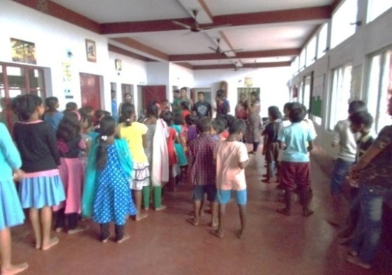

Baksara Home Howrah

**SAPNO KI UDAAN** - On the day of 15th of April the youth boys and girls from the organization of “SAPNO KI UDAAN” came to our Kalipathar Home at Asansol to meet and distributed chocolates, sweet and biscuits. The children were happy to meet their new helping elder brothers and sisters.

**UNITY INDIA** - During this month a great helping hand was forwarded to the children’s of ANAND BHAWAN HOME ASANSOL. The youth boys of the organization of “UNITY INDIA” offered a grand lunch and dinner for the children on 17th JUNE 2017.They distributed chocolates, cold drink, copies and pens to the children. Their family members also came in our HOME to meet the children. Our children gave them a warm welcome with flowers, greeting cards and songs.

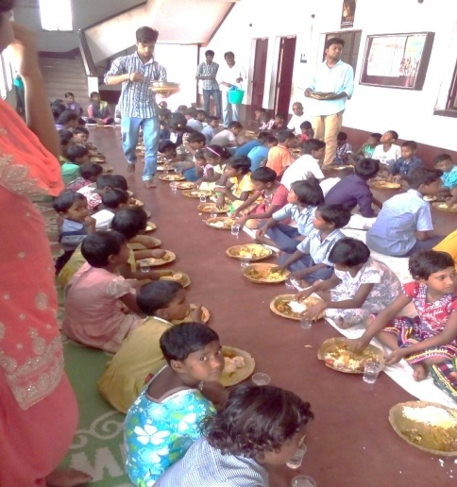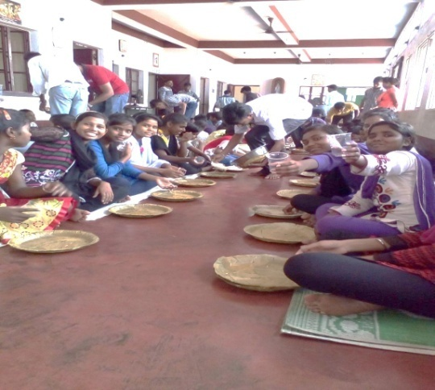



**ANUPRERONA**

**RABINDRA JAYANTI -** Rabindra Jayanti was celebrated on 09-05-2017. Students from EPN Home performed a small programme under the guidance of their dance teacher. The Headmaster coordinated the program. Gifts were received from our local friends of EPN Home Howrah.

All four homes and Schools of JPG celebrated Rabindra Jayanti on 9th may with songs recitation and short drama.

**STAFF TRAINING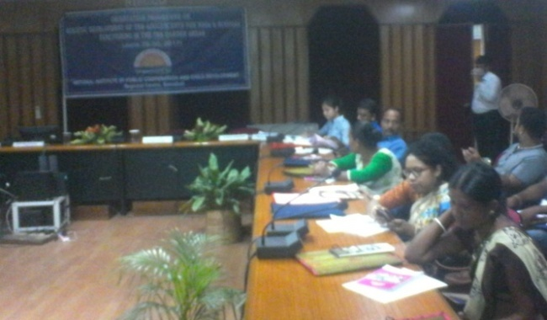 -** Shaktipada Panja & Dipali oraon two teachers from HSP Shikarpur School JPG attended ***the orientation program on Holistic Development of the Adolescents for NGOs & Schools*** functioning in the tea garden ***areas*** organized by the National Institute of Public Cooperation & Child Development **(NIPCCD)**, Guwahati from 28th June to 30th June. In this program they have acquired knowledge on Understanding Adolescence- their needs and rights, physical wellbeing of Adolescents, empowering adolescents with life skill education, counseling of adolescents, Govt. schemes and programs for the welfare of adolescents and the Role of teachers in shaping lives of adolescents.

Dipali Oraon (right end)

**Inspections & Visits -** Ms. Rachana Bhagat IAS, District Magistrate of Jalpaiguri visited Jordighi Home and assured them to renovate the approach road and play ground.

Mr. Dhaval Jain IAS , SDO, Mal visited Orthopaedic Workshop , Jordighi to see our production unit and to explore possibilities.

Jordighi Home was inspected by ADM Jalpaiguri, 7 Deputy Magistrates, Jalpaiguri, DSWO and District Child Protection Unit officials were asked to prepare observation report on Home.

All four homes were inspected by District Officials in the month of May 2017 and they advised HSP to follow strictly J.J.Act rules.

Official from ***MGNREG*** *Scheme, Rajganj block visited Bakuabari Home to explain to the residents the Jeevanpath norms of Schemeand Bay Leaves project guidelines.*

**Educational Visit by other Institution**:-

On 5th may2017 40 Student and faculty of B.Ed( Special on Mental Retardation) from Rabindra Bharati University came to visit Howrah South Point Manus Domini Special school, Bakuabari. Jalpaiguri for their educational exposure. On 25 th May 2017 trainees of Diploma in Special Education on Mental Retardation from North Bengal Handicapped Rehabilitation Society, Siliguri visited us. On 06th January 2017 32 trainee Nurses from Nursing Training School , North Bengal Medical College and Hospital visited Bakuabari Home JPG.

**TREATMENT -** 5 children have completed their treatment **-** AID & APPLIANCES - Operated both legs & B/L A.F.O Plastic shoe were given, for Sk. Faijaan - Special chair, Mamoni Pal - B/L Gaitus, Anshu Kumari – She special shoe modified.

This year 5 physically handicap students appeared for school final exams – Piya Halder, Binita Soren, Lucy Das, Mamoni Mirdha,

Sampa Mahato is a C.P girl who moves on wheel chair. She also passed.

**ANUPRERONA**

**MEDICAL CAMP** : A Medical Camp was organized by the Medical College students of Kolkata in EPN School Howrah on 13th April 2017. Main aim of the camp was to provide free AIDS check-up for the students. Camp was held by some senior doctors along with their team members between 10:00 am to 5:00 pm. The camp was run along with teachers and some ex-students. Medicine was given free to the patients according to their health condition and further advice was also given to the patients on how they can be fit and strong. The camp was a grand success.

**AIMS OF THE CAMP**

* This medical camp provided free consulting. General physician ,eye B.t Test and Pediatrician consulting.
* Total Medical check-up was done.
* Free Medicines were distributed to the patients.
* **Doctors** – in - attendance: Dr .Rahul Dev Barman, Dr. Arijt chakraborty ,Dr.Abhash Raj Dr Saikat Das , Dr.subir Mondal.
* **Volunteers**: Puja sheet , Arpita Nath, punam dey, Sweeta Das, and Teachers.

**DEVELOPMENT & RENOVATIONS:**

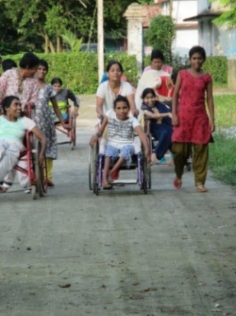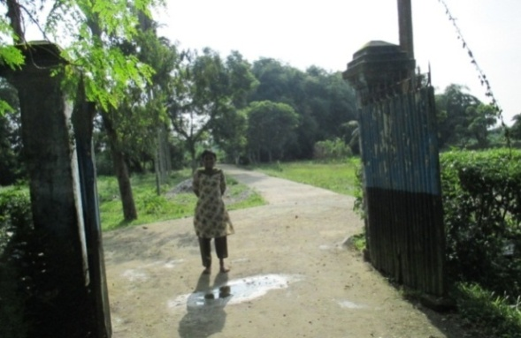Local Gram Panchayat office completed new concrete pathway from main road to entrance of Mariabasti Home JPG. So now our residents and vehicles can move smoothly.

Local Gram Panchayat office also installed a new tube well inside the Home.

They also helped the residents of Maria Bastee Home to acquire Aadhar card. They also helped in acquiring **Job card** under ***Mahatma Ganghi*** ***National Rural Employment Guarantee Scheme ensuring some days of employment***.

**VOLUNTEERS AND VISITORS**

* Our regular local donor – Parvinder Neha, Sachin, Rolhit, Roshni & their friends are giving groceries, like – Rice, Dal, Sugar, Oil, Atta etc. for our Lalkuthi children.
* Yoga Vidya Pranic healing foundation had given us – Rice – 60 kg, Dahl – 40 kg, Soya bins – 10 kg. at Lalkuthi Home in Howrah.
* Shubham and Megha Bhadani and their relatives; Dilip Bhadani and family had given new dresses to all our Lalkuthi children. They also gave apple, orange, grapes & bananas to all children. They also same rice – 20 kg, 10 kg Sugar. 4 Mats.
* Sree Arabinda Guho, our local councilor and Chair man of Howrah Municipal Corporation visited our Lalkuthi home at Howrah. He gave us 60 kg of wheat free of cost. He organized an eye check-up camp for Home children and staffs. They gave medicine to 12 children and Staff. Sree Arabinda came again on 24th of June with many other delegates like Mr. Prabal Naskar, Headmaster of Thanamakua Model High School. Mr. Dutta founder of South end centre English medium school. Mr. Guha requested other delegates to help H.S.P. They promised to buy phenyl and sweaters for their school students from H.S.P.

**ANUPRERONA**

* This year we got 2 broad minded friends among us. 1 is Monalisa Chowdhuri; she gives song classes and poem recitation free of cost. She also gives Rs. 500/p.m. as donation for our children. Mrs. Chitra Lekha Mukherjee is giving training of different kind like quiline jewellery and cards; nylon cords beautiful bags free of cost.
* On 24th of JUNE 2017, sisters of MISSIONARIES OF CHARITY sent to our Kalipathar Home Asansol a lot of gifts such as colors, pencils, erasers, bats and balls for the children’s. We are deeply grateful to the sisters for their gifts.
* On 14-05-2017 Dipanjon kar resident of 266 Arabindanagar Bhattanagar of Liluah provided lunch for the EPN Home children (Rice; chicken, Dal, Chatni, Sweet).
* Manami Talukder on 17-05-2017 resident of Barast on her birthday provided dinner to the Home children of EPN (Rice, Chicken, Dahl, Salad).
* On 20-06-2017 ST. Mary Convent (Santragachi) teacher provided dinner to the EPN Home children (Rice, Dal, Chicken).
* On 28-06-2017 ST. Mary Convent School teachers provided dinner to the EPN Home children (Rice, Dal, and Chicken).
* 05th April 2017 –Maheswari Mahila Parished , Siliguri donated 50kgs of Rice, 5kg Dal, Sugar 5kg, Milk Packets, snacks and oranges for Bakuabari children

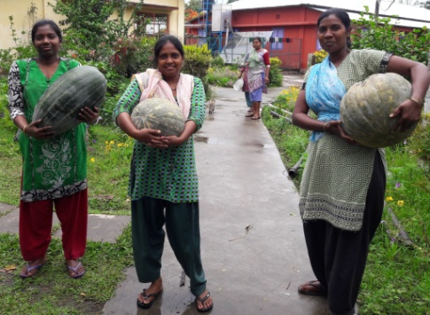

* ay 2017- Sarita Kalyani , Madhu Kalyani and Shakuntala from Siliguri donated Six Ceiling Fans for Bakuabari as some Fans were damaged due to Lightning.
* 23rd May 2017- Sathia Group, Siliguri donated a milch cow with calf for Bakuabari centre at JPG.
* 30th Jul10th May 2017 –Shakuntala Didi & other members of Maheswari Mahila Mandal, Siliguri, donated 50kgs of Rice, 1Bag Atta, Sugar 5kg, Milk Packets, snacks and fruits  for Bakuabari Children.
* 12th M y17-Sarita Kalyani donated 75kg of Rice, Cooking Oil 5lts, Dal 5kg, Sugar 7kg, 2packs of Biscuits , milk one package and distributed snacks among the children of Bakuabari
* 15th April 17 –Mr.Nitai sarkar, Mogradangi donated copy books, pen and pencils to children of Bakuabari and Mogradangi centre of JPG.
* 22nd April 17- Darshika Singhal family offered Special Lunch at Mogradangi Home on the occasion of  Marriage Anniversary of her parents .

**ANUPRERONA**

* 1st May 2017 –Dilip Roy, Rajganj contributed Lunch for all residents of Bakuabari. He also offered mangoes on 13th July to all 60 residents.
* 9th May 17 –Tamanna Yasmin donated 1bag potato, 45 kgs of Pumkins for Bakuabari Children.
* 19th May 17-Kiran Devi Periwal, Siliguri donated a Refrigerator for Bakuabari Home.
* On occasion of Environment day 50 Nos Papaya Seedlings were donated and planted by Mr. Dilip Sarkar of Belacoba with the help of Big Girls of Bakuabari in their garden.
* 26th June 2017- Maina Das District Mass Education Extension Officer, Jalpaiguri hosted lunch to all residents of Bakuabari Home.
* 25th July 2017-Mr. Lakhotia of Siliguri donated 115 kg of Rice to Bakuabari Home.
* 27th July 2017- Mr.Tapan Roy Chowdhury, hosted special lunch at BB Home on occasion of Birthday of his son Rajdeep.
* 27TH July 2017- Mr.Babun Dutta of Siliguri donated 50Kg of Rice and 12kg of Dal to Bakuabari Children.
* One day lunch offered for all Jordighi boys and staff by Mr Radheyshyam & Saroj Gupta on 15th April in the memory of their son.
* Mr Mukesh Agarwal a well wisher of Howrah South Point gifted 10 Big umbrella, 36 towel, 36 vest , 7 mosquito net and 20 pair shoes for our boys JD Home .He also donated school books for the class IX and X boys of JD Home .
* Lal Mohammad of Maldah gifted 14 Kgs mangoes from his own garden to our boys JD Home.
* Mr Prabin Agarwal, Rajgang offered, 25 Kgs rice, 10 Kgs flour, oil, vegetables, spices to cook, sweets & bananas for the children at HSP Shikarpur School, Bakubari JPG on 27th May. Again on 27th June he offered 2kg of Chana dal and 2lts of Mustard oil.
* 





 !

" #$





%&'$

 #$%





( )'*)

+) ,' %





'!--$  

#$%

.



'/)0)$1 ") 

#$2%





' !

#3"  #$2%





'(4'526 #$)

6)%

.



'(!  #$

+)%

7



'(8) %

9 :,)'"'$'#8

 #$8%%#$* 

%

;



<(* #$+)%

7



<'(%!'!--*





<'( !#$+)%





<'(%/!'2'* 

!-=#'%

* 

/+

<'(%#$34 ! !

#$2

7



<'(4' !29

 #)$)

**BOOK POST**

## HOWRAH SOUTH POINT

P-249 Andul Road, Podrah, Halderpara, Howrah-711109

Telephone: 0091-33-2644 4481

E-mail – [hsouthpoint@gmail.com](mailto:hsouthpoint@gmail.com)

Website – www.howrahsouthpoint.org