##### 

**ANUPRERONA**

**March, 2017**



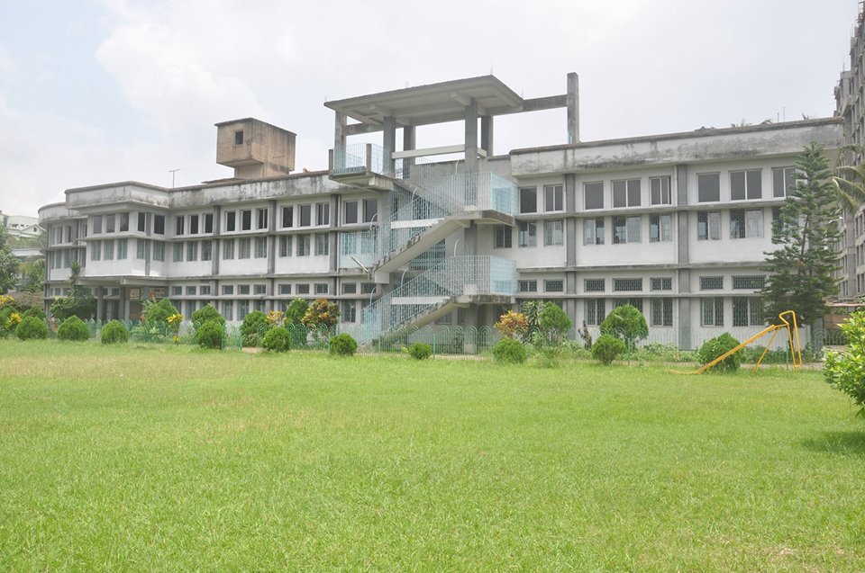

SPORTS **02**

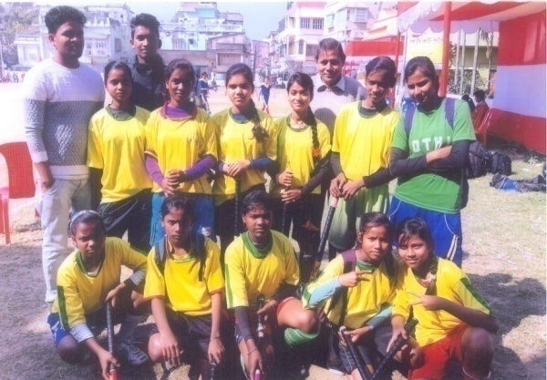

SPECIAL EVENT **03**

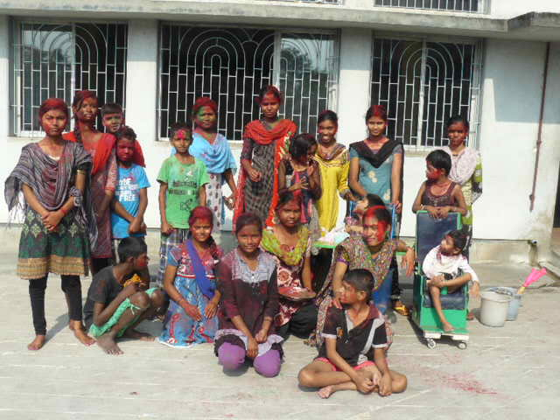

**Editor’s Message**

Greetings from HSP to all its valued donors.

The Anuprerona brings to its readers an update on its recent activities. The past few months have been extremely busy for HSP.

A new building in EPN adds to the list of educational and comfort for the less privileged. Sponsors, staffs of various schools took their children to picnic to get relief from the stress of the effort they have given in their education, relax themselves and also learn from the environment. They also had their annual sports and prizes were distributed to appreciate their effort. Many of them were given clothes and gifts by the donors and sponsors during the beginning of the year.

Placing their trust in HSP, donors and supporters have never been let down by us. Striving and marching on with its noble contribution towards a better India, HSP holds on steadfastly to its convictions, never missing an opportunity to serve its citizens. Looking forward to many more partners and supporters, joining to play their part for a healthy and educated India.

From the next newsletter our new secretary Mr Amulya Rajan Anthony Sah will be addressing the editorial column.

Once again I thank you for all the support and faith that you have so kindly bestowed on me.

Father Jose Luke

Secretary

With Love and regards,

Terence John

Hony. Secretary

***Mr. Terence John  
Secretary***

*Sincerely*

*Tapati Mukherjee*

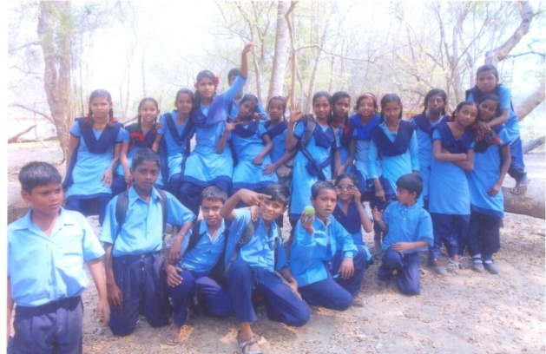

PICNIC **05**

VISITORS **07**

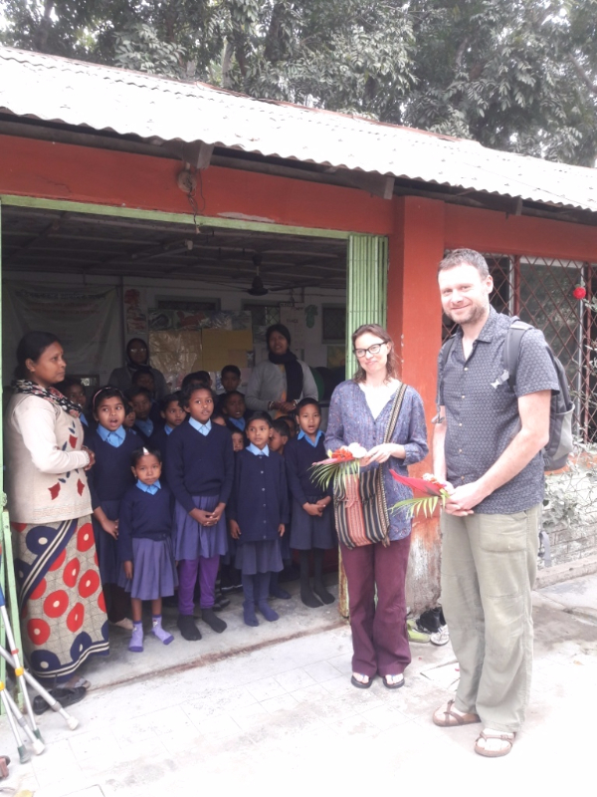

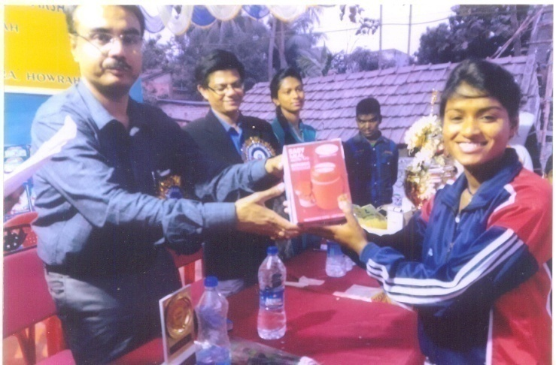

**SPORTS**

1. Two of our girls namely Punam Oraon and Lakshmi Lohar who represented Bengal Hockey Association, got opportunity to participate in 7th Hockey India Sub Junior National Championship 2017 (Women at Ramanathapuram, Tamilnadu from 11th Jan. to 22nd Jan 2017. They received certificate of Participation and track suit, socks, jersy etc.
2. Our girls Hockey Team participated in all Bengal Women’s Hockey Tournament held on 21st Jan & 22nd Jan 2017 at Behala.
3. The most successive achievement of our girls that they received the Runner Up Trophy of Inter Club Hockey tournament held on 29th Jan 2017 at Dumurjola Stadium, Howrah. The girls participated in the tournament received set of bowls.
4. On 4th Feb. 17 the Kanak Kanan Football Coaching Centre organized a sports and most of our children participated in it. Four girls and one boy won the prizes.
5. This year the **annual sports** and 26th January the Republic Day was a combined celebration at Baksara Vidyalaya. It was a grand program in our school, for which all the students waited for it. We had five days of hit and trail for all the student of different game and the final event was on 26th January, with prize distribution. Every one participated in each events but the special talent and able students picked up the prize of first, second and third, for their hard work. 13 children of Baksara Non-formal School participate in these sports.
6. Annual sports of prognalaya spl school at Ashaneer complex. All children participated from school & Ashaneer home. Among them some children won prizes according to their ability and consolation prizes for all children. Food packets were distributed for all children.

**Punam Oraon and Lakshmi Lohar who represented Bengal Hockey Association**

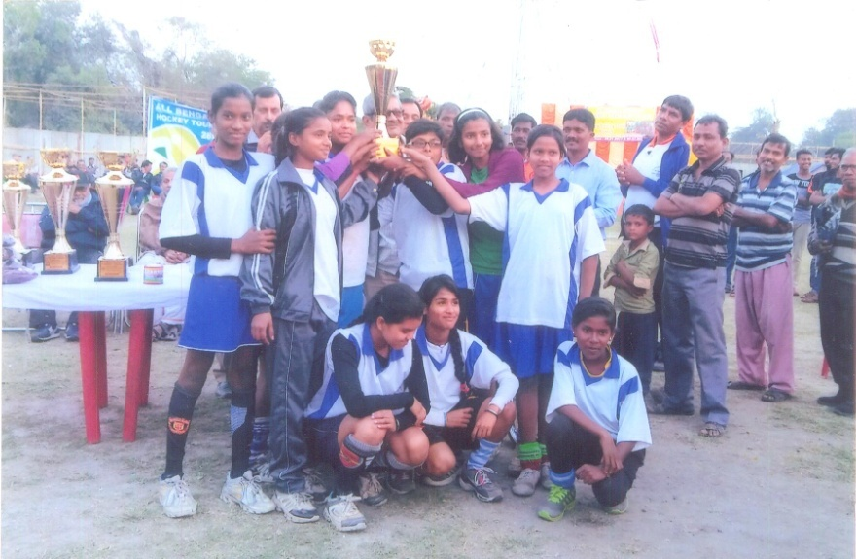

**Our Hockey team with Runner Up Trophy of Inter Club Hockey tournament**

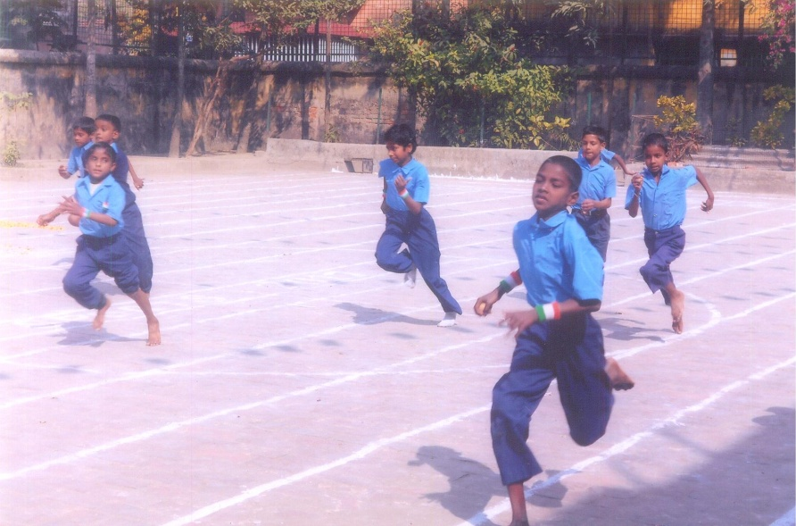

**Annual sports at Baksara School**

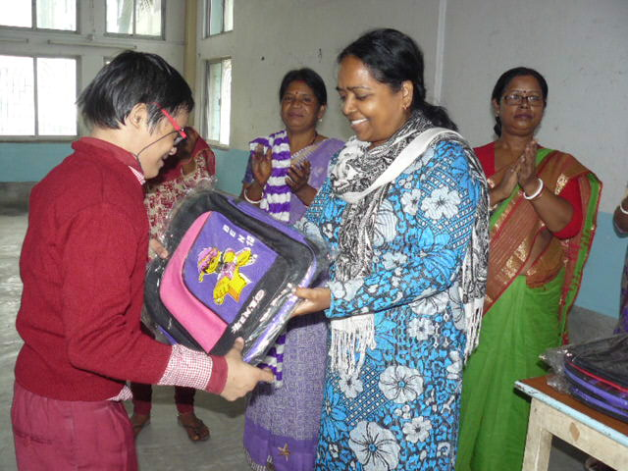

**2**

**Prize distribution at Ashaneer Annual sports**

**Special Event**

**Saraswati Puja** : As usual we had the Saraswati Puja. It is different kind of program arranged by prognalaya spl. School. Saraswati Puja is is celebrated for awareness, concentration, development, encouragement in education. They enjoyed very much with colourful sari and other traditional dress. It was a meaningful occasion to discover about the inner strength of children whose smiles are a gift of God. At the end of the occasion sweets, fruits were distributed for all.

**Netaji’s Birth Day & Republic day:** All branches of Howrah South Point celebrated the Netaji’s Birthday on 23rd Jan’17 & republic day on 26th January 2017. Children performed the cultural program, drill and marchpast. In Asansol home on this National festival we invited the senior citizen of the Kalipather Village. The Flag was hoisted by the in charge Mr.Anup Kachhap. Patriotic songs were sung by everyone. After the ceremony distribution of oranges, bun, sweets and chocolates were done among the children. On the same day Howrah & Jalpaiguri also hoisted flag and colourful patriotic cultural program was performed by the students to elevate the day. Girls and boys gave their best in their performance. Everyone was mesmerized by their dance. We had also arranged a delicious meal for everyone to enjoy. Indeed it was an enjoyable day, and an entertainment for one & all.

**Holi Celebration:** We celebrated the festival of Holi. It is a very colorful festival for Indians. So we celebrated this day with great pomp and joy in our all Home at Howrah, Jalpaiguri & Asansol Branch. Our children put colours at each other and were very happy.

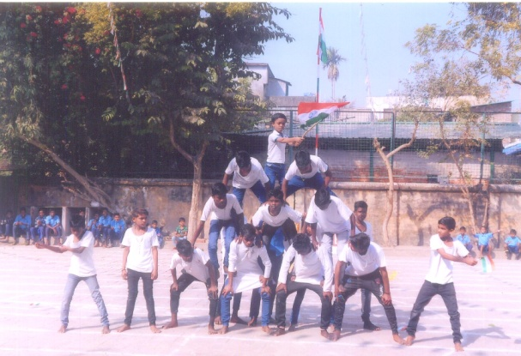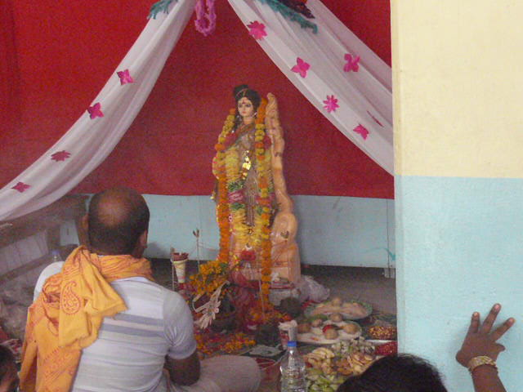

Republicday celebration at Baksara School

Saraswati puja celebration at Ashaneer Home

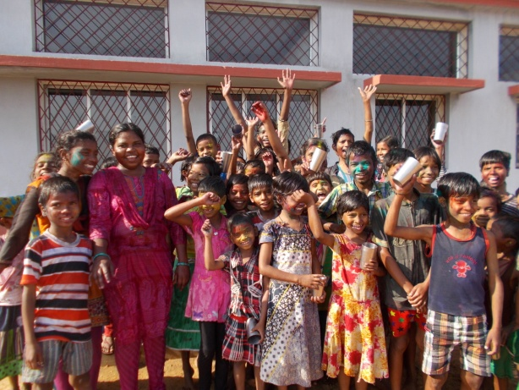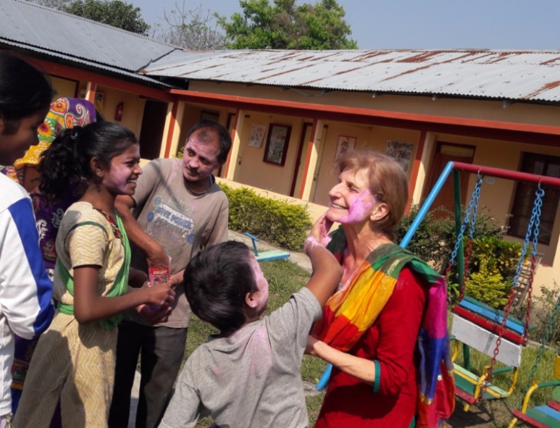

Holi celebration at Asansol Home

**3**

Holi celebration at Jalpaiguri Home

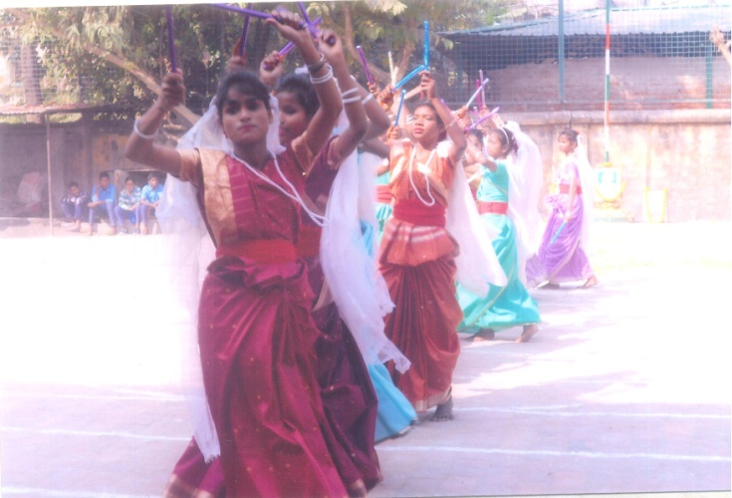

**DANCE PERFORMANCE:**

With request of the Secretary of Kanak Kanan Football Coaching Centre, Baksara, our Boys and Girls performed dance based on patriotic Song both in the opening Ceremony and closing ceremony Football Tournament.

**EDUCATION :**

1. 12 children admission at mainstream in January and some in February from Non-formal
2. 7 children admission in Baksara mainstream in class IV, III, & II.

Dance performance at Kanak Kanan football Tournament

1. 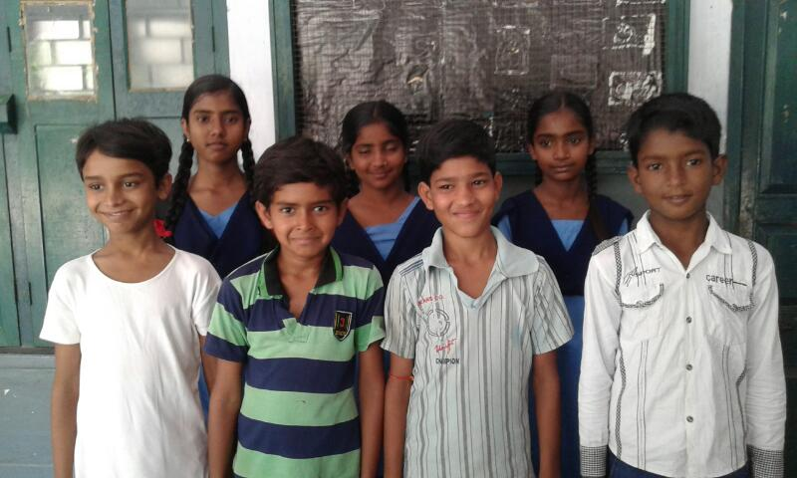31 children admission in mainstream in EPN School.

Children admition in Baksara Mainstream

1. 9 little girl’s new admission on Lalkuthi home.
2. 14 children (8 boys & 6 girls) admitted at EPN Home.
3. 2 children admitted at EPN crèche.

**Acheivement:**

* Two big Girls from Bakuabari Home and 10 boys from Jordighi Home appeared the school final Exam called Madhyamik 2017.
* 5 girls from Lalkuthi Home appeared Madhyamik Exam, 2017.
* 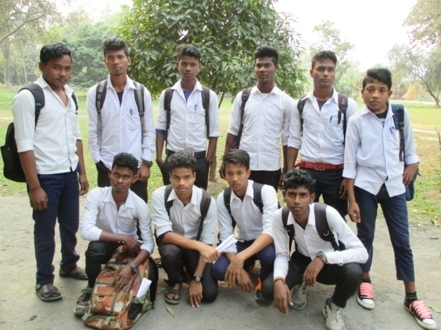11 boys and 10 girls from Baksara Home appeared Madhyamik Exam, 2017.
* 12 boys from Ashaneer Home appeared Madhyamik Exam, 2017.

**FAREWELL:**

On 10th March’17 Madhymik appeared children received a grand farewell from Baksara Home. Each one received a copy of their group photo and clothes. At the end a special food served to them. There were 11 boys and 10 girls from Baksara Home who appeared in the Madhyamik Pariksha 2017. The Examination started on 22nd February and ends 10th March 2017.

Madhyamik Candidate of Jordighi Home

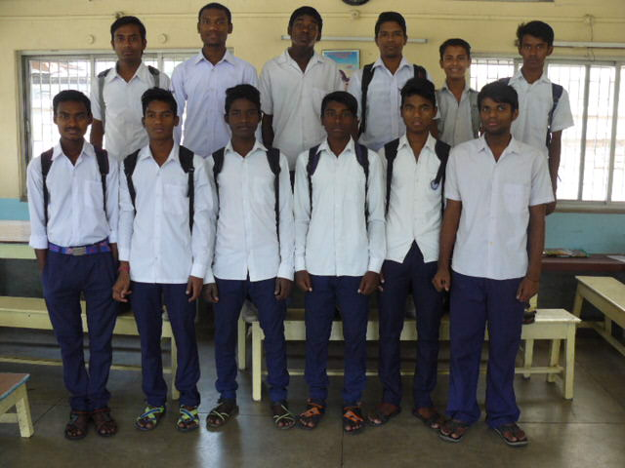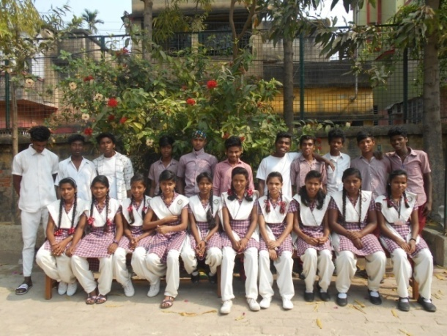

**4**

Madhyamik Candidate of Baksara Home

Madhyamik Candidate of Ashaneer Home

**Educational Trip / PICNIC**

* On 6th of January 2017, 32 Trainee Nurses of Nursing School from North Bengal Medical College came to Howrah South Point Bakuabari Home **for their Educational Exposure.** They have spent few hours with the children of Manus Domini Special School. They have collected lot of information about the rehabilitation of Children with disabilities and the activities of HSP. They also assured to help our children during admission to Medical College.
* Juliano`s uncle and his friend Claire Lisze came at Anand Bhavan Home (Asansol) for visiting the home and met the children. They came on 1st  February and were very happy to be here as well as the children were also very happy to see them. Children and staffs also went to Panchit Dam for picnic on 8th February with Juliano uncle and his friend .They were overjoyed in this tour.
* Our Baksara formal & Non- formal school children didn’t have a picnic for many years. It was the students demand to have a day of picnic before their first Quarterly exam to refresh their mind. So keeping up their desire alive, we arranged a day of picnic to 58 gate, deer park at Ulberia, Howrah. It was a grand family gathering which enriched every one. The park was a greenery pasture but place to move around with some beautiful deer’s and colourful birds and few small animals that we witnessed. All the children enjoyed the day. Financial crisis was a major problem. We are all working for the happiness of these little poor children. We hope, God will provide us with better facility next year.
* 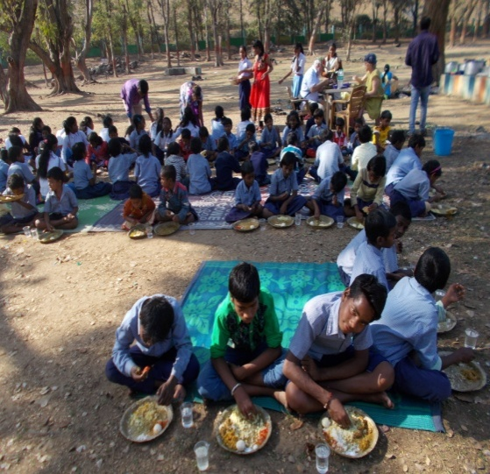This is the first time children of Ankurhati Non Formal enjoyed & had fun at Zoo on dt. 24.02.17 .The all pooled in money for their picnic.

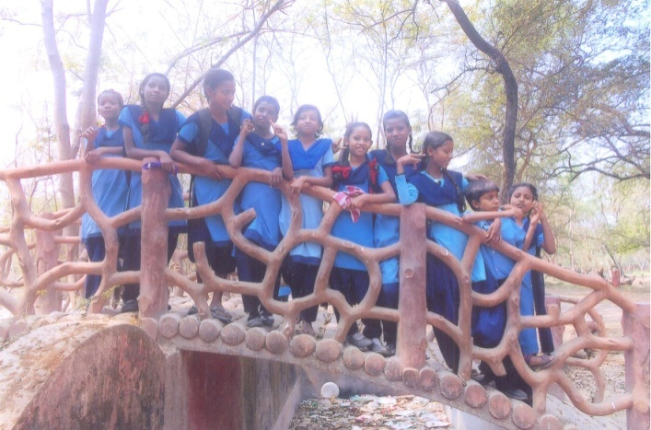

Baksara school picnic

Asansol Picnic

**Rehabilitation of Congenital Equino Verus and Cerebral Palsied Children:**

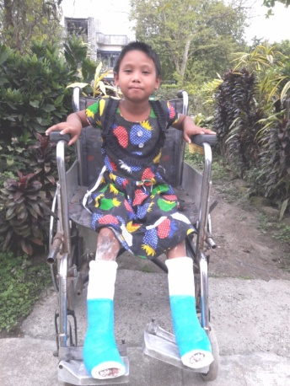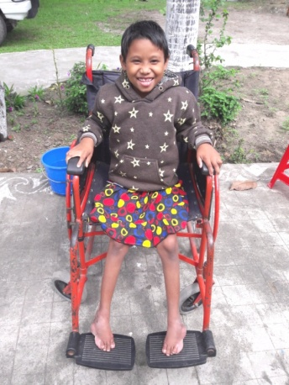

* In the beginning of 2017 we have corrected club foot with serial plaster management for 15 children and attended 30 children they were given advice to the parents with weekly involvement in physiotherapy intervention.
* On 21st march the world Down’s syndrome Day has been celebrated at Manus Domini special school.

**5**

**Gift/ Donation**

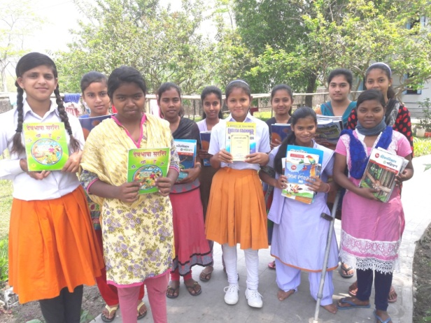

* The 7 Big Girls of class X of Bakuabari received science (Physical and Life) books from Mrs. Ajukta Sarker a science teacher from a government High School near our Bakuabari Home. She also brought biscuits and snacks for all the children of Bakuabari home.
* Mr. Lakhotia from Siliguri, neighbors of HSP Bakuabari sponsored books of Class ix and x and few books for VIII. He also brings food items time to time for the children.

Gift received from Mrs. Ajukta Sarkar

* 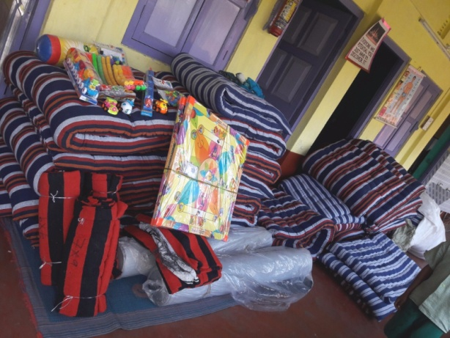Mr. Gerard the president of **Terre Des Homes Alsace** donated the new mattresses, mosquito net, Rexine, Pillow, Floor mat and toys for psychotherapy for all the children of Nirmala Nivas.
* A Home theater and DVD player was gifted to Bakuabari Home by Marwari Mahila Parishad, Siliguri.
* Clothes given by Pushpa Tandan for EPN home children.
* Cloths given by Marium Sayeed for Ankurhati Non-formal Children

Gifts from TDHA for Children of Nirmala Nivas

* Biscuit, 8 kg Rice & 2 kg Dal given by B. Khamdelwal for Ashaneer children.
* 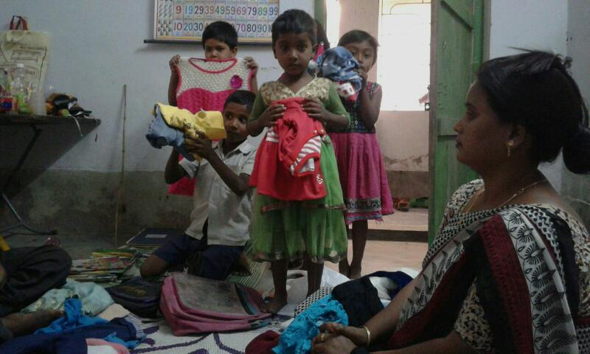Vegetable, 20 kg rice, 5 kg dal, 1 bag puffed rice, biscuit, toffee, sweets, orange, banana, 2 kg Soyabean, pasta and salt distributed by Niew Agarbal for Ashaneer children.
* 7 blankets, 10 kg rice, 1 pakt salt, 1 lit Mustard oil & 60 pcs sweets given for Ashaneer children by Shuchita Shukla Pandey.
* Food stuff given by Hasthimal Kankaria, Pawanpreet Singh Grewal, Dr. J.P Bihani, Vikas Bansal, Vikash PoddarKamala Daga for Ashaneer Home Children.
* G M of Salanpur,officer of (ECL) Donated 430 copies for our Asansol home children. The copies were received by Sir Anup Kachhap on 15th March and distributed to the children.

Cloths distributed to Ankurhati Children

* Tapan Pattanayak & Anil Dasani give lunch to all residents of EPN Home on 26th Jan,17
* D.R. Kartik Kayan gave lunch to all residents of EPN Home on 12.03.17.
* Ms Jayashree teacher of St. Mary Convent School (Santragachi) provided breakfast for all residents of EPN Home a day.

**6**

**Friends/Visitors**

* 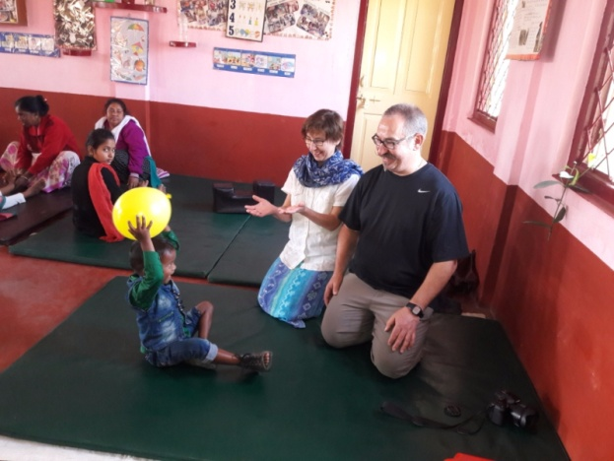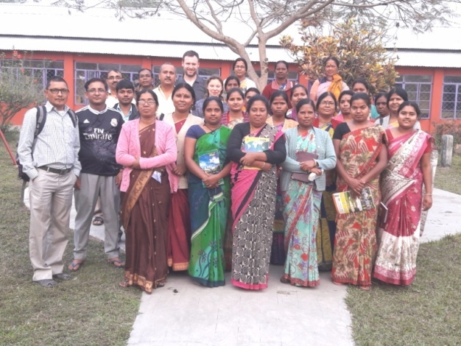**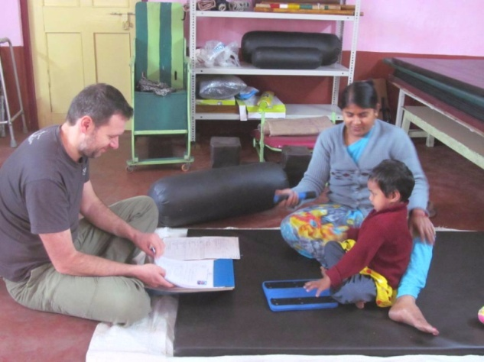KDM**: Kines Du Monde, France is well known to the staff of Howrah South Point for Physiotherapy. It is a French association for physiotherapy and organizing training in different countries in the world. HSP had the opportunity to organize the training for the staff of Jalpaiguri and Howrah in the field of physical rehabilitation of the disabilities in 1992-94 and after that there was a long gap. The staff had very good base on physical management especially on Polio, Cerebral palsied and other disabilities. Presently few staff trained are retired or left the job. Also thanks to immunization against Poliomyelitis the pathology has been changed we find more Cerebral pa lsy, mentally challenged Autistic and other disabilities. So our new staffs need training and we have requested to KDM to start training again. It was the important visit on **19th to 22nd February’17 Mm. Julie and Mr. Mattheiu Jean Pierre from KDM** to Jalpaiguri and Howrah. They observed and evaluated the need of the children, the working experience and knowledge of the staff. Also we had organized a staff training program at Manus Domini Special School at Bakuabari to utilize the presence of both resource persons at Jalpaiguri. The main topic was how to facilitate the children and their parents with their special child. Also we organized one day parent’s awareness and training program at Manus Domini special school. They have been visiting our Outdoor program and home visit in the villages. We are sure their visit will be fruitful for HSP.

KDM with our staff

Mattheiu Jean Pierre from KDM

* 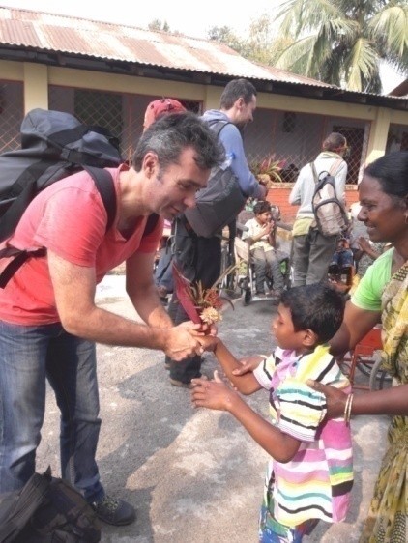Madam Hilde and Hartmut Stadmuller from Pro-Interplast Germany came to visit Jalpaiguri Homes for two days. It was a valuable visit for HSP because pro interplast is supporting the corrective surgery camp at Japaiguri since 2005 till now. We organized Ceft lip ,palate also the lower limbs surgery camp at Chalsa by the German and Australian doctors’ team. Pro inter plast support our outdoor posts program.

Stadmuller from Germany

* Benoit Chevalier from Orthez, France came to visit Howrah & Jalpaiguri Homes. His mother and her team are friend and well wishers and also donors since long time of HSP. Children enjoyed lot with him. He played with them, helped them in their studies and bought games etc.

**7**

Benoit dada

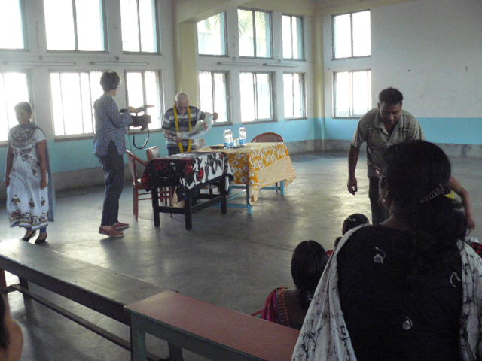

* Mm. Virginia from a French TV channel came to capture the activities of HSP. Grace Lucas & Sunil Lucas also came with Virginia.
* Mr. Guilliano Minisini came to HSP Jalpaiguri for one month. It is always pleasant moment with him. Children enjoyed a lot with him and also he supports picnic outing etc. This time we had feast in each home with him and he made paper hot air balloon. We lit big Colourful hot air balloon the day of Holi. Everybody was very cheerful on that day.

**Mm Virginia with Father at Ashaneer Home**

* 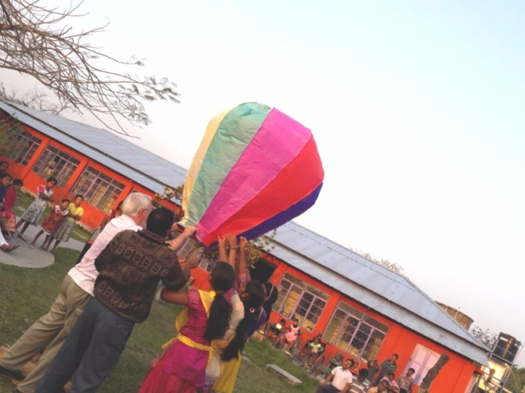Gerard Romeder from France gifted one suitcase of cloths for brick field children of Howrah on 20.01.17.

Guilliano Dada made paper Fanus & we lit it on the day of Holi

* Claire lise Vouga from Switzerland & Catherine from France visited Howrah south point and all our units.

**Workshop from the Art of leaving Foundation:**

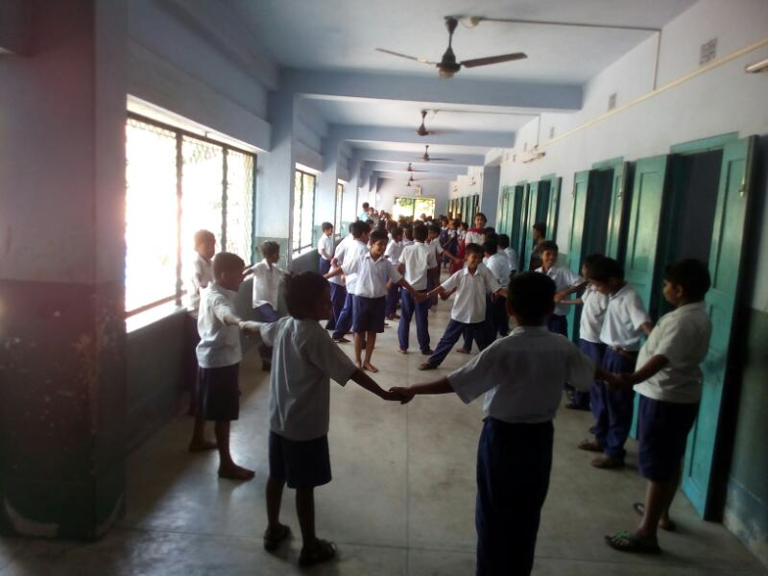

The Art of living foundation workshop on stress management was held from 21st to 24th March’17 in Howrah South Point School (EPN), South Duilya, to keep student stress free, how student can manage stress and how education can be joyful and not a stressful one. Art of living by their stress elimination program which includes breathing techniques, meditation and yoga has helped the children in stress management.

**Health Checkup:**

French doctors arrived on 3rd & 4th March, 2017 .Health checkup program was carried out at EPN Home. Checkup of 39 children of EPN Home was done.

Workshop from Art of leaving Foundation

**Upcoming Initiatives of HSP:**

1. HSP is making arrangements and working on to provide centralized food commodities to all units of Howrah to save finance.
2. HSP is making plans and initiating to exploit lands and space of HSP to generate income and help in recovering the financial crisis to some extent.

**8**

**ACTIVITY PAGE**

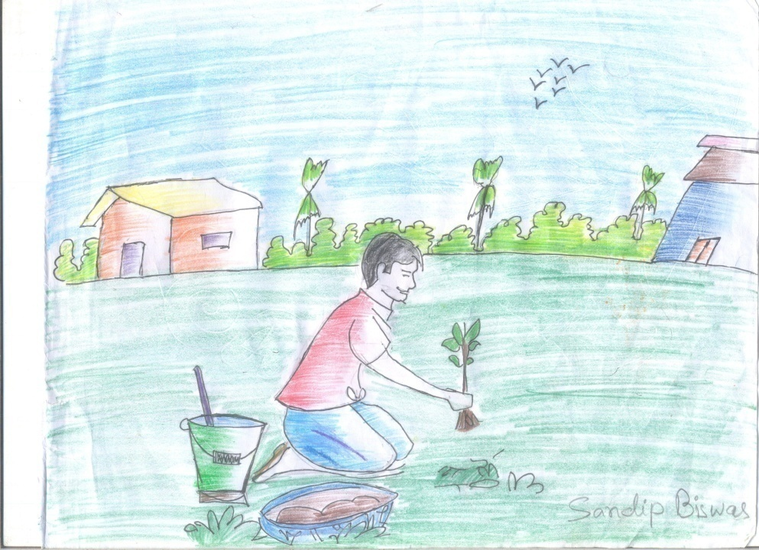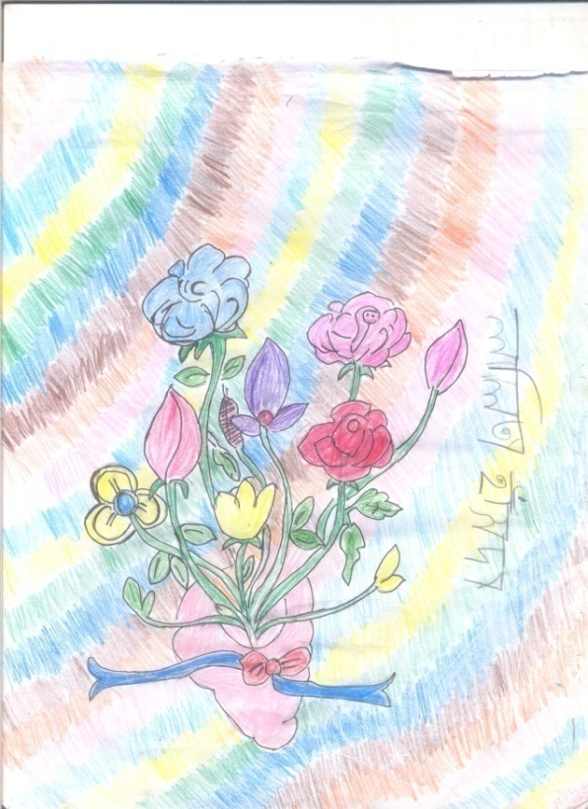

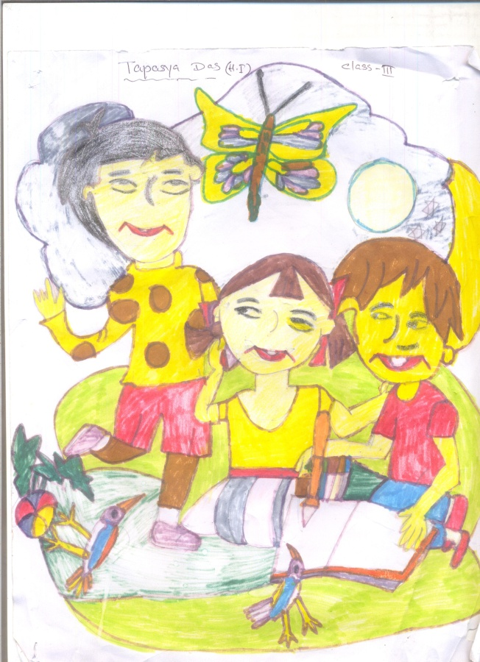

**9**

**MEDIA COVERAGE**

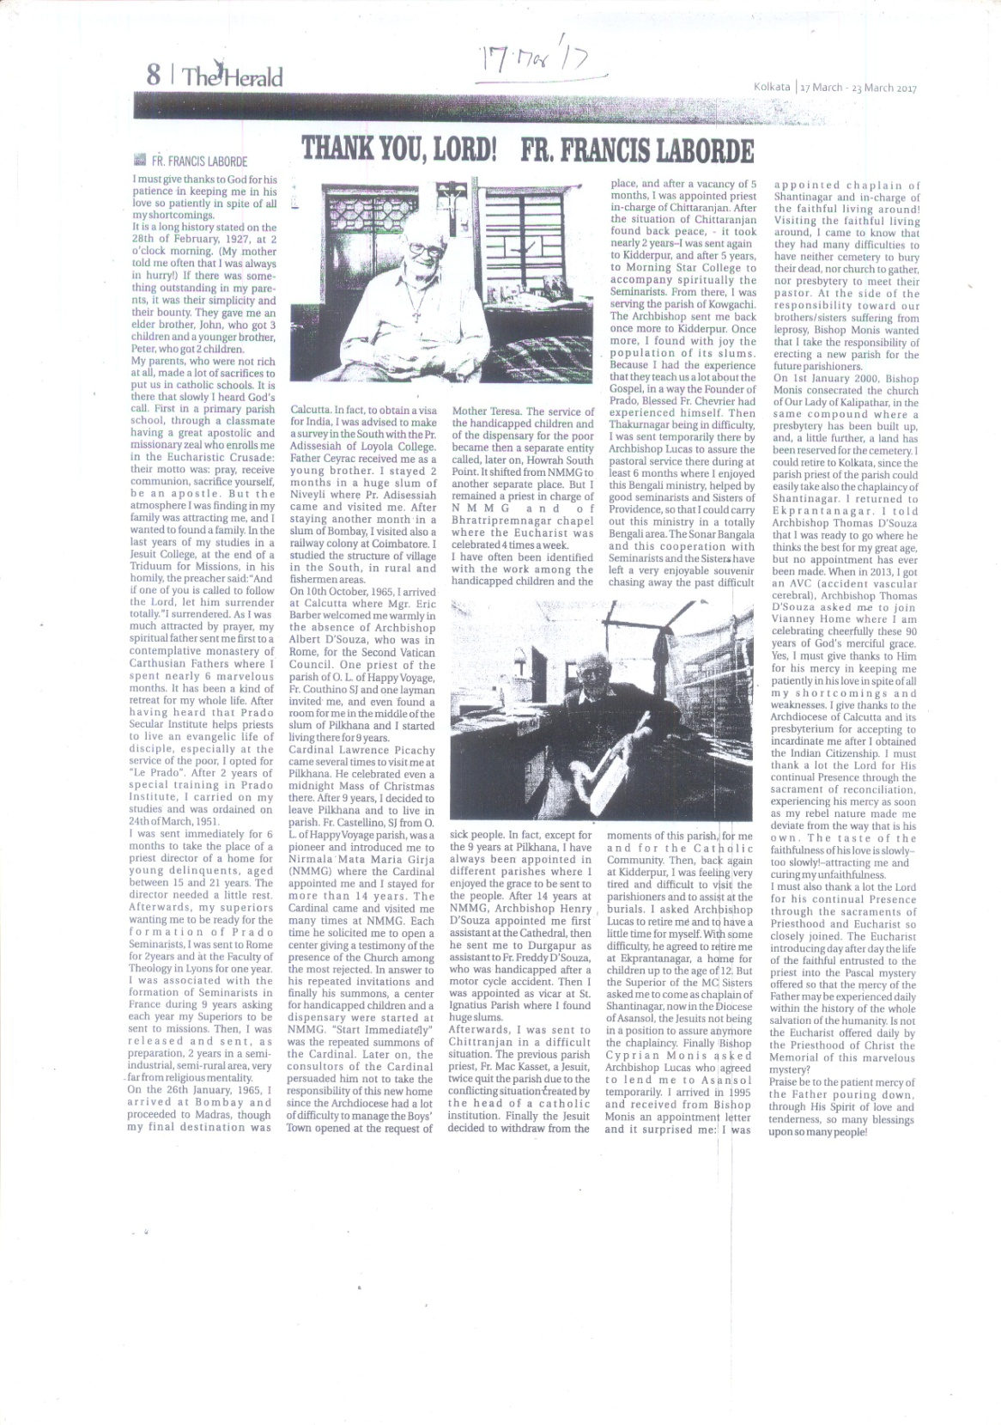

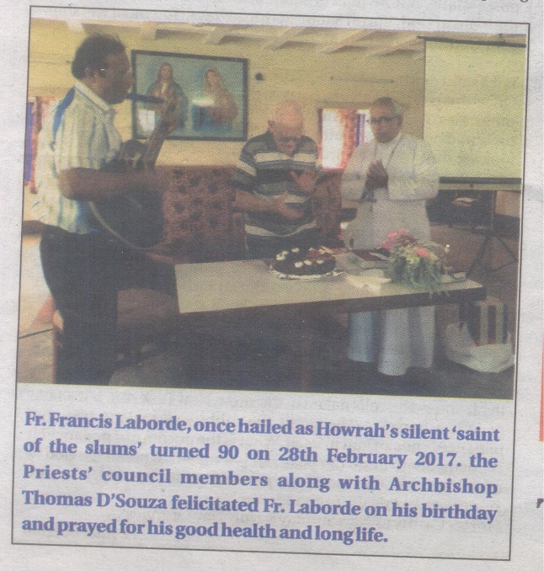

**17.03.2017**

**BOOK POST**

## HOWRAH SOUTH POINT

P-249, Andul Road, Halderpara, Podrah, Howrah-711109

Tele : (0091) 33-2644-4481,

E-mail – [howrahsouthpoint@gmail.com](mailto:howrahsouthpoint@gmail.com)

Website – www.howrahsouthpoint.org.in

**10**