##### 

**ANUPRERONA**

The Newsletter to the Friends of HSP

**Issue 56 October, 2016**

**EDITORIAL**

Dear Friends, Partners and well wishers,

Indeed we are happy to bring out this edition of the Anuprerona which is a vital link among all our supporters, donors and partners with our activities, aims and objectives enabling the most deprived of the society to stand up in life with dignity and respect. We know that what we do is a drop in the ocean of suffering and need, but still it gives relief to many who otherwise will go without any hope in life condemned to suffering and depravity.

We owe much to the donors and other supporters of ours without whose assistance and commitment to us we would not have been able to carry out this humble work of ours which is entrusted to us by God for whose glory we carry out this activity.

In Fact Howrah South Point has witnessed a lot of changes in the last few years with new members inducted into the Governing Body, ensuring better implementation, transparency and accountability without which any social service organization cannot survive positively.

Once more I thank all our donors, supporters and associates for their continued support and appreciation.

With warm regards

Fr. Jose

Hony. Secretary, HSP

With Love and regards,

Terence John

Hony. Secretary

***Mr. Terence John  
Secretary***

*Sincerely*

*Tapati Mukherjee*

HIGHLIGHTS

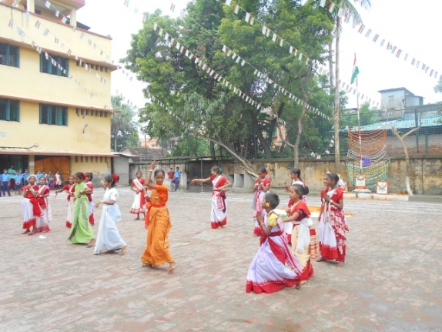

CELEBRATION

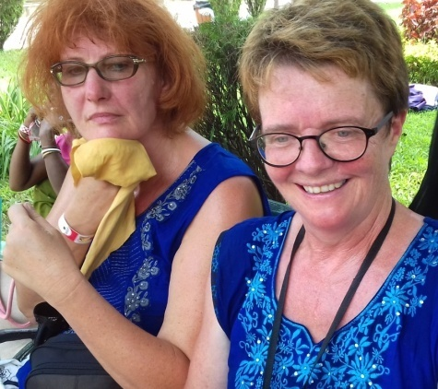

VOLUNTEERS AND VISITORS

**What is Howrah South Point ?**

**Howrah South Point is an Indian NGO working for the poorest of the poor, rendering services to poor handicapped children, reaching to those who are in medical need but cannot afford, educating children through formal school who cannot afford , bringing education to those children whom society does not give opportunity through our non-formal schools.**

**This NGO was started in 1976 by Rev. Fr. Francis Laborde who was inspired to start this mission by two people, first, (blessed) Fr. Antony Chevrier (1826-1879) a priest who lived at Lyons and consecrated his life to service of the poor, especially for the poor children in the beginning of Industrialization in Europe. Second, Cardinal L. T. Picachy, then the Archbishop of Kolkata. He summoned Fr. Laborde to start at Andul Road a home for poor handicapped children to which will be attached a dispensary for the poor of the locality. Since then till date poor and neglected of the society, irrespective of caste and religion have been the beneficiaries of this Organization.**

**These services are provided through the three Units, Jalpaiguri, Howrah and Asansol.**

# Published by: Secretary H.S.P.

Email: [hsouthpoint@gmail.com](mailto:hsouthpoint@gmail.com)

# 

# For private circulation

Face book .hsouthpoint@gmail.com

**ANUPRERONA**

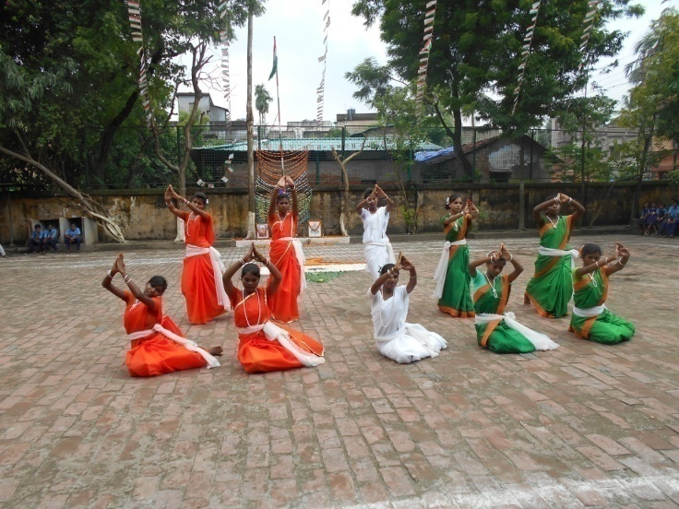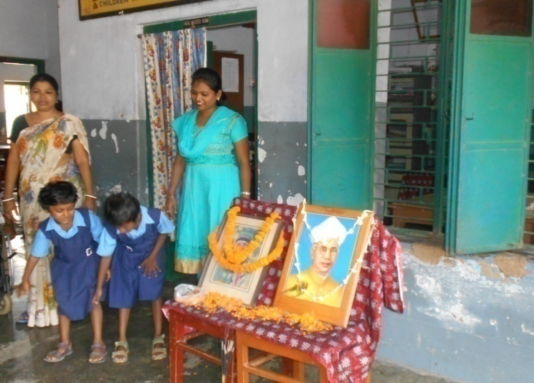

CELEBRATIONS

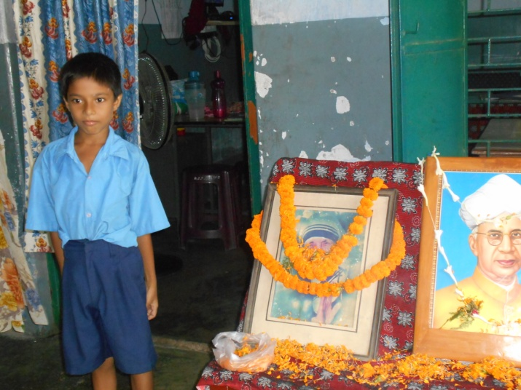

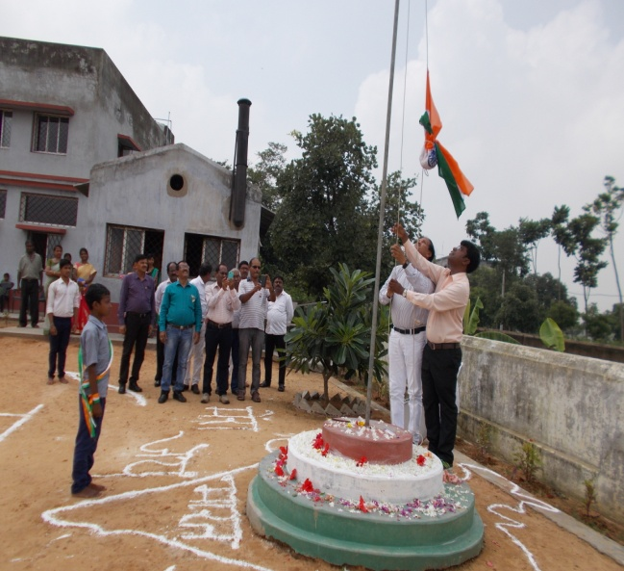

**INDEPENDENCE DAY CELEBRATION (15 AUGUST,2016)**

Independence Day celebration was organized by the children under the guidance of the teachers. The program started with the march past by the day children followed by a drill performed by morning children. The children of morning session also performed beautiful cultural dance and drama. The program was enjoyed by all and later it ended with a speech given by the chief guest.

All the children of Jalpaiguri homes.and Schools celebrated Independence Day with lot of interest.

Howrah South point Asansol Branch, Kalipathar Hindi Primary School Has Celebrated the Independence Day On 15th August 2016. At that day Mr J. K. Vishwakarma sir was the chief guest, He hoisted Flag and the National anthem was sung.

**TEACHERS DAY (5th SEPT)CELEBRATION**

Teachers Day was celebrated on 5th September on the birth anniversary of Dr. Sarvapally Radhakrishnan. We had a small prayer service in honor of Mother Teresa and Dr. Sarvapalli Radhakrishnan. Children from lower class sang songs, recited poems etc. The teachers garland the portrait of the two honorable person. The children of Upper class took classes of lower class for two periods.

**ANUPRERONA**

**SONG COMPETITION**

On 25.09.2016 like every year, the Bharat Bikash Parisad at Kakurgachi organized an inter school national group song competition in which 24 students from Baksara Home participated and performed Adiwasi flock song and bagged 4th position.

**RAKHI PURNIMA**

Maria Basti community residents celebrated Rakhi Purnima where sisters tie a band around the wrist of brothers so that their bond remain eternal ,at Bakuabari Home and enjoyed the Day.

Registrations

**National Trust registration renewed for** Jordighi Home got registration under Juvenile .Justice (care & protection ) Act,2015 as children’s Home for 50 boys with special needs for the period of 5 years

Renovation work

At Maria Basti Home toilet doors and floor renovation work Completed .Basket Ball stands was renovated as boys of Jordighi enjoy to play every day .Thanks to Christine Behlar and Maria Hublitz , Germany for sponsoring both items.

Training

* Ranjita Oraon ,payel Bagchi staff of Bakuabari Home attending two months course of care giver training at IICP , Kolkata
* Tapan Dhara attended one week course on Solar Pv system at ICOD, Howrah.
* 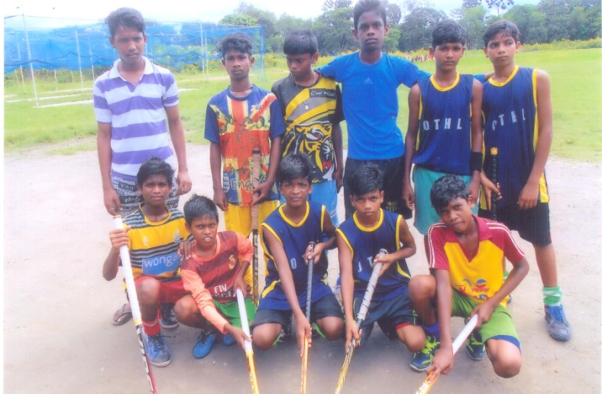HSP Staff attended Power grid Corporation of India with collaboration of ALIMCO, identification camp for free distribution of Assistive devices of persons with Disability organized at Rajgnaj Welfare organization  **106** CWSN from homes and outdoor posts enlisted for wheel chairs, crutches, multi sensory kits.

Hockey team

Baksara School Day section boys play Hockey tournament under 1000 Hockey legs Organization from Delhi recently they have registered their names under Hockey India League. Hope their dreams come true to play for India. Now these boys are saplings in Hockey they have to be groomed and nurtured for future.

**ANUPRERONA**

Visitors

* Child Protection Officer, Jalpaiguri inspected Jordighi and Bakuabari homes and advised to maintain registers as per J.J Act 2015.
* Ms.Moumita Roy Choudhury , Administrator of Howrah South Point visited all the homes of Jalpaiguri Branch.
* The Block Welfare officers of Sadar and Rajganj Blocks inspected four homes in order to renew Home License.
* State deputy inspector, District Officials, Block officials of Mid Day Meal program inspected Shikarpur School and appreciated
* District Child Protection officer attended Home Managing committee meeting and informed various schemes of Government.
* Visitors from District Mass Education Department and District Child Protection Officer from Jalpaiguri came to visit at Bakuabari Home. The DCPO was present for the Home Managing Committee Meeting. The Joint Block development officer and Block Social Welfare officer came to visit at Bakuabari.
* Mr Tapan Roy Chowdhury is a Physiotherapist from Siliguri, orgaganised a birth day party for his son and one day meal for all of Bakuabari home. His friends Mr. Suresh Agarwal from Siliguri donated 400 kilograms of rice, 100 kg Sugar, 120 kg dal etc. for the children.
* The manager of a local tea factory given a bag of Rice and chocolates. Mr Nandalal Sharma from Siliguri donated a bag of rice and chocolates.
* Christine and Maria brought three wheel chairs and five pairs of crutches from Germany and they purchased a wheel chair from Siliguri. Two wheel chairs given to the women of Maria Baste Home, one for Jeevan Path and one for Nirmala Nivas Children. Christine Behlar , Maria Hublitz ,Germany came on 2nd August 16 and brought wheel chairs, crutches, special shoes . They have visited all homes and Outdoor posts and distributed the items. They also donated clothes for Jordighi, Mogradangi home children, Physio materials for Mogradangi, music system for Maria Basti Home, renovation of Doors of Big Girls at Bakuabari. They purchased the toys games and chairs for the children of Bakuabari Home.
* On 16th  September 2016 Ms Stephanie Perreauxe, come from Switzerlard. She lived in Anand Bhavan Home for two days. She was very happy to see the Childrens . She donated 9 solar street lights for the Anand Bhavan Home .We never forget her children and staffs are very grateful to her for it . These street lights inaugurated on 17th September by Ms Stephanie dadas & didies. She also visited Mogradangi Home to review solar systems

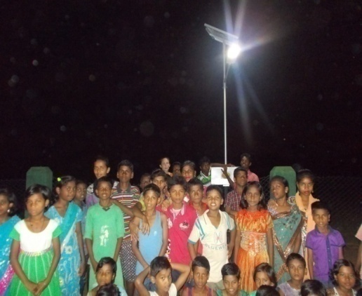

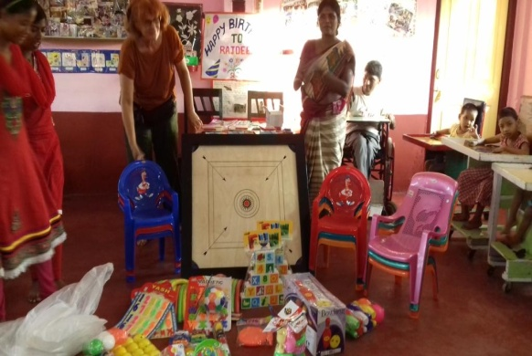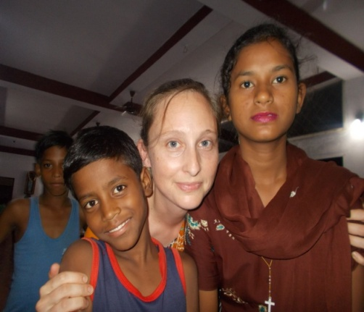

**ANUPRERONA**

OUTING

* The two German friends of HSP came to Jalpaiguri in the first day of August. They organized a big charming day on 4th August for four homes at Jalpaiguri to visit Amusement Park at Siliguri.
* Christine Behlar and Maria Hublitz , Germany sponsored one day outing to all four home children with staff at Savin Kingdom ,Fun Park ,Siliguri.
* On July the residents with special needs form four homes of Howrah South Point, Jalpaiguri Branch went to a screening camp at Rajganj for the free distribution of assistive devices by ALIMCO .

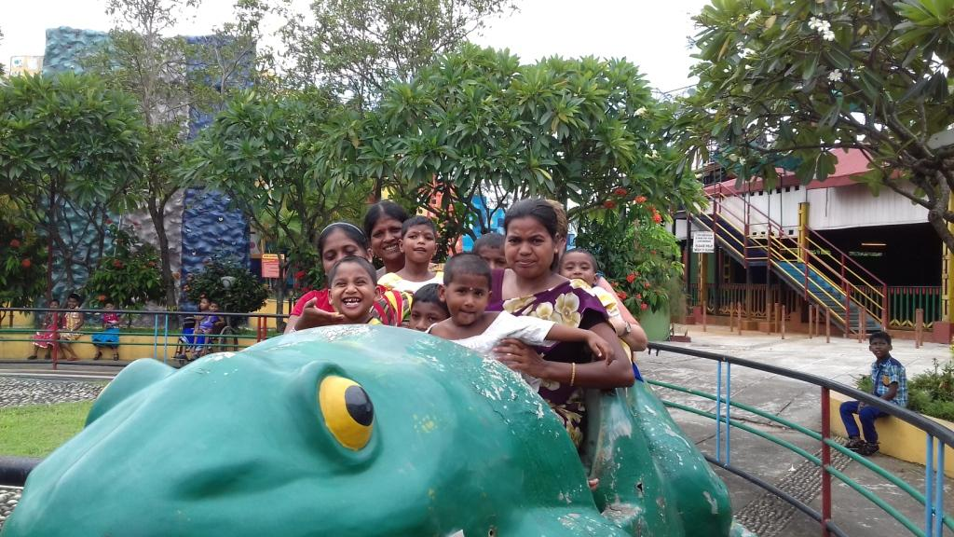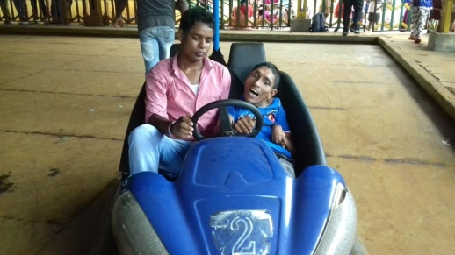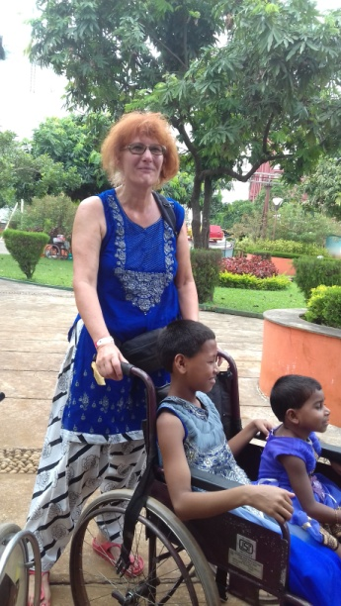

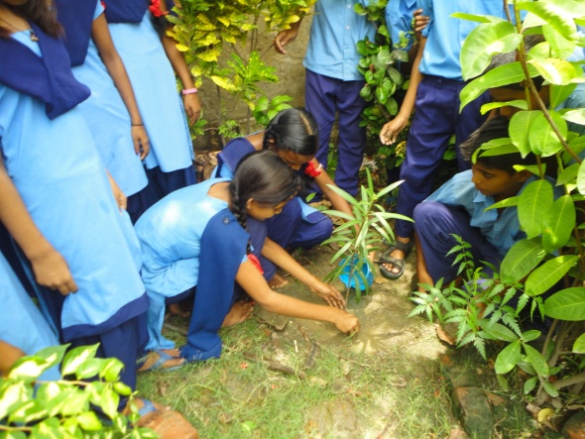Tree plantation

Plantation is one of our school curriculum activities. Students participate twice or thrice a year to plant trees in and around Hostel and school campus and care for the environments. After planting the senior student’s class take care of the plants planting trees motivates the students to keep the environment green and safe. Students have planted more than 100 trees but during the summer vacation nobody to take care and it dues away. Some are still alive and looks healthy plant.

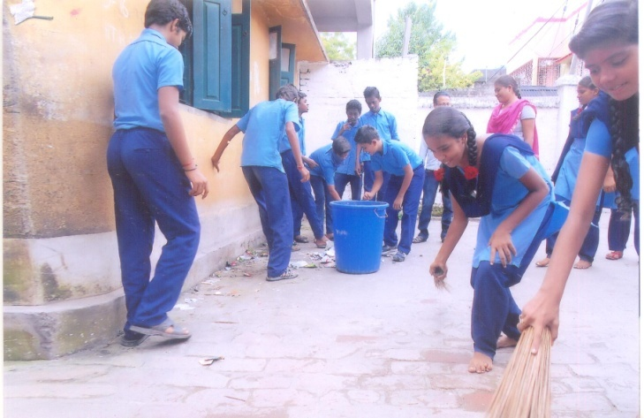Cleaning our locality

Under the swatch Bharat Abhiyan scheme our students take up cleaning the surroundings of our school and locality class – VIII students clean the surroundings and keep the place clean. They know that clear liners are next to Godliness. Students are taught to be hygienic and tidy in their daily life and activities. Every month each class is given responsibilities to clean. So everyone gets chance to do. It is one of our extracurricular activities of our School.

**ANUPRERONA**

GIFTS FROM OUR LOCAL FRIENDS

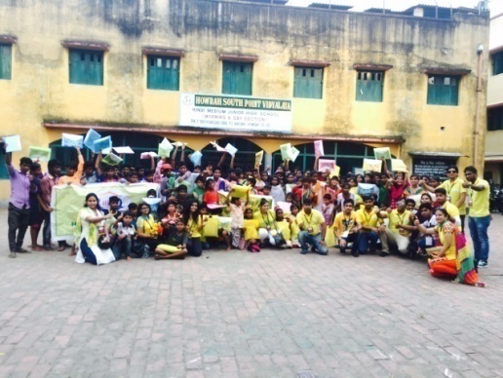

* 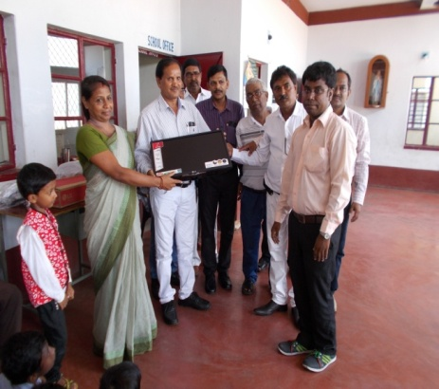Nawaid Akhter with friends (group of Humanity for you and me) around 16 people, in all visited the Baksara Home on 25.09.2016 spend half day with the children & staff. They sponsored new T. shirt, Pants for boys, Kurti, leggings for girls for 25 students and note book, file, chocolate, pen, Biscuits, cold drinks for other students. The children and staff enjoyed the day with the “HUM”
* Mr.Pawan Kr.Agarwal Rajganj donated 15 kg of rice 8 kg vegetables, cooking oil for the use of Shikarpur School Children.
* Dr.Bijoy Kandoi, Jalpaiguri distributed Biscuits, chocolates cleaning goods among children Of Jordighi Home.
* Dhiraj Chowdhury , Jalpaiguri donated wheel Chair to Mongala Toppo resident of Maria Basti Home and fruits to children of Jordighi and Maria Basti Homes on Occasion of Independence Day.
* Mr.Biswajit Roy resident of Panikouri donated Almirah and copy books, Snacks on occasion of Independence day for Shikarpur School children
* 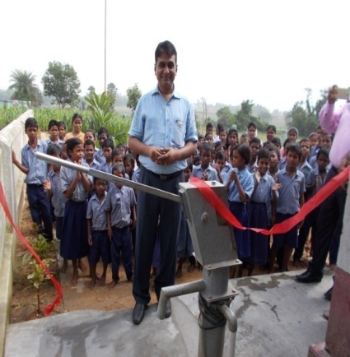Mr J. K. Vishwakarma, is a staff of E. C. L Company .He and his group have given. L C D T. V . to the Childrens of Anand Bhavan Home Kalipathar . They visit the Childrens from time to time. And also they distribyted sweets, chocolates etc to the children. The Children enjoyed eating it.
* 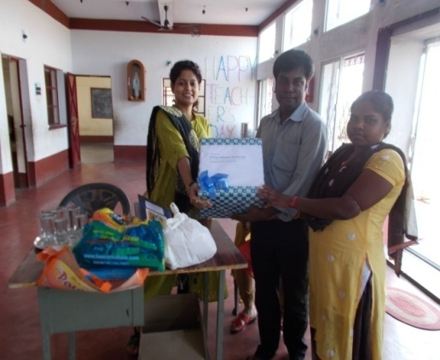On15th August 2016 came Mr . Bijay Agarwal and Mr . Shivcharan miharja from Barakar west bengal. He has donated a hand pump with Submersible pumpset to the Kalipathar Hindi Primary School And Anand Bhavan Home Kalipathar. The Opening Ceremony of this pump held was on 15th August by respected Mr Bijay Agarwal and team. The total Budget of this pump set Machine was 100000/-Rs Only. The same day Mr Bijay Agarwal has donated some Special domestic things which are 50kg Rice, 50kg Wheat ,5kg mustard oil, 6kg mung dal, 5kg flat rice ,1kg Haldi Powder, 1carton butter Biscuit &124 pic cadbery chocalates for all Childrens . Home In charge of this home has given special thanks to the honorable guest.
* 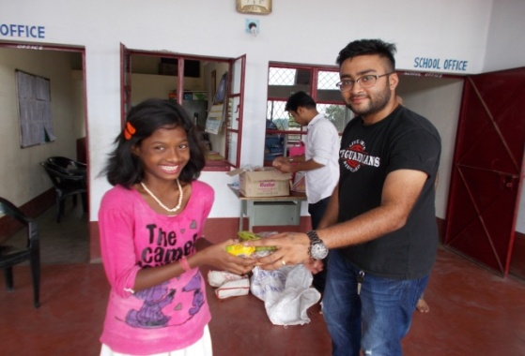On 15Aug 2016 .Mr Manoj Soni and Mr Akash Burman, they come in the Afternoon At 2:30 p m. They have given Breads, Bananas, Chocolates etc to the children of Anand Bhavan Home Kalipathar.
* 4TH SEPTEMBER 2016 Mr Akash Burman, he lives in kulti. He visited on Sunday at 1:30p m . He is interested in the children. He donated copies, Bananas, biscuits etc.
* 10th September2016 Dr Akansha Bhaskar , She is an I S Officer and her father B. S. Pandey visited the Children. They sow everything and impressed by it. They donated 50 pieces L. E. D Bulbs and distributed cakes to the children.

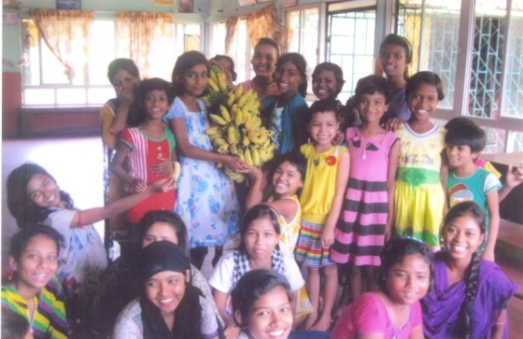

**ANUPRERONA**

* Group of young people Parvindar Singh, Neha Agarwal, Roshnik Mainan, Sachin, Saharsh, Rohit. These young groups of our local Donors gives Rice, Atta, Dal & some time mustarded oil for our children at Lalkuthi every month. They are very sincere to give these food items regularly.
* Mr. Swapan Kumar Ghosh Managing director has given us 120 kgs of rice and banana for all children of Lalkuthi Home.
* 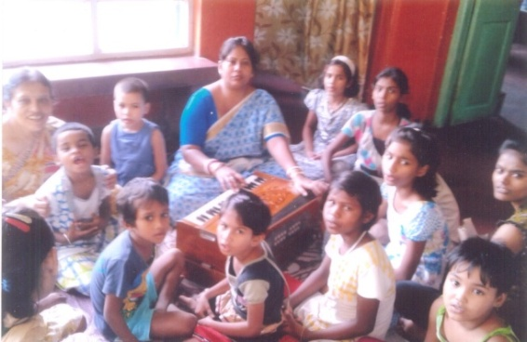Monalisha Choudhuri a song teacher gives singing class every Sunday free of cost more over she gives Rs. 500/- as donation every month for our Home children at Lalkuthi. She has arranged drawing competition for the children and all of them received prize.
* “MCKS Trust Fund” Yoga Pranic Healing Foundation has given us 60 kg soybean for Lalkuthi Home Children.
* 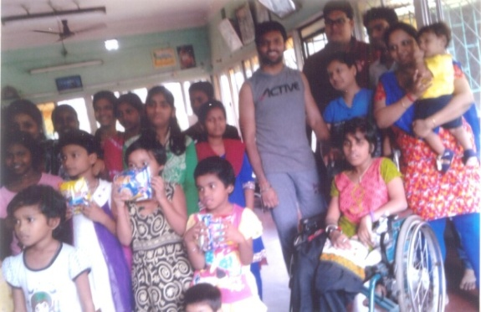Kabita Jhalani is one of our local donors. She is giving fruits to our children at Lalkuthi. Manali is her office friend and they celebrate her daughter’s birthday. She gave towel, soap, washing powder, cream, park, biscuits for each girl. She also gave 15 lt. refine oil, 10 kg Sugar, 1 and ½ kg tea leaves 2 bigs plastic tub & 2 bucket.

Govt. support

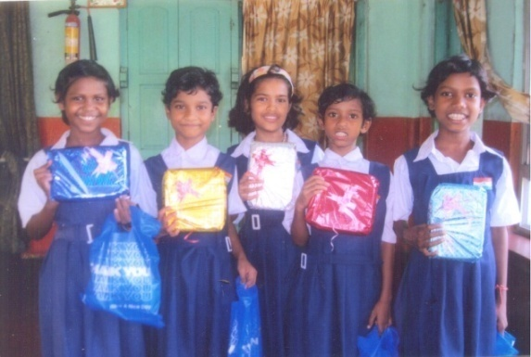Howrah Municipal corporation chairman cum councilor of 41 no ward of Baksara had organized a health checkup programme for our children at Lalkuthi. There after he has given 90 kgs of wheat free of cost for our Home children.

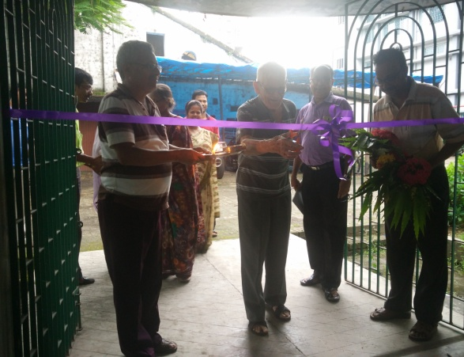Change of hsp office address

Our office shifted at the P-249, Andul Road, Podrah, Halderpara, Sh ibpur, Howrah – 711109 from 15 P.M. Bustee 3rd bye lane, Shibpur, Howrah – 711102 on 12.09.2016. Our president Fr. Laborde inaugurated the new office by cutting the ribbon.

**ANUPRERONA**

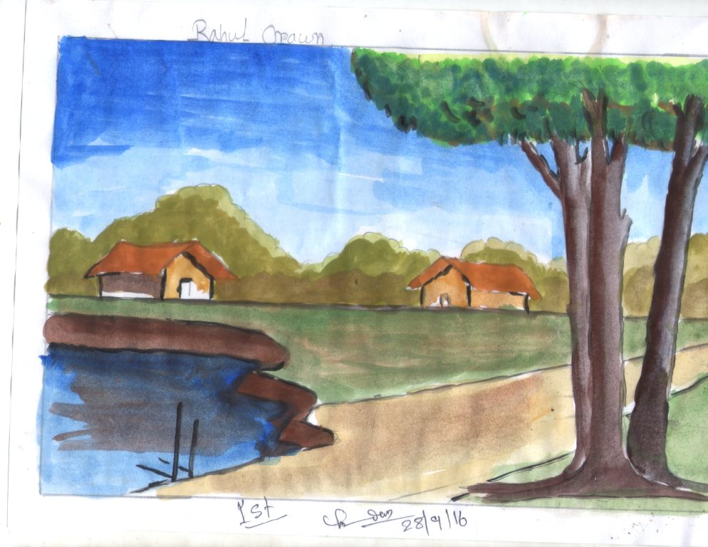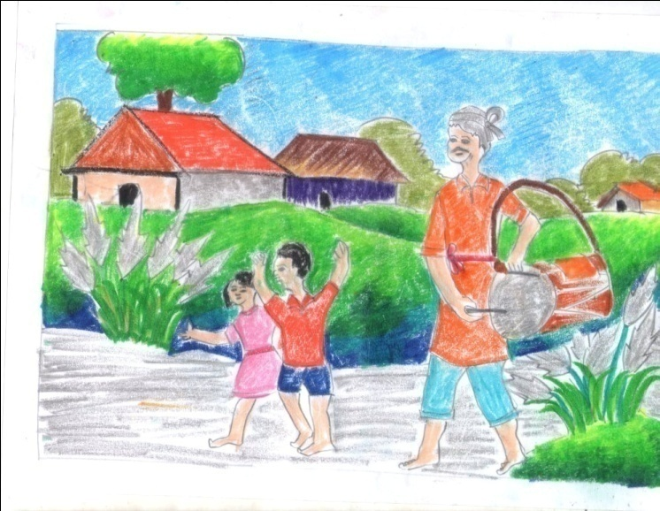

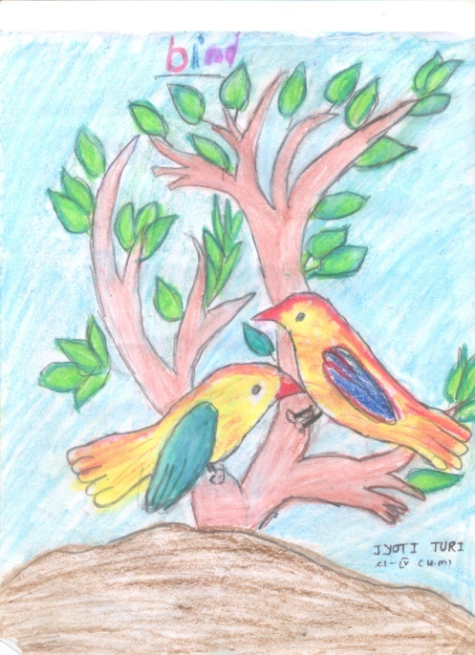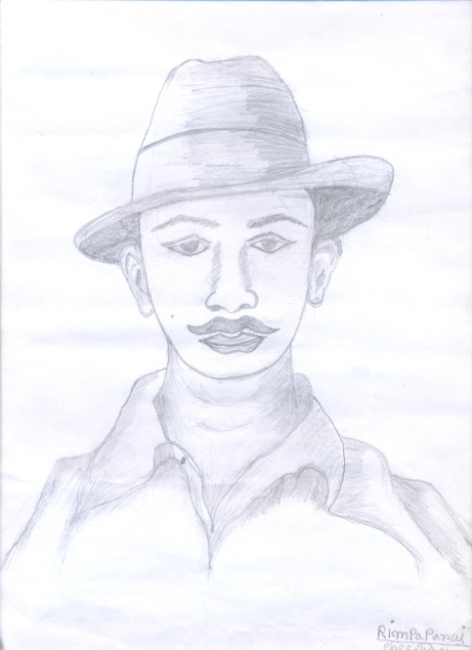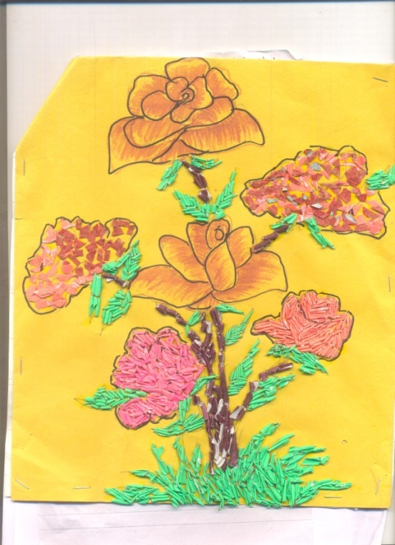

Made by : **AMISHA ROUT** (hearing impaired child of **PROGNALAYA SPL. SCHOOL**

**BOOK POST**

## HOWRAH SOUTH POINT

15, P M Bustee 3rd Bye Lane, Shibpur, Howrah-711102

Tele : (0091) 33-2638-8608, 2638-4481

E-mail – [hsouthpoint@gmail.com](mailto:hsouthpoint@gmail.com)

Website – www.howrahsouthpoint.org