##### 

**ANUPRERONA**

The Newsletter to the Friends of HSP

**Issue 57 December, 2016**

**EDITORIAL**

Dear Friends, Partners and well wishers,

Our Dec 2016 issue of ANUPRERONA has many updates on the interesting activities continuing at HSP. The philanthropic support received from donors helps change live and build communities, hence representing a mighty force with immense capabilities. Undoubtedly HSP values each of its donors and is greatly indebted to them all; their contributions are helping HSP accomplish milestones at its on-going projects.

This times newsletter gives a close looks at our activity over the concluding months of 2016. There has been an amazing step up in involvements in new schemes and ways to generate funds in the vocational Unit that help in the smooth functioning of the HSP network.

Our Dec issue of HSP brings with it up dates on HSP activities since last of the year. The most important event of HSP was the program arranged by the Staffs of HSP for the WORLD DISABLED DAY which was a thumping success. The new members of HSP contributed significantly to its success.

As always we thank our patrons for their generosity, with the help of which HSP is steadily moving towards improving the lives of many underprivileged communities. We also take this opportunity to thank all our valued donors for their kind support and invite others to come forward as well.

On behalf of the whole team of HOWRAH SOUTH POINT

Moumita Roy Choudhury(Administrator)

With warm regards

Fr. Jose

Hony. Secretary, HSP

With Love and regards,

Terence John

Hony. Secretary

***Mr. Terence John  
Secretary***

*Sincerely*

*Tapati Mukherjee*

HIGHLIGHTS

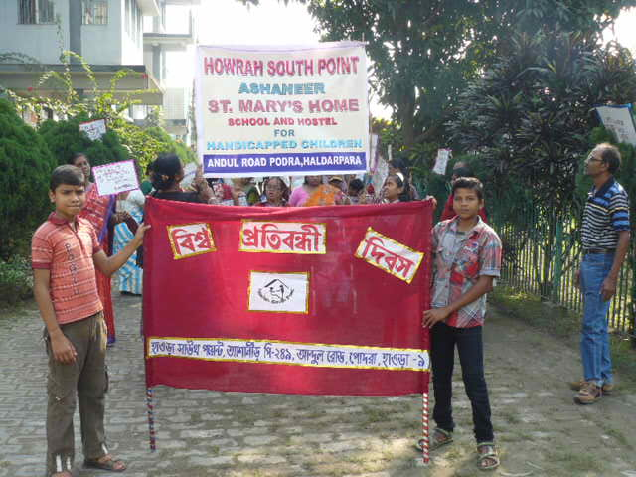

CELEBRATION

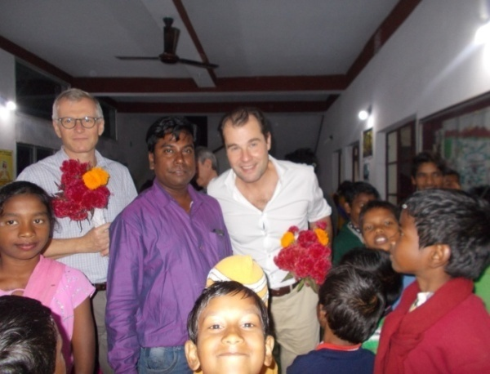

VOLUNTEERS AND VISITORS

**What is Howrah South Point ?**

**Howrah South Point is an Indian NGO working for the poorest of the poor, rendering services to poor handicapped children, reaching to those who are in medical need but cannot afford, educating children through formal school who cannot afford , bringing education to those children whom society does not give opportunity through our non-formal schools.**

**This NGO was started in 1976 by Rev. Fr. Francis Laborde who was inspired to start this mission by two people, first, (blessed) Fr. Antony Chevrier (1826-1879) a priest who lived at Lyons and consecrated his life to service of the poor, especially for the poor children in the beginning of Industrialization in Europe. Second, Cardinal L. T. Picachy, then the Archbishop of Kolkata. He summoned Fr. Laborde to start at Andul Road a home for poor handicapped children to which will be attached a dispensary for the poor of the locality. Since then till date poor and neglected of the society, irrespective of caste and religion have been the beneficiaries of this Organization.**

**These services are provided through the three Units, Jalpaiguri, Howrah and Asansol.**

# Published by: Secretary H.S.P.

Email: [hsouthpoint@gmail.com](mailto:hsouthpoint@gmail.com)

# 

# For private circulation

Face book .hsouthpoint@gmail.com

**ANUPRERONA**

**CELEBRATION**

**Childrens Day Celebration:**

This year children’s day was celebrated on 15th November because14th was the Gurunanak’s Jayanti (Birthday) and a holiday. This Program started with a beautiful assembly prayer and there after all the staff welcomed the children by their melodies song and garlanding. There were lot of sports and games competition for boys and girls. Most of the students participated in it and respectively won the prizes. Almost all were given small prizes. Staffs had contributed money to celebrate this day and made it a successful one for the good of the students and for their happiness. It was a wonderful day.

**Child Rights Week** Celebrated by The District Child Protection Unit, Jalpaiguri was invited by the children Of Howrah South Point , Jalpaiguri. The girls from Bakuabari went at the river side of Dooars, the children from Mogradangi and Jordighi Home went to North Bengal Science City. The B**oys from Jordigh**i took part in 2 days Nature study camp at the forest & river at ***Jhalong*** .

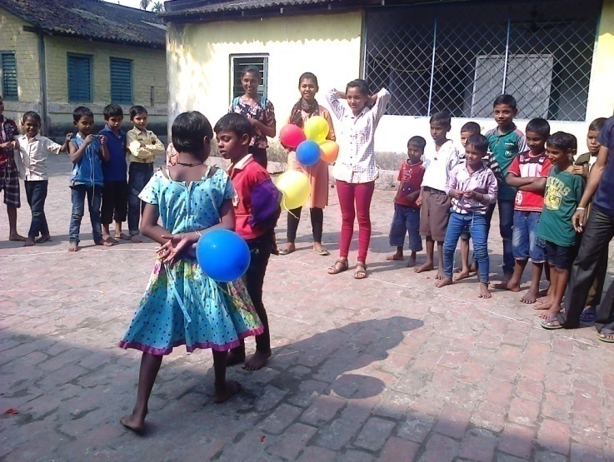

Hockey competition on Children day at Baksara

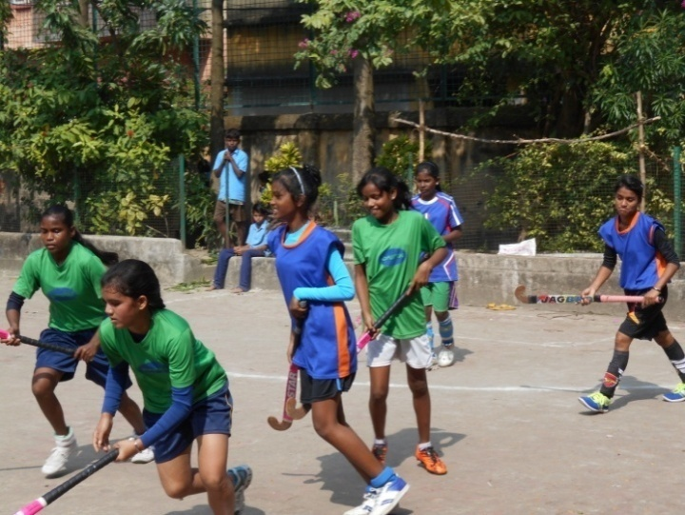

Children Day celebration at EPN

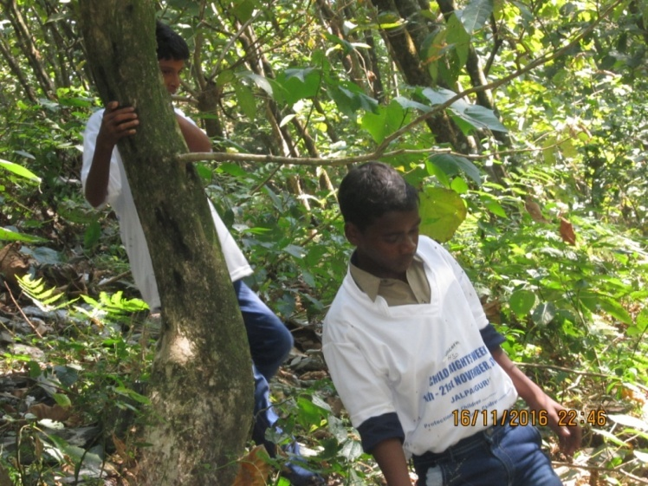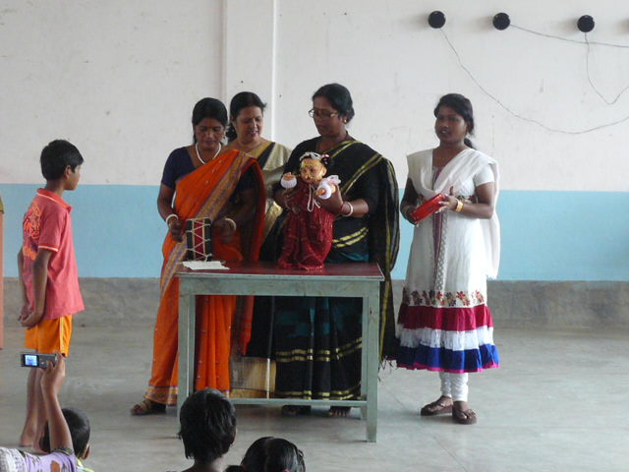

Nature study camp on Children Day at Jalpaiguri

Children Day celebration at Prognalaya Special School

**ANUPRERONA**

**World Disable Day**

One exceptional and special program was 3rd Dec’16 for World Disable Day. The day began with a rally where the children along with their parents, teachers and the staff members joined their hands to walk, along the road with banners and posters depicting that disability is just another medical condition and not a curse and that they can perform activities like others if they are provided with equal opportunities. And on that day a magic show was arranged for our children. There was a talking doll in the magic show. This is the frist time they watched magic show in the Prognalaya Special School.

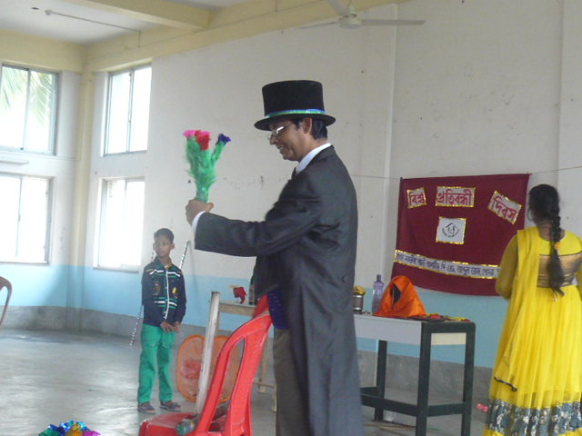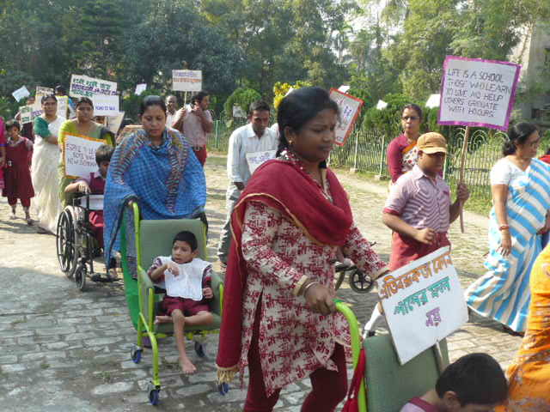

A Magic show on 3rd Dec, World Disable Day at Prognalaya Special School

Rally on 3rd Dec, World Disable Day at Prognalaya Special School

**Christmas Gathering:**

On 11th December, 2016 all homes celebrated Christmas by having a Gathering. Father Sakhar of Santragachi Paris graces the occasion and organizes a beautiful Mass at Baksara Home. Baksara Children played songs and drama very well. Children received gift and food on this day.

Staff and children of H.S.P Asansol Branch Anand Bhavan homes celebrated christmas gathering on 11 December. The elder children sang Christmas songs and danced. They did carol songs also. They were very happy and enjoy their self. They made model of jesus birth place .This is very beautiful to see. Special food for the day was fried rice and chili chicken in this occasion. Cakes and oranges were also distributed among the children.

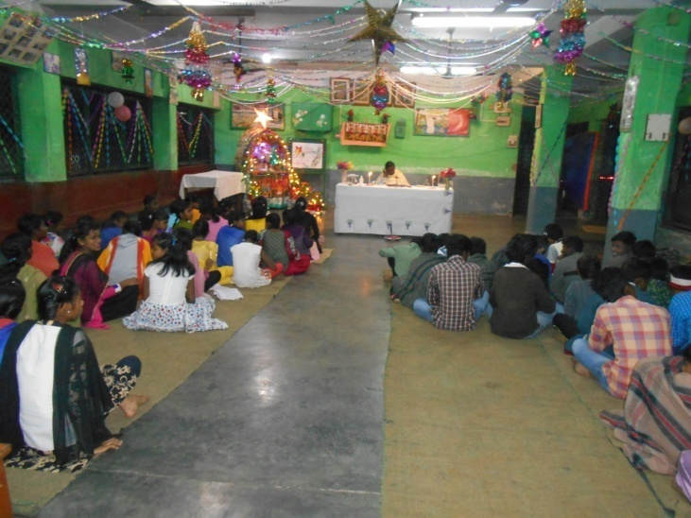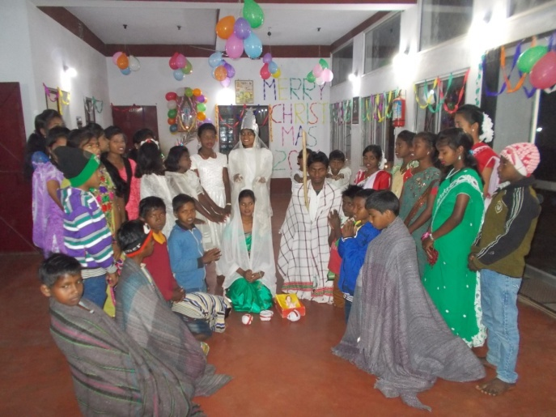

Christmas Gathering at Baksara Home

Christmas Gathering at Asansol Home

**ANUPRERONA**

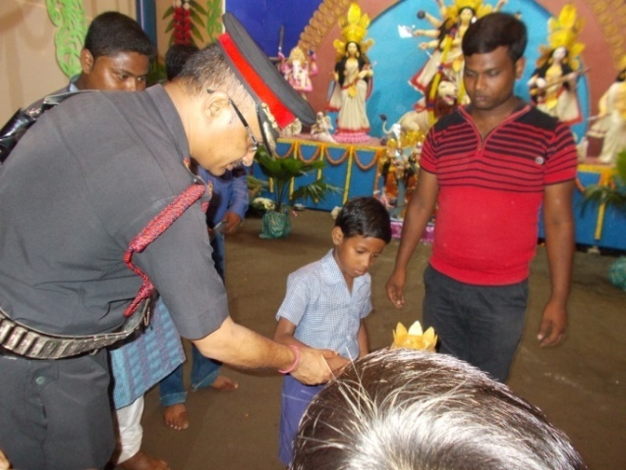

**Durga Puja**

Chalbalpur durga puja committee had invited our HSP Asansol Anand Bhavan Homes’ children with the home incharge Anup kachhap and other three staffs. We enjoyed and saw durga puja pandals. The children had inagrauted the durga puja pandalof Chalbalpur durga puja. They were very glad to invite our children.

**Diwali festival**

Incharge Anup kachhap of the H.S.P asansol anand bhavan home invited the E.C.L bofficer Mr. J.K.Viswakarma and Mrs. Viswakarma for diwali fastival. They had accepted our invitation and they had came in our home anand bhavan ,to see our home’s children they had very happy time and gave some diwali sweets, pataka, fuljhari etc. Our children very happy and joyful to get the gifts.

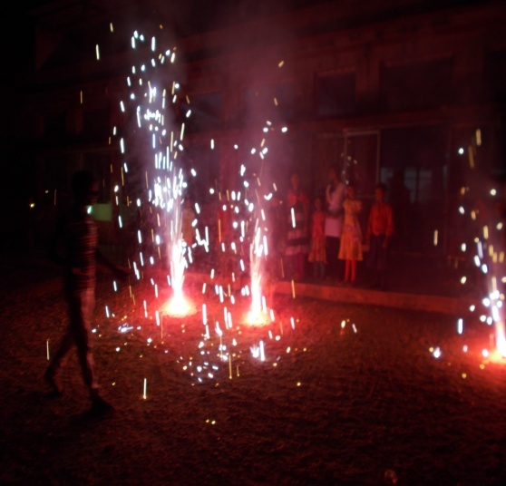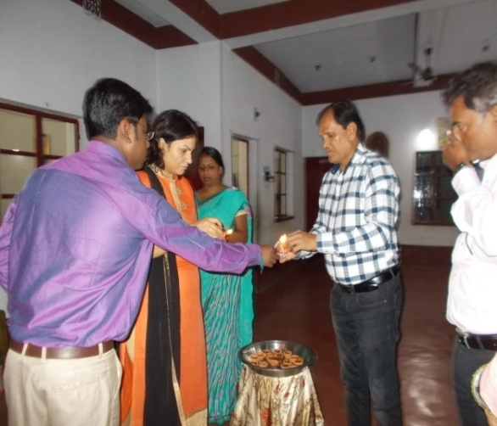

**Fair & Exhibition**

**Book fair**

Manus Domini school vocational unit’s handicraft item were displayed at Jalpaiguri Book fair. Some students actively participated to sell their products.

**Exhibition at TCS**

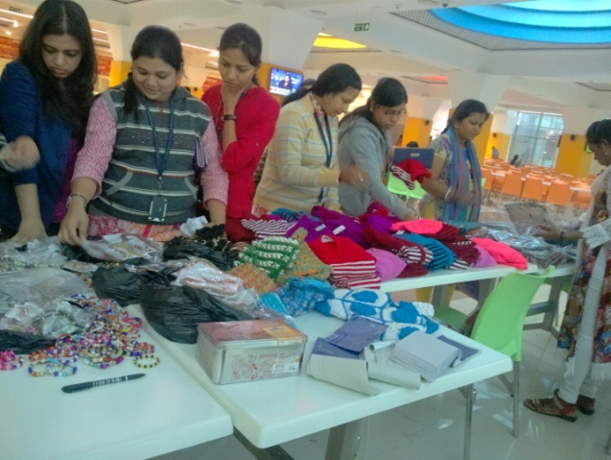An exhibition cum sale was organized by Tata Consultancy firm, Kolkata, involving Howrah South Point in their premises at Rajarhat on 16th December 2016. Howrah South Point has various wings of vocational training and items made in these units were displayed for sale. Items displayed were Woolen garments, Candles, Batik clothes and Artificial Jewellery. The products received a rousing response. It was the most memorable day for the staff as their products received such an exposure. They not only gained monetarily but they came back with rich experience and confidence about their skill and their products.

Thanks to Mr. Ronald Phillip & Suhrit Choudhuri of TCS for organizing this wonderful event and thanks to all those who worked to make the day a successful one.

**ANUPRERONA**

**Rojgar Mela:**

Child welfare, women development dept. and social welfare dept govt. of West Bengal celebrated international Day of persons with disabilities. This year also they organized the program on 3rd Dec. to 5th Dec. at college Square, Kolkata. HSP also participated in cultural program on 4th Dec. with 30 differently abled children. They performed a dance drama based on Rabindranath Tagore rhymes “Kumor Para Garur Gari” .We also display our vocational workshop production like Batik, Woolen garments, Candle, Jewellery, Base let etc. Many local people came to buy our product. Our Hony. Minister of women & child development dept. Mrs. Shashi Panja inorgated the programme, along with disability commissioner Mrs. Ranu Bhattacharya. Asst. commissioner Mr. S. S. Vinayak and Local councilor Mrs. Swapna Das also graced the occasion. Last Day they gifted a Memonto and cheaque of Rs 1000/-& a calendar of 2017.

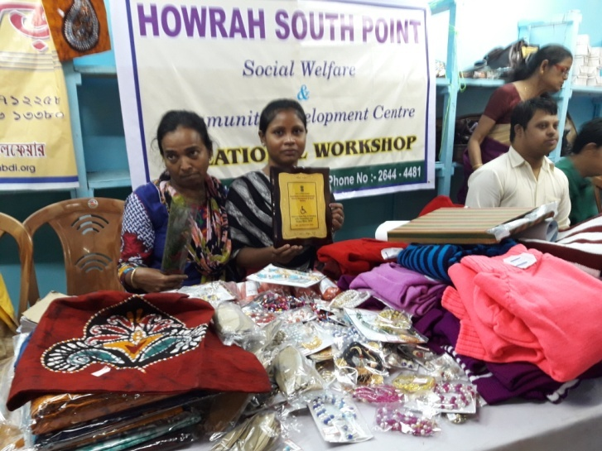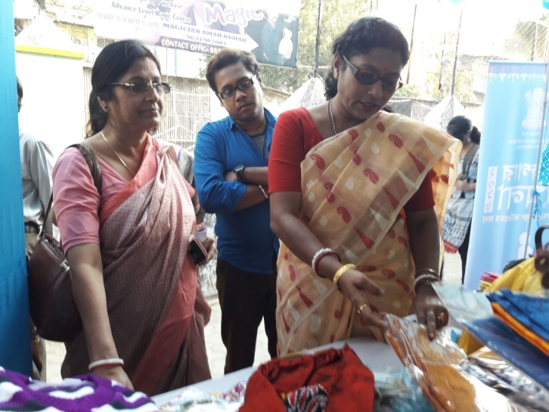

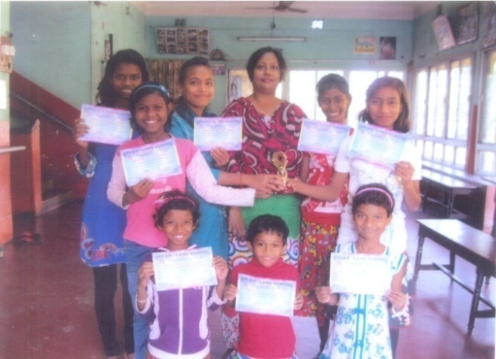

**Song Competition:**

Monalisa Choudhuri who gives song class every Sunday, free of cost. She had arranged with dream Land English Medium a song competition. 9 little girls of Lalkuthi Home went for the competition and got the 1st prize. Each girl had received certificate Indeed they were very happy to get the 1st Prize.

**Drawing competition:**

A Drawing competition was held on 16.11.2016 for class III & IV students (both Medium) on the Occasion of Children’s Day.

Lalkuthi children got 1st prize from song competition

And another drawing competition held on 14th November on occasion of Children’s Day at Bakuabari in which the boys of Jordighi home also took part.

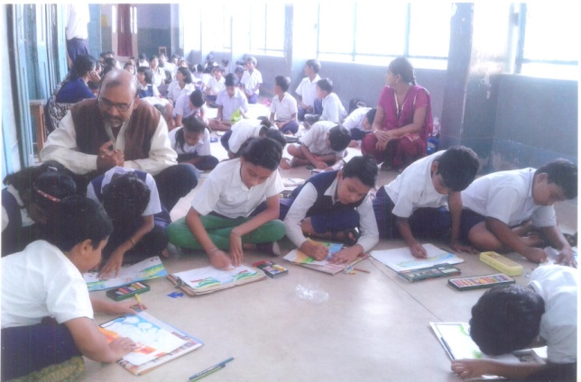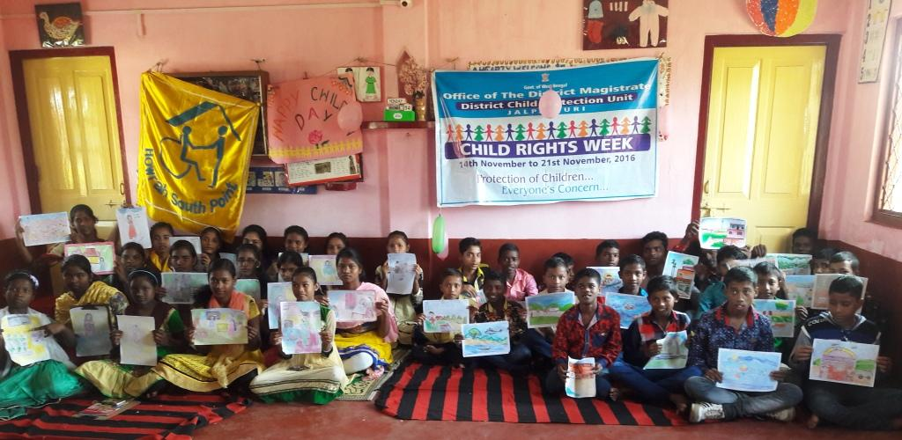

Drawing competition at Bankuabari Home, Jalpaiguri

Drawing competition at EPN School, Howrah

**ANUPRERONA**

**Sports :**

* A Friendly Kabadi Match was held on 22.10.2016 between Hindi & Bengali Medium girls for class IV in our School Compound.
* Special Olympics Bharat, West Bengal held on 9th & 10th December on Saltlake Stadium for Disable child. Our children from Ashaneer home participated on it and two of them one Babulal Kisku take 1st position on 100 mit. Run and Jahid take 4th position.
* 25 Children of home are participated at North Bengal Council for Disabled sports meet at Siliguri on 18th December 2016 and received Group Champion ship trophy through footballer Mr.Baichung Bhutia.

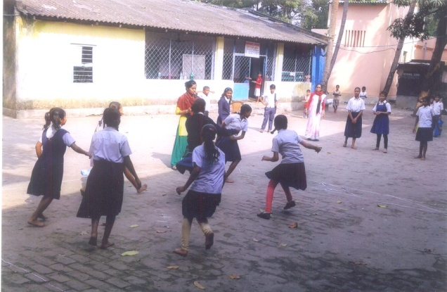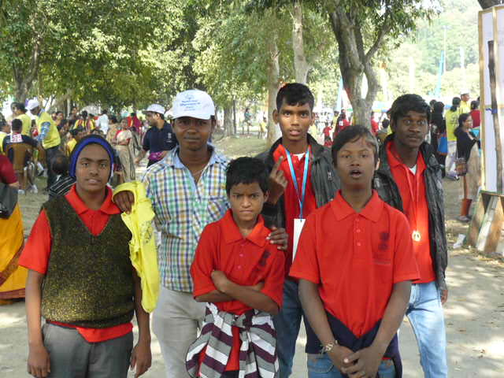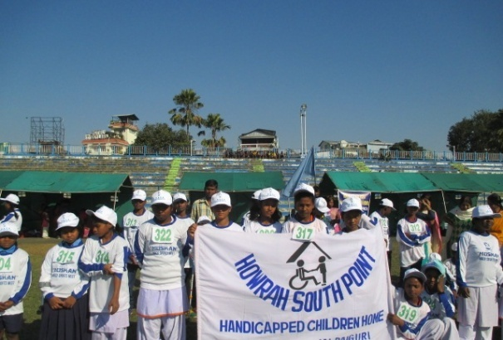

Disabled Sports meet at Saltlake

Disabled Sports meet at Siliguri

Kabadi Match at EPN School

**LOCAL DONATION**

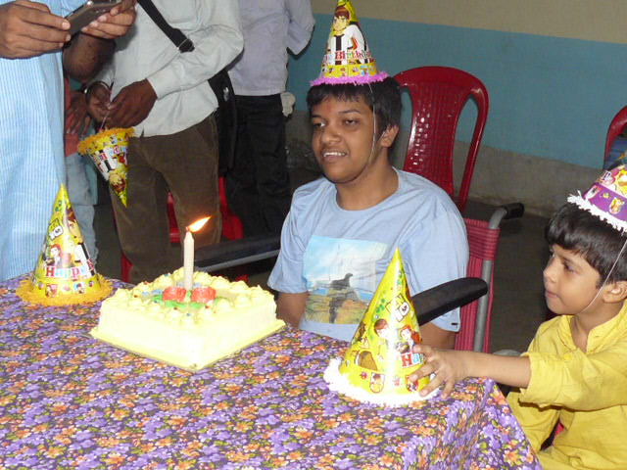**Ashaneer Home :**

* Punit Swreka family & friends come Ashaneer Home on 01.10.2016 to celebrated Birthday of Jay Sureka. They distributed cakes, snacks and Cadbury to all the children and staff.
* Suchita Pandey & his family came Ashaneer Home on 27.10.2016 and they arranged lunch like puffed bread, Potato curry, sweets, chatni, Papad & cake for our children & staff.
* Vipul Jain & friends come on 20.11.2016 and distributed one box sweets, Frooti, Choclates, pencil box, cake & chips among the Ashaneer Home children & staff.

Celebration of Joy Sureka’s Birthday

* Simran Agarwal come on 07.12.2016 and give Marie Biscuits, Good day Biscuits, chocolate, cake, pen, pencil, eraser & sharpener to our children & staff.
* Vivek Kumar Agarwal & Mr. Sharad Diwan come on 18.12.2016 give food items i.e. Rice 100kg, Dal 7 kgs, tiffin cake, Muri 5 kgs, Potato 20 kgs for our children.
* Monish Goel come on 22.12.2016 with his family to celebrate his son’s birthday with our children and gave breakfast to our children.

**ANUPRERONA**

**Lalkuthi Home:**

* Neha Agarwal, Simran & Gazal has given50 kg rice & few old cloths, Biscuits, Kurkure, Munch, cake etc. for children.
* Monij Saxena & family gave 20 kgs rice, 20kgs Atta, 10 kgs sugar, 5 kgs Dal & 4 packets Biscuits, 4 packets Maggi.
* Parvinder Sing, Neha Agarwal, Shahid Sachin, Rohit, Rostini & friends gave 113 kgs rice, Motor Dal 10 kgs, Musur Dal 3 kgs, Atta 5 kgs.
* Vivek Agarwal and family gave 10 kgs rice, 3 kgs Muri & 2 kgs Dal.

**EPN School :**

* On 17.12.2016 Neha Ghosh, a Local well wisher had donated Rs. 500/-for the development of School.

**Jalpaiguri**

* **Mass Education Department** granted an amount of Rs 35000.00 to purchase festival garments for 70 students for the year 2016.
* Local administration has allotted work to Jeevan Path residents under National Rural Employment Guarantee Scheme for development of pathway at Bakuabari. Seven residents participated actively during the project work, waiting for their wages.

**Maintenance work :**

* Lalkuthi over head water tank leaked & it had to repair very urgently. Now the problems are solved our big girls toilet is repaired kitchen tiles was broken & it has been repaired.
* Thanks to Christine Behlar and Maria Hublitz, Germany for their support for renovation of Maria Basti home dormitory floors, toilet doors of Big Girls Home, Bakuabari.

**17th Cleft lip Surgery Camp**

* 17 th Cleft Lip Surgery Camp was organized in the month of November 2016 total 40children were operated during the camp. Thanks to Pro-interplast, Germany for all the financial support, Dr. Hajo Sachs team of Doctors professional support and Goodricke Group Tea Company’s hospitality at Chalsa, Jalpaiguri.

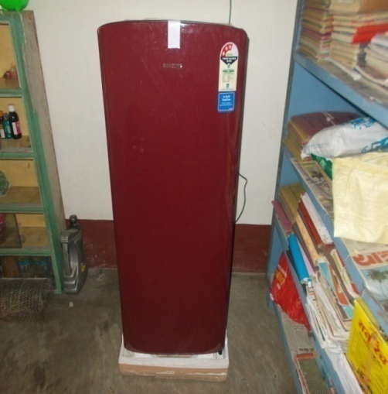Gift

On 10 December, In our HSP Asansol Anand Bhavan home get a new refrigerator from mr. Manoj soni and his family. He lives in Kulti asansol. We are very thankful to have this refrigerator. He has became our local doner. Our foods were wasted in summer day due to excessive heat so, that we are requested to Mr. Manoj soni for give refrigerator and he accepted our request .

**ANUPRERONA**

**FRIENDS & VISITORS**

* 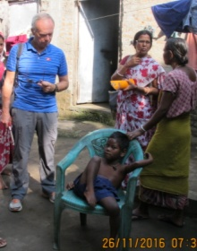**Stéphanie Perregaux**, President of Indian Project , Swiss visited all four homes to review solar systems, also donated Computer Monitor & accessories for Shanti Rani Primary School.
* **Gérard Romeder** ,President along with Jean-Louis Schneberger Board member of TDHA , France spent three days with Nirmala Nivas Children and visited some families of Outdoor and home children of Nirmala Nivas. They have donated clothes & toys for children and sponsored one day outing for Nirmala Nivas Children with Staff at Eco Park, Siliguri.

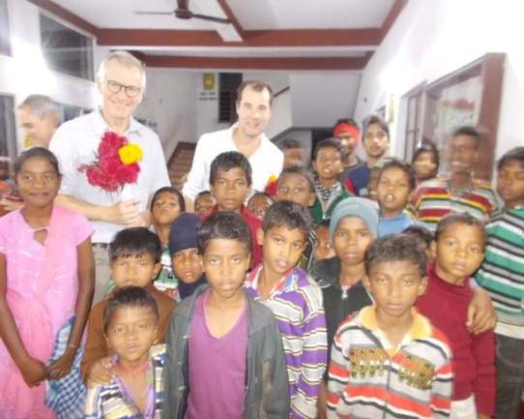

Gerard Romeder at Jalpaiguri

* In the month of november **Dr. Ettine** and his team were came in missionaries of charity for the operation to leprosy patient. They were interested to come our home anand bhavan. So, they had finished their work and then after, Dr. Ethen had came in our home anand bhavan home to just see our Homes’ children and distributed sweets among the children.

Dr. Etttine at Asansol

**Gardening**:-

The staff and children of H.S.P. Asansol Branch Anand Bhavan home in their campus grew like raddish, carrots, cabbage, cauliflower, potato,tomato, chilli, pulses, onion etc. Our homes’ staff and elder children hard worked to grow the plants .The vegetable and flowers are very beautiful to see . We did not buy vegetables from outside for some time. It is very tasty, delicious and organic. We are very happy to eat and to see the vegetables. The campus was very beautiful to see with full of greens in Anand Bhavan home.

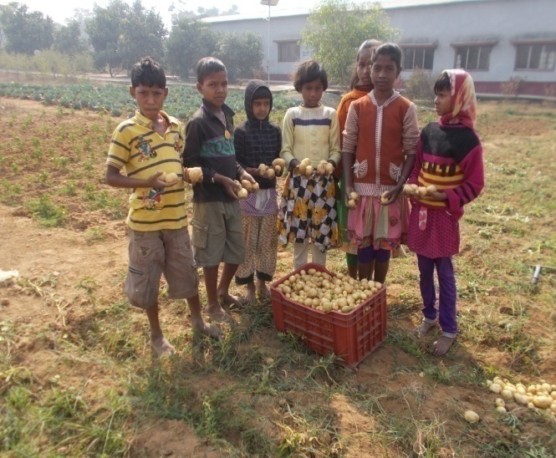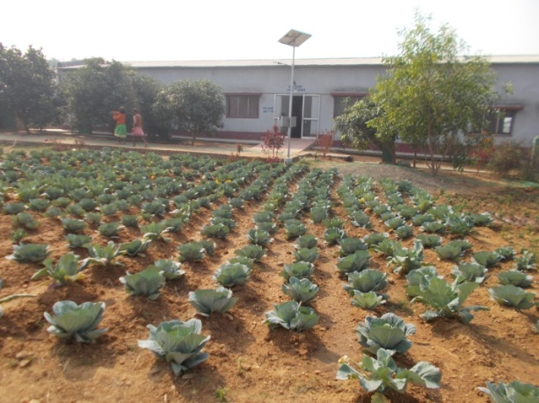

**ANUPRERONA**

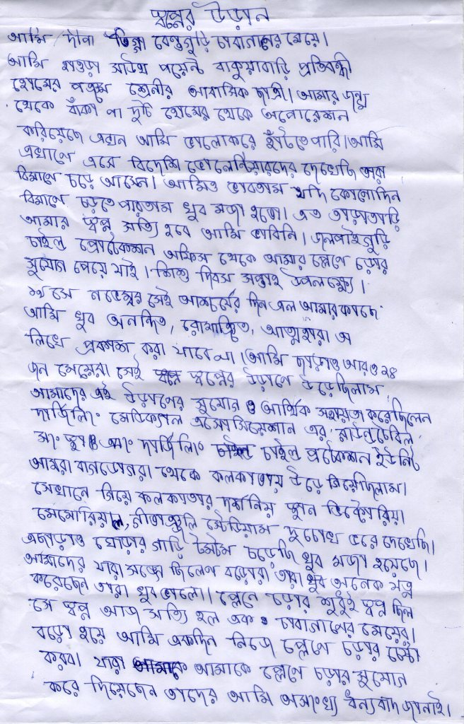

A flight of dream

I am Dipa Tigga of Beguguri tea garden. I am a residential student of Howrah South Point Bakuabari Disabled children home. I have club foot from my birth which was operated by HSP and now I can walk properly. I have seen foreign visitors/volunteers coming by flight. I used to think if I also could board a flight I would be very happy. I didn’t think my dreams will come true so fast. Jalpaiguri child protection office helped me to travel an aeroplane to celebrate children’s day.19th nov was the surprising day when I was very happy, excited and overwhelmed that I cannot write and explain . 24 girls along with me travelled by aeroplane that day. The travel was sponsored by Darjeeling medical association round table committee. We all travelled by aeroplane from Bagdogra to Kolkata.In Kolkata we visited Victoria memorial and Geetanjali stadium. We also were very happy to go around in a horse chariot. The people who escorted us and guided us were very good. Travelling by aeroplane was only a dream which came true for a simple girl like me of a tea garden. When I grow up I will try to travel by aeroplane by myself. Those who all made my dream possible of travelling by aeroplane I am very thankful to them.

**Translate**

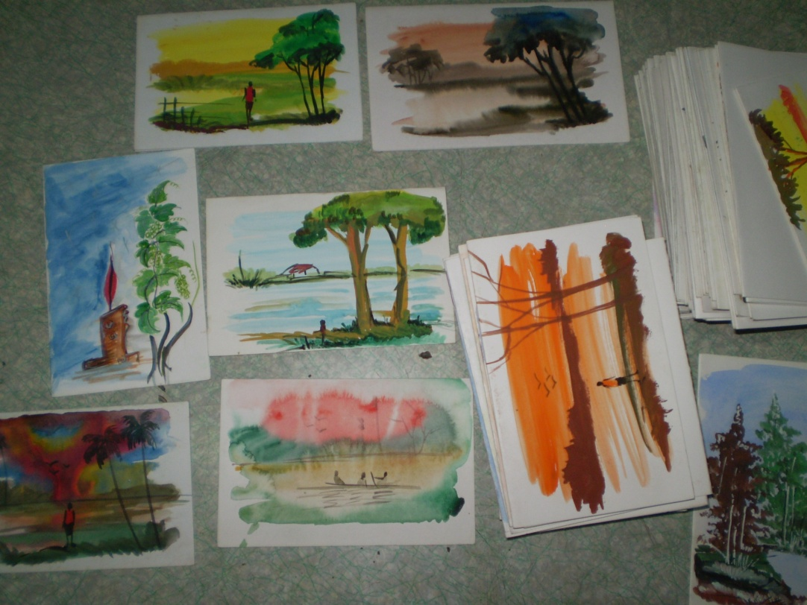

**ANUPRERONA**

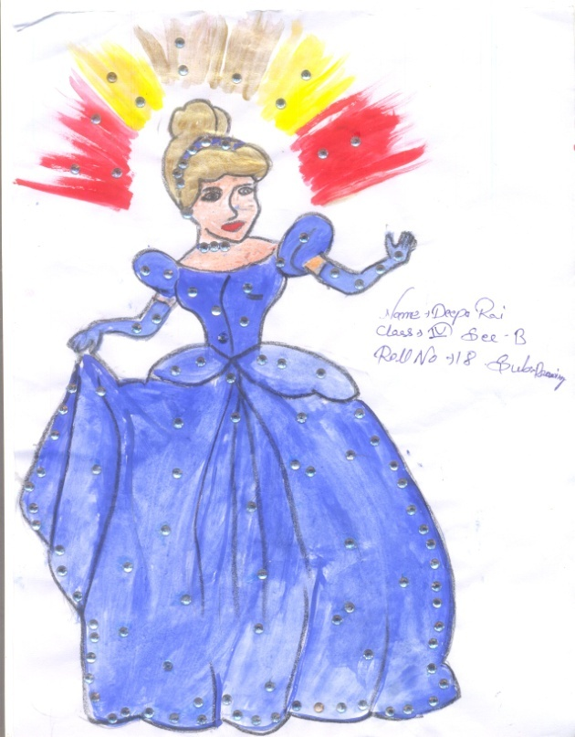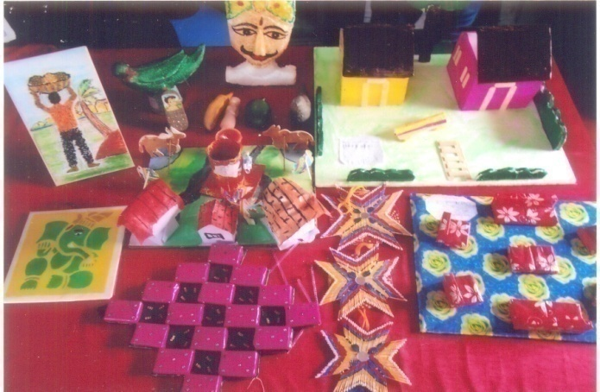

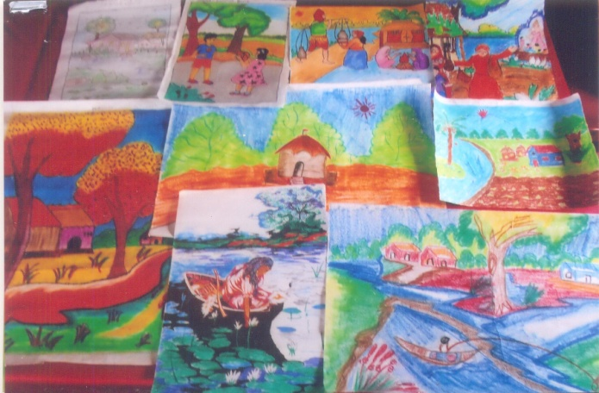

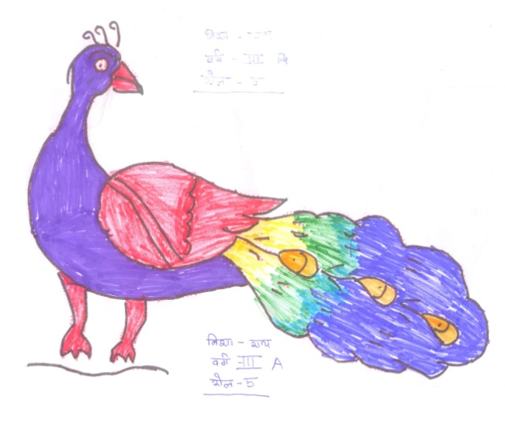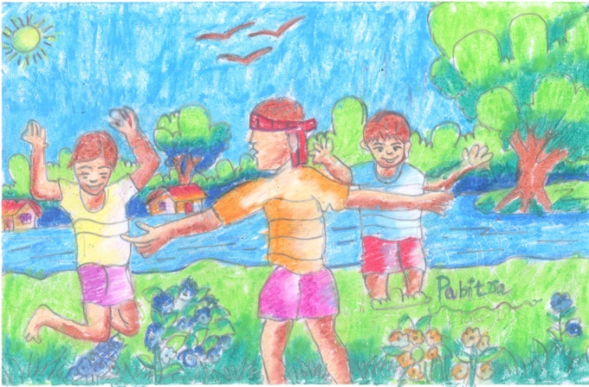

**BOOK POST**

## HOWRAH SOUTH POINT

15, P M Bustee 3rd Bye Lane, Shibpur, Howrah-711102

Tele : (0091) 33-2638-8608, 2638-4481

E-mail – [hsouthpoint@gmail.com](mailto:hsouthpoint@gmail.com)

Website – www.howrahsouthpoint.org